Duke OESO Guidelines for Safe Use of
CYANIDE SALTS
(and suspensions/solutions)
Covers: Potassium, sodium, silver, potassium silver, copper, gold and zinc cyanides
Lab-specific Safety Information on pages 3-4 or separate SOP MUST BE APPROVED in advance by OESO and the PI.
Hazards | Potential Hazards | - All above-mentioned cyanide salts are acutely toxic, fatal in contact with skin, if inhaled or if swallowed. All are high risk for skin toxicity (category 1); potassium and sodium cyanide are also high risk for inhalation (category 1). Doses in milligram quantities can be fatal.  - All above-mentioned cyanide salts will react with acid (or water, including moisture in air) to form hydrogen cyanide, a flammable and toxic gas that may produce a bitter almond odor.  - Potassium and sodium cyanide also cause target organ damage, with single exposures targeting the brain, heart, and testes; repeated exposures may affect the thyroid.  - Potassium, sodium and silver cyanide may also corrode metals, cause eye damage or irritate skin.  - These compounds inhibit cellular respiration, which leads to anoxia. Cyanide poisoning is associated with blue skin discoloration (cyanosis) but the cyanide-hemoglobin reaction can cause pink/cherry red skin. Initial symptoms of exposure are difficulty breathing, weakness, headache, dizziness, nausea and vomiting.  - The Permissible Exposure Limit (PEL) is 5 mg/m³. The PEL for hydrogen cyanide is 10 ppm.  - Toxic metal cyanides (cadmium, nickel, mercury) have other hazards not covered here.  - See compound-specific Safety Data Sheet (SDS) for detailed hazard information.
Exposure response | Medical Treatment and First Aid | Immediate first aid and medical treatment is essential for people exposed to cyanide salts or hydrogen cyanide. People working in and around cyanide salts must be familiar with the first aid procedures in the Emergency Response Flip Chart or webpages as well as these guidelines.  For an actual or suspected chemical exposure/injury:  - Do not wait for symptoms to develop. Seek immediate medical attention at the emergency department for ANY suspected exposure. The SDS should be taken to the emergency department if possible. Follow FIRST AID instructions below.  - Persons helping an exposed colleague must wear PPE as indicated on next page (2 pairs of nitrile gloves, splash goggles, fastened lab coat, and protective sleeves).  - Call 911 from a campus phone or 919-684-2444 from any phone to request assistance and/or emergency transport. Inform them that this is a possible cyanide poisoning and that cyanide antidote should be available. Provide details of exposure including the compound, potential dose, route of exposure, time since exposure, and any specific symptoms.  Provide FIRST AID immediately  (and during transit to Emergency Department as indicated)  Skin exposure: Take off contaminated clothing immediately (before transport or flushing); wash skin with soap and plenty of water.  Eye exposure: Immediately flush eyes at an eyewash station for at least 15 minutes. Continue rinsing eyes during transportation to a medical facility and while waiting to see a physician.  Inhalation: Move all persons to fresh air. If not breathing, give artificial respiration using a suitable mechanical device. Do not use mouth-to-mouth resuscitation.  Ingestion: Do not induce vomiting.  - After receiving medical treatment, complete the Injury/Illness report and contact Employee Occupational Health and Wellness (919-684-8115) for exposure-related follow-up.

Hazard Controls  Hazard Controls - 2 | Selection/ Purchase | - Consider safer alternatives. |  | - Purchase the smallest quantity feasible.
 |  | - When possible, order the material as granules instead of powder.
 |  | - Keep a portable bottle of sterile (non-expired) eyewash flushing solution in the lab.
 | Storage & Transport | - Cyanide salts must be in sealed shatter-resistant containers during transportation. Use a secondary container if the container is not shatter resistant.  - Store in secondary container below eye level. Consider storing in a locked cabinet.  - Keep cyanide salts away from acids and water.  - Store away from incompatibles such as strong oxidizers and CO₂. (See SDS for specifics.)  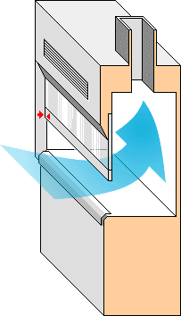  - Potassium, silver, and potassium silver cyanides are light sensitive.
 | Engineering Controls | - Eyewash-drench hose required in immediate work area.  - Safety shower may be required when using large volumes. | 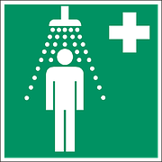 |  |  | - All work must be done in a chemical fume hood.
 | Work Practice Controls | - Detail lab practices on pages 3-4 or separate SOP, approved by OESO & PI.  Cyanide Work Area: Toxic!  - Designate a specific work area for cyanide salts and solutions and label it.  - Never work alone when handling cyanides.  - Tare (pre-weigh) empty container with lid.  - Go to hood, add powder, close lid.  - Go to balance to weigh.  - Return to hood.  - Line work area with absorbent, leak-proof bench pads.  - If weighing, place balance in hood OR use Tare Method  - Use an anti-static gun if powder sticks to sides of vial, etc.  - Protect vacuum lines and pumps using filters or scrubbers.  - Decontaminate the work area:  - Carefully fold bench pad keeping contaminated surface inward. Place in waste container and seal; dispose as P-list chemical waste.  - Wash contaminated surfaces, glassware, and equipment using a pH 10 buffer solution; rinse with 10% bleach solution.  - Maintain awareness of the pH of cyanide salt solutions. (An acidic pH will release flammable and highly toxic hydrogen cyanide gas.)
 | Personal Protective Equipment  (PPE) | 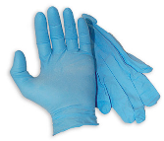  - Minimum PPE:  - 2 pairs of nitrile gloves  - Safety goggles  - Fastened lab coat; protective sleeve covers |  |  | 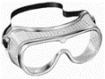  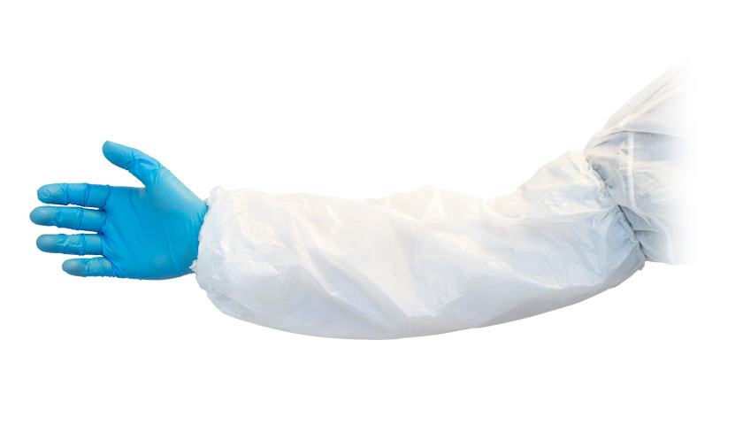
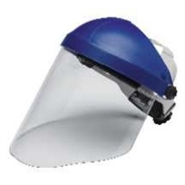
- Risk of splash, add:
  - Face Shield & Disposable gown or apron
- Change gloves immediately if contaminated & every two hours.
- Wash hands at time of glove change and after removing gloves.
 |  | - *Check the manufacturer’s glove guide for glove effectiveness with any solvents you are using.
Non-medical Emergencies | Fire | - Use ABC Dry Chemical Fire Extinguisher. (Most of the fire extinguishers supplied for Duke Lab buildings are this type, but look at the label.)  - DO NOT use a Carbon Dioxide (CO₂) Fire Extinguisher for a fire involving or near cyanide salts.
 | Spills  For exposures, see first page! | - ANY spill of non-water cyanide solution: Remove everyone from the room and contact the OESO spill team by calling 911 from a campus phone or 919-684-2444.  - Spills of dry powder or water-based solutions outside the hood: Remove everyone from the room and contact the OESO spill team by calling 911 from a campus phone or 919-684-2444.  - Spills inside hood:  - Small (<10 mg) amounts of powder or granules: wear PPE indicated above and wet an absorbent pad with pH 10 buffer solution, cover the spill, and wipe up carefully.  - <10 ml spill of water-based solutions: wear PPE indicated above; use absorbent pads.  - Clean spill area thoroughly with pH 10 buffer solution followed by a 10% bleach solution.  - Submit spill waste through OESO. Store double-bagged in hood until pickup.

Other | Waste | Cyanide salts are P-listed wastes. Keep separate from other wastes. Dispose of empty manufacturer’s container as waste, as well as syringes, pipette tips and other containers if the cyanide salt was the sole active ingredient in the container. Sharps used with cyanides must be collected in a special sharps container labeled for cyanide wastes. NO DRAIN DISPOSAL.  See Lab-specific Chemical Hygiene Plan and Lab Chemical Waste Management Practice.
 | Training | Sign CHP signature page to indicate review of this Guideline and Lab-specific safety information.
 | Questions | - Contact OESO Lab Safety at 919-684-8822 or labsafety@dm.duke.edu.  - See Emergency Response webpage or flip chart and/or Lab-specific Chemical Hygiene Plan for general emergency information.

Lab-Specific Safety Information for
CYANIDE SALTS
Supplements the Guidelines for Safe Use
of Cyanide Salts
Must be approved by OESO and PI below.
Lab Info | PI Name | Click or tap here to enter PI Name |  | PI Signature:  Date: Click or tap to enter a date.
 | Location | Enter building(s) and room(s) where lab is located
 | OESO approval | Click or tap here to enter OESO Reviewer |  | Signature:  Date: Click or tap to enter a date.
Lab-Specific Hazard Controls | Purchase  Details | Specific cyanide salts present | Enter cyanide salt name | Enter cyanide salt name | Enter cyanide salt name
 |  | Maximum container size | Enter maximum container size purchased | Enter maximum container size purchased | Enter maximum container size purchased
 |  | Maximum concentration | Enter maximum concentration purchased | Enter maximum concentration purchased | Enter maximum concentration purchased
 |  | Container type | Enter the container material | Enter the container material | Enter the container material
 |  | Specific product info. | Enter supplier name/product number, purity/grade, granules vs. powder. | Enter supplier name/product number, purity/grade, granules vs. powder. | Enter supplier name/product number, purity/grade, granules vs. powder.
 | Storage | Specific location | Enter specific storage location | Enter specific storage location | Enter specific storage location
Continues on the following page
Lab-Specific Hazard Controls, continued | Use Information | Designated work area (specific room(s) and area(s)) | Enter rooms and areas designated for use |  |  | Label work area!
 |  | Type of container to use | Type of container in which cyanide salts are used or stored in the lab |  |  | Shatter Resistant!
 |  | Maximum quantity | Enter maximum quantity to be used at a time | Enter maximum quantity to be used at a time | Enter maximum quantity to be used at a time
 |  | Typical concentration used | Enter typical concentration used | Enter typical concentration used | Enter typical concentration used
 |  | Solvent to be used | If a solvent other than water is used, also provide type of gloves to be used | If a solvent other than water is used, also provide type of gloves to be used | If a solvent other than water is used, also provide type of gloves to be used
 |  | PPE Storage Location | Location of PPE, particularly the protective sleeve covers and gloves other than nitrile.
 |  | Location of supplies for decontamination  (or spill clean-up) | Location of pH10 buffer and bleach.  All decon materials must be submitted as P-listed waste (e.g. paper towels, benchpads, etc.)
 | Exposure Response | First Aid Eye Wash Bottle Location | Location of portable eye wash bottle for first aid use.
 | Waste Information | Details about waste (location, type of containers) | Enter waste collection details – location, type of container  Empty containers are submitted as waste  Accumulate separately from other wastes! Accumulate different cyanide salts separately from each other unless they are combined in the research process!
 | Details of Process | - Enter steps used in lab process(es) or experiment(s)

