DANGER! |  |  | Duke OESO Guidelines for Safe Use of  Hydrofluoric Acid  Lab-specific Safety Information on page 3 MUST BE APPROVED  in advance by OESO and the PI. |  |  |  |  |  | DANGER!
Hazards | Potential Hazards | - Fatal if swallowed, in contact with skin, or if inhaled.  - Causes severe skin burns and eye damage.  - See also the SDS for your product & the Lab Chemical Safety Summary for hydrofluoric acid.  - Exposure limits: ACGIH TLV – 2 ppm ceiling, 0.5 ppm average over 8 hrs. OSHA PEL: 3 ppm.  - Hydrofluoric acid penetrates the skin and dissociates into hydrogen and fluoride ions, which can subsequently cause tissue destruction, decalcification of bone, cardiac arrhythmia, and liver and kidney damage. >50% hydrofluoric acid usually causes immediate burns that are extremely painful and slow to heal. Exposure to lower concentrations may not be apparent for several hours but can still cause burns and further damage if not washed off.
Hazard Controls - 1 | Selection & Purchase | - Consider the use of an alternative acid.  - Purchase the smallest container at the lowest concentration practical.  - Stock benzalkonium chloride solution (0.13%) or calcium gluconate gel (calgonate.com)
 | Storage & Transport | - Store in compatible (e.g. polyethylene) primary and secondary containers.  - DO NOT use glass containers – hydrofluoric acid dissolves glass.  - Keep the primary container tightly closed.  - Store in a dry and well-ventilated place. |  |  |  |  |  |  |  |  |  |  | No Glass!
 |  | - Store below eye level but not on the floor.  - Store away from bases, metals, and other incompatible materials.  - DO NOT store under the sink.  - Transport in a bottle carrier. |  |  |  |  |  |  |  |  |  | 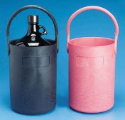
 | Engineering Controls & Safety Equipment | - Eyewash and drench hose are required in the immediate work area.  - A safety shower will also be necessary for most uses of hydrofluoric acid. Contact OESO at 684-8822 about the need for a shower if there is not one available. |  | 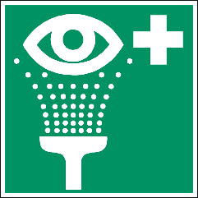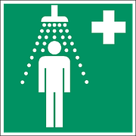 |  |  |  | - All work must be done in a chemical fume hood. |  |  | 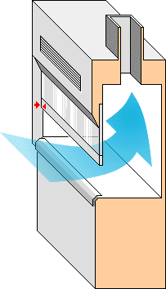
 | Work Practice Controls | - Use page 3 to create a lab-specific SOP and get PI approval signature.  - Before using, make sure benzalkonium chloride or calcium gluconate gel are not expired.  - Have an area in the laboratory that is exclusively designated for hydrofluoric acid use.  - Post warning signs in both the designated area and on the door to the room when in use.  - Work within sight and/or hearing of at least one other person who is familiar with the hazards and lab-specific written procedures.  - Line all work surfaces with plastic-backed absorbent paper and/or a containment tray that is compatible with hydrofluoric acid.  - Always add hydrofluoric acid to water and not the reverse.  - DO NOT use glass, ceramic or other incompatible containers.  - DO NOT heat.  - DO NOT breathe hydrofluoric acid vapors, mists, or gas.  - DO NOT get in eyes, on the skin, or on clothing.  - Wash hands immediately after handling.  - Once work is complete, decontaminate the area by wiping with a 10% sodium carbonate (Na₂CO₃, also known as soda ash) solution.
Hazard Controls - 2 | Personal Protective Equipment | Eyes & Face: Tight fitting safety goggles and face shield (8” in length, minimum)  Hands: Use 5 mil Neoprene for <50 ml of 48% |  |  | 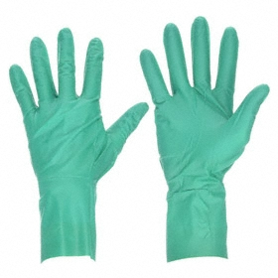  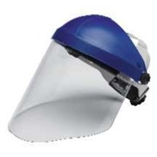  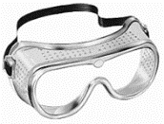
 |  | or less. Change gloves every 30 min. |  |  |  |  | 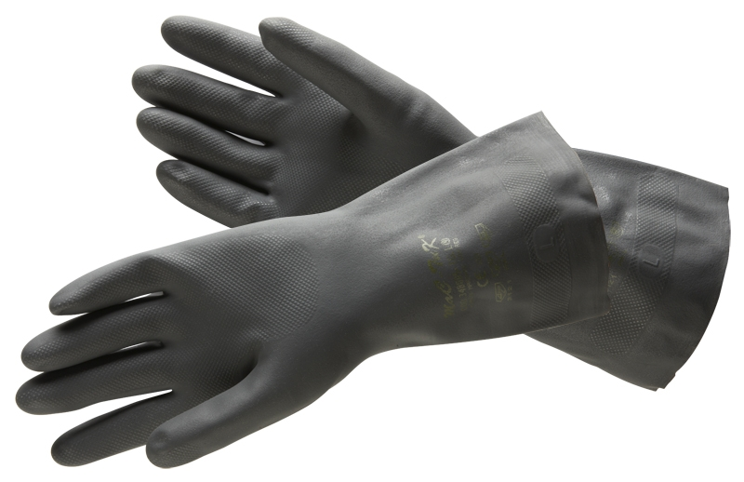
 |  | For >50 ml, >48%, or for spills: use 17 mil (or thicker) Neoprene, 14 mil (or thicker) butyl, or 5 mil neoprene over laminate (e.g., Silver Shield).
 |  | - Inspect gloves for defects prior to use.  - Remove gloves after handling and take care to not touch the outer surface of the glove. |  |  |  | 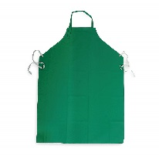  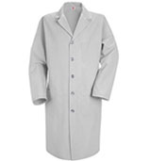
 |  | Body: Fully buttoned lab coat, sleeves to the wrist; |  |  |  | 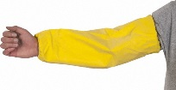
 |  | Clothing covering legs; Closed toed shoes; Rubber apron; Chemical-resistant sleeves.
Other | Medical Emergencies | Immediate first aid and medical treatment are essential for people exposed to hydrofluoric acid.  People working in and around hydrofluoric acid should be familiar with the Hydrofluoric Acid First Aid Guidelines. These guidelines should be printed and kept with first aid supplies.  For an actual chemical exposure/injury:  - Seek immediate medical attention at the emergency department for any exposure. Show SDS and Hydrofluoric Acid First Aid Guidelines to the medical provider(s).  - Persons helping an exposed colleague must wear PPE as indicated above.  - Call 911 from a campus phone or 919-684-2444 from any phone to request immediate help.  - Contact Employee Occupational Health and Wellness (919-684-8115) for exposure-related advice. Complete the Injury/Illness report after seeking treatment.  - Benzalkonium chloride (such as Zephiran) or calcium gluconate gel will bind to the fluoride ions and prevent further tissue destruction, but to be effective they must be applied quickly, even before burns are felt.  Skin exposure:  - Flush with water for 5 minutes then soak area in an iced (cubes not shaved) benzalkonium chloride (0.13%) solution or rub calcium gluconate gel onto the burn site. Continue to soak in benzalkonium chloride or massage the calcium gluconate gel into the burn site during transportation to a medical facility and while waiting to see a physician.  - If immersion in benzalkonium chloride solution is not practical, soaked compresses of the same iced solution should be applied to the burned area.  - If not using calcium gluconate gel, continually rinse with water until treatment is provided.  Eye exposure:  - Flush eyes for at least 15 minutes with large amounts of gently flowing water.  - If sterile calcium gluconate solution (1%) is available, flushing eyes may be limited to 5 minutes. Afterward, use a syringe (no needles!) to repeatedly irrigate the eye(s) with the 1% solution.  - Take the victim to a doctor, preferably an eye specialist, as soon as possible. Use ice water compresses on the eyes during transportation.  Inhalation: Remove victim to uncontaminated area. Seek immediate medical attention.  Ingestion: DO NOT INDUCE VOMITING. Seek immediate medical attention.
 | Spills | - Spill >5 ml: On Duke’s Durham campus, any spill >5 ml hydrofluoric acid must be referred to the OESO spill team by calling 911 from a campus phone or 919-684-2444 from any phone.  - Spills <5 ml: Absorb using magnesium sulfate, soda lime, sodium carbonate (Na₂CO₃), or other spill absorbent specified for hydrofluoric acid. DO NOT use organic spill kits containing Floor-Dri, kitty litter, or sand because a toxic gas (silicon tetrafluoride) will be created.  - AFTER the spill has been absorbed, use a 10% sodium carbonate solution to clean the area.  - See Emergency Response webpage or flip chart and/or lab specific chemical hygiene plan.
 | Waste | See lab-specific chemical hygiene plan or Lab Chemical Waste Management Practice.
 | Training | Sign lab-specific SOP to indicate review.
 | Questions | Contact OESO Lab Safety 919-684-8822.

Lab-Specific Safety Information for
Hydrofluoric Acid
Supplements the Guidelines for Safe Use of Hydrofluoric Acid
Must be approved by OESO and PI below.
Lab | PI Name | Click or tap here to enter PI Name |  | PI Approval (signature):  Date: Click or tap to enter a date.
 | Location | Enter building(s) and room(s) where the lab is located
 | OESO Approval | Click or tap here to enter OESO Reviewer |  |  | Signature:  Date: Click or tap to enter a date.
Lab-Specific Hazard Controls | Purchase  Details | Maximum container size | Enter maximum container size purchased
 |  | Maximum concentration | Enter maximum concentration purchased
 |  | Container type | Enter the container material
 |  | Specific product info. | Enter supplier name/product number or purity/grade to purchase
 | Storage | Specific location | Enter specific storage location
 | Use Information | Designated work area (specific room(s) and area(s)) | Enter rooms and areas designated for use |  |  |  |  | Label work area!
 |  | Type of container to use | Type of container in which HF is used or stored in the lab |  |  |  |  | NO GLASS!
 |  | Maximum quantity | Enter maximum quantity to be used at a time
 |  | Gloves  (Note other PPE requirements in Guidelines) | Necessary glove for handling <50 ml:  ☐5 mil neoprene gloves (change every 30 minutes)  Necessary gloves for handling >50 ml or for cleaning spills < 5 ml:  ☐17 mil (or thicker) neoprene gloves  ☐14 mil (or thicker) butyl gloves  ☐5 mil neoprene gloves over laminate (e.g., Silver Shield)  PPE Location: Indicate where special PPE for hydrofluoric acid is stored
 |  | Location of Na₂CO₃ | Indicate where sodium carbonate (for decon) is stored
 | Emergency Information | Type of spill absorbent | ☐ Magnesium sulfate  ☐ Soda Lime (CaHNaO₂)  ☐ Sodium Carbonate (Na₂CO₃)  ☐ Other sorbent specified for hydrofluoric acid (NOT an organic material such as Floor-Dri or kitty litter, and NOT sand):  Indicate another type of HF-compatible sorbent to be used
 |  | Location of spill supplies | Indicate where spill supplies are stored
 |  | Location & Type of First Aid Materials | Indicate where first aid supplies are stored |  |  | ☐ Benzalkonium Chloride (0.13%)  ☐ Ice cubes (not crushed or shaved)  OR  ☐ Calcium gluconate gel
 | Waste Information | Details about waste – location, type of container | Indicate location & type of container used for waste accumulation |  |  |  |  |  | NO GLASS!
 | Details of Process | - Enter steps used in lab process(es) or experiment(s)

