Duke OESO Guidelines for Safe Use of
Sulfuric acid
Complete Lab-Specific Safety Information on page 2
Hazards | Potential Hazards | - Corrosive - causes severe skin burns and serious eye damage. Corrodes metals.  - Reacts with most metals to produce hydrogen gas, which is flammable and explosive.  - Can react with many substances to generate highly toxic products. Reactions may be violent.  - Possible carcinogen and particularly hazardous substance.  - OSHA Permissible Exposure Limit (PEL) is 1 mg/m³ over 8 hours.  - For more information, see the SDS and the Lab Chemical Safety Summary for Sulfuric Acid.
Hazard Controls | Selection & Purchase | - Purchase the smallest, shatter resistant containers (such as PVC-coated glass), at the lowest concentration possible.  - Consider alternate methods and use a less dangerous acid if possible.  - Buy inert absorbent or spill pads that can be used to absorb small spills of sulfuric acid.
 | Storage & Transport | 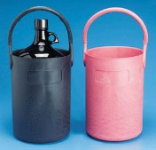  - Store in secondary containment in a well ventilated area.  - Store away from incompatibles such as organics, bases,  halides, nitrates, chlorates, reducing agents, and others.  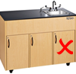  - Transport in secondary containment, preferably a  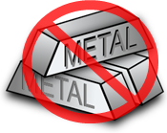  Polyethylene or other non-reactive acid/solvent bottle carrier.  - Store below eye level but not on the floor.  - Store away from metal and do not store under the sink.
 | Engineering Controls | - Eyewash/drench hose is required in immediate work area.  - For large quantities a safety shower will also be needed.  - Work in a clean chemical fume hood free of incompatible materials. | 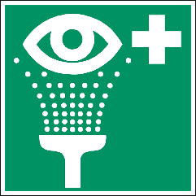  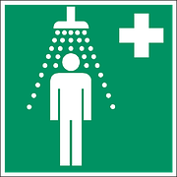  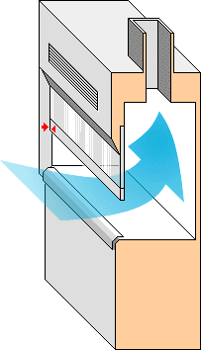
 | Work Practice Controls | - When diluting, add acid to water slowly, in small amounts. (Never add water to acid!)  - Work with the smallest practicable amount and lowest practicable concentration.  - Decontaminate work area by wiping it down with a soap and water solution.
 | Personal Protective Equipment  (PPE) | - Wear closed-toed shoes and clothing covering the legs.  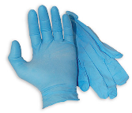  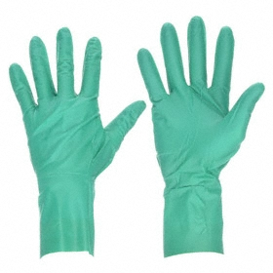  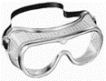  - Minimum PPE:  or  - Buttoned lab coat  - Safety goggles  - 5 mil NEOPRENE gloves or 2 pairs of 4 mil NITRILE gloves for  10 - 30 minutes of protection. Change immediately if splashed. |  | 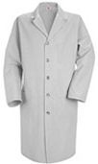  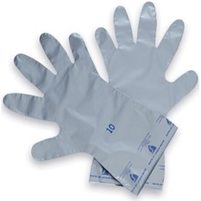  If glove contact is expected  or
 |  | 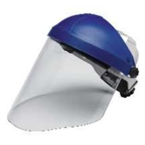  - Risk of splash/work with >100 ml add: face shield, impervious  apron & sleeves (or coverall).  - For expected glove contact use gloves rated for > 60 minutes with sulfuric acid (e.g., laminate or butyl).  - Wash hands at time of glove change. |  | 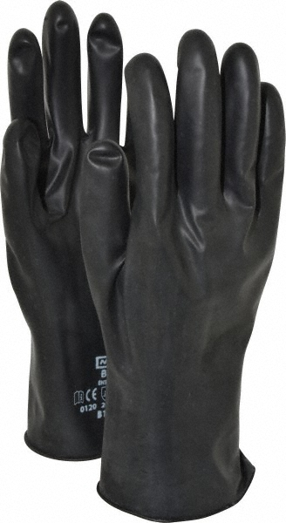  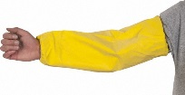  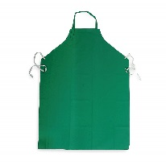
Other | Emergencies | - See Emergency Response webpage or flip chart and/or lab specific chemical hygiene plan.  - For clean-up of small spills (<200 ml), wear butyl or laminate gloves and neutralize with sodium carbonate from edge to center, then absorb with inert material. Do not use combustible materials such as saw dust to absorb sulfuric acid spills!
 | Waste | See lab-specific chemical hygiene plan, Lab Chemical Waste Management Practice, and Drain Disposal Practice. DO NOT MIX sulfuric acid waste with incompatible wastes (e.g., organics)!!!
 | Training | Sign signature page in lab-specific chemical hygiene plan to indicate review.
 | Questions | Contact OESO Lab Safety at 919-684-8822 or labsafety@dm.duke.edu

Lab-Specific Safety Information for
Sulfuric Acid
Supplements the Guidelines for Safe Use of Sulfuric Acid
Lab | PI Name | Click or tap here to enter PI Name
 | Location | Enter building(s) and room(s) where lab is located
Lab-Specific Hazard Controls | Purchase  Details | Maximum container size | Enter maximum container size purchased
 |  | Maximum concentration | Enter maximum concentration purchased
 |  | Container type | Enter the container material |  | Purchase in PVC coated or HDPE “poly” bottle if possible
 |  | Specific product information | Enter supplier name/product number or purity/grade to purchase
 | Storage | Specific location | Enter rooms and areas designated for storage
 | Use Information | Designated work area  (specific room(s) and area(s)) | Enter rooms and areas designated for use
 |  | Maximum quantity | Enter maximum quantity to be used at a time
 |  | Gloves  (Note other PPE requirements in Guidelines) | If glove contact is NOT anticipated  ☐ 5 mil NEOPRENE gloves  OR  ☐ 2 pairs of 4 mil NITRILE gloves | If glove contact IS anticipated  ☐ Laminate  OR  ☐ Butyl
 |  | PPE Storage Location | Enter location where specific PPE above is stored (e.g. specialized gloves, sleeves, apron, etc.)
 |  | Location of supplies for  spill clean-up | Enter location of spill supplies (sodium carbonate and inert absorbent)
 | Waste Information | Details about waste (location, type of container) | Enter location of waste container, type of container used
 | Details of Process | - Enter steps used in lab process(es) or experiment(s)

