May show |  | Duke OESO Guidelines for Safe Use of  Cryogens  Examples: Dry Ice, Liquid Nitrogen, Liquid Helium, Liquid Hydrogen, Liquid Oxygen (O₂) |  |  |  |  | May show  or
Hazards | Potential Hazards |  | - Potential explosion due to pressure buildup (mostly for liquid He and H₂, which can solidify air).  - Oxygen (O₂) deficiency (through displacement of O₂ by cryogens other than liquid O₂). For cryogen leaks, see “Emergencies”. If large amounts (>2L) are dispensed, contact Lab Safety to assess ventilation and the possible need for an O₂ monitor.  - Oxygen enrichment around liquid oxygen may cause or intensify fire.  - Liquefied gases may condense oxygen from the air, causing liquid O₂ to build up as a contaminant. If oxygen-incompatible materials are present, violent reactions could occur.  - Tissue damage (frostbite)
Hazard Controls | Storage & Transportation |  | - Never store cryogenic liquids or dry ice in a walk-in cold room!  - Store liquid O₂ away from open flames and post “No Open Flames” nearby.  - Store liquid hydrogen, helium, and nitrogen away from flammable materials and ignition sources. (These gases may become contaminated with liquid O₂.)  - Store and transport cryogenic materials ONLY in Dewars or cryogenic liquid cylinders designed specifically for that cryogen. Inspect storage containers daily to ensure that no air or ice plugs exist in the openings.  - Cryogens may be transported in elevators ONLY in containers certified to leak at less than or equal to 1 L of liquid (or 1 kg of solid) per day. |  |  |  |  | 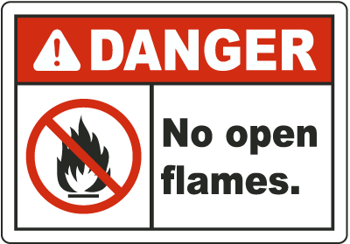  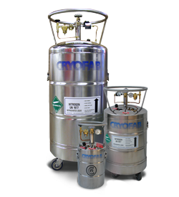
 | Engineering Controls |  | - Each part of a cryogenic system must have a pressure relief system (may require maintenance).  - Use and store cryogens in well-ventilated areas such as most labs (not a closet or cold room).  - OESO evaluation/approval is required for use of cryogens in a manner that could displace oxygen. See Lab-Specific Chemical Hygiene Plan template for examples of these high risk uses of cryogens (including examples of “large quantities”) or contact OESO with questions.
 | Work Practice Controls |  | - Use liquid hydrogen, oxygen, helium and nitrogen away from flammable materials & sparks.
 |  |  | - For liquid helium and hydrogen storage systems, check the pressure relief and inspect for leaks regularly because of the risk of solidified air.  - Do not put your head inside a liquid nitrogen freezer, dry ice chest, or other enclosed space containing a cryogen.  - Do not use hollow rods or tubes as dipsticks. (When a warm tube is inserted into a cryogen, liquid will spout from the top of the tube.)  - Check the liquid levels regularly. If the liquid evaporates more rapidly than normal, the Dewar/liquid cylinder may be losing its vacuum.  - When retrieving cryopreservation vials that have been stored in liquid nitrogen, raise the vials out of the liquid phase and store them in the gas above the liquid for 24 hours to allow any trapped liquid nitrogen to escape. |  |  |  | 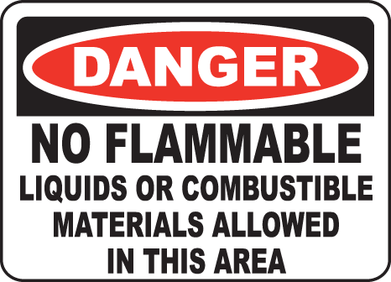  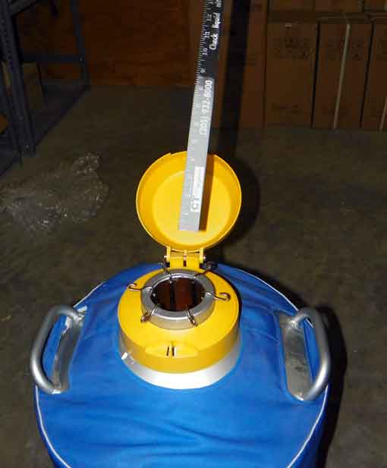
 | Personal Protective Equipment |  | Minimum PPE:  - Safety glasses  - Lab coat  - Cryogenic gloves | 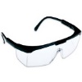  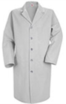 | If working with an open container:
 |  |  |  |  | 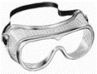  - Safety goggles  - Face shield  - Cryogenic apron  - + Lab coat & cryo gloves | 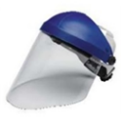
Other | Emergencies |  | See Emergency Response Flip Chart and/or lab specific chemical hygiene plan. (If cryogen is leaking, evacuate the area & call Duke Police at 919-684-2444.) If there is an oxygen monitor, document emergency procedures on Pages 2 & 3. For other gas-specific monitors, use the blank SOP template.
 | Waste |  | If the cryogen has been mixed with a hazardous waste, follow disposal procedures for that waste AFTER allowing the cryogen to evaporate in an unsealed container in a chemical fume hood.  Do not dump the cryogen into sinks as the thermal shock may damage the sink or plumbing.
 | Training |  | Sign signature page in lab-specific plan to indicate review.
 | Questions |  | Contact OESO Lab Safety at 919-684-8822 or OESO Occupational Hygiene & Safety at 919-684-5996.
Safety Information for
OXYgen monitors
Supplements the Guidelines for Safe Use of Cryogens
Lab or Area | PI or Manager Name | Click or tap here to enter Name |  | Signature:  Date: Click or tap to enter a date.
 | Location | Enter building(s) and room(s) where lab or area is located, specifically where cryogens are stored
 | OESO approval | Click or tap here to enter OESO Reviewer |  | Signature:  Date: Click or tap to enter a date.
Specific Hazard Controls | Cryogen Details | Specific cryogen present | Enter cryogen used
 |  | Maximum volume on hand (in tanks and equipment) | Enter maximum total volume
 |  | Container type (freezer, high pressure cylinder, low pressure cylinder, etc.) | Enter the container type
 |  | Is cryogen or gas being supplied from a tank outside of building? | Yes ☐ No ☐
 | Location | Specific location of monitor | Enter room where monitor is located
 | Alarm Response Procedures | Current Alarm Status | Procedure
 |  | Alarm sounds for the first time | Leave the area. Do NOT enter the room if the oxygen level shown on the monitor/display is below 19.5% or if alarm is sounding. For areas with a source of oxygen, do not enter the room if the O₂ level is above 23.5%.
 |  | If alarm continues for >15 minutes, check oxygen levels | Safety Contact should check the oxygen levels with a handheld meter (if available). If no meter is available, contact OESO at 919-684-2794.
 |  | If alarm continues and oxygen levels are determined to be safe | Contact **Choose Maintenance Provider.** Add any additional contact information here. to calibrate the sensor.
 |  | If monitor indicates a fault condition (or, in rooms without a source of O₂, if concentration displayed is over 20.9% | Contact Maintenance Provider** selected above to check the monitor or recalibrate the sensor.
 |  | For frequent alarms (more than once a day) | Contact OESO Lab Safety at 919-684-8822 to assess ventilation and appropriate placement of sensors.
 | Details Specific to the Lab or Area | - Provide additional details specific to the space, monitor, etc. Note if the alarm needs to be reset to stop the sound even after concentration has returned to above 19.5%.
** Any lab/area not supported by E&O needs to have written procedures for regular maintenance/calibration of O2 monitors & sensors.
A
Responding to Oxygen Alarm
(Post this sign next to each alarm monitor/display and outside of the monitored room.)
You are entering an oxygen (O₂) monitored area. If you have not received the proper training to enter this room, see contact first:
Safety Contact Name | Safety Contact Full Name
Safety Contact Phone Number | Contact Phone Number
PI or Manager Name | Name of Principal Investigator (PI) or Manager
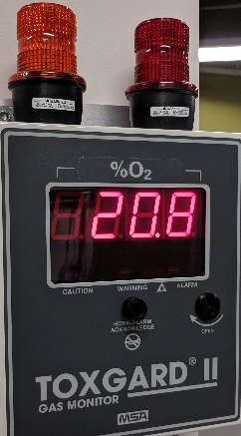
You may enter the room if the oxygen level shown on the
monitor/display is between 19.5% and 20.9%. For areas with a
source of oxygen, you may enter if the oxygen level is between
19.5% and 23.5% O₂.

Do not enter the room if the oxygen level shown on the
monitor/display is below 19.5%, or if alarm is sounding. For
areas with a source of oxygen, do not enter the room if the
oxygen level is above 23.5%. If the alarm is sounding or the lights are flashing, close all doors and leave the room immediately.

For “latching alarms” (where audible alarm continues when concentration returns to a safe level), push the reset button on the monitor display box to acknowledge the audible alarm. If the alarm horn and lights continue, push the reset button again.
If the problem continues for >15 minutes, contact safety contact listed above to check oxygen levels with a handheld meter (if available). If no handheld oxygen meter is available, contact OESO at 919-684-2794.
Once the oxygen level has been determined to be safe, contact your maintenance provider **Choose Maintenance Provider.** Provide any additional data or phone numbers here to calibrate the sensor.
If the monitor indicates a fault condition, or (only in areas without a source of oxygen) if the oxygen concentration displayed is above 20.9% (normal air) contact your maintenance provider** to check the monitor and/or recalibrate the sensor.
For frequent alarms (more than once a day), contact OESO Lab Safety at 919-684-8822 to assess ventilation and appropriate placement of sensors.
** Any lab/area not supported by Engineering & Operations needs to have written procedures for regular maintenance/calibration of O2 monitors & sensors.

