Duke OESO Guidelines for Safe Use of
Nitric Acid
Complete Lab-Specific Safety Information on page 2
Hazards | Potential Hazards | - Very strong oxidizer: can ignite or react explosively with both organics and inorganics.  - Concentrated nitric acid can release vapors and toxic gases (including NO₂)  - Corrosive. Burns skin, eyes, mucosal membranes, and respiratory tract.  - OSHA Permissible Exposure Limit (PEL) is 2 ppm over 8 hours.  - For more information, see the SDS and the Lab Chemical Safety Summary for Nitric Acid.
Hazard Controls | Selection & Purchase | - Purchase the smallest, shatter-resistant containers at the lowest concentration practical (less than 70% if possible).  - Consider alternate methods and use a less dangerous acid if possible.  - Buy inert absorbent or spill pads that can be used to absorb small spills of nitric acid.
 | Storage & Transport | 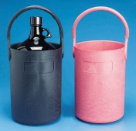  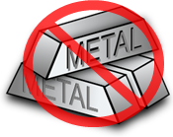  - Store in secondary containment in a well ventilated area.  - Store away from incompatibles such as organics and  combustibles as well as bases, reducing agents, and others.  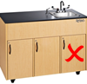  - Transport in secondary containment, preferably a  polyethylene or other non-reactive acid/solvent bottle carrier.  - Store below eye level but not on the floor.  - Store away from metal and do not store under the sink.
 | Engineering Controls | - Eyewash and safety shower are required in immediate work area.  - Work in a clean chemical fume hood that is free of organics and other incompatibles.  - Keep the sash lowered while reactions are in progress. | 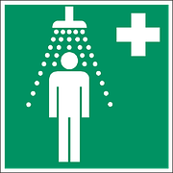  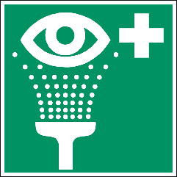  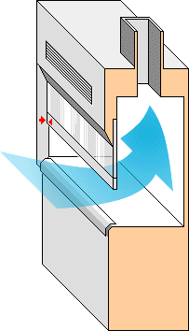
 | Work Practice Controls | - Work should be done in a way that avoids hand/glove contact with nitric acid.  - When diluting, add acid to water slowly, in small amounts. (Never add water to acid!)  - Decontaminate work area by wiping it down with a soap and water solution.
 | Personal Protective Equipment  (PPE) | - Wear closed-toed shoes and clothing covering the legs.  - Minimum PPE:  - Buttoned lab coat  - Safety goggles  - 5 mil NEOPRENE gloves (Change immediately if splashed)  - Note that nitric acid penetrates lab nitrile gloves in <5 minutes. Lab neoprene (5 mil) gloves last 10–30 minutes. |  | 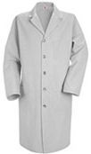  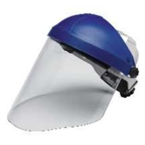  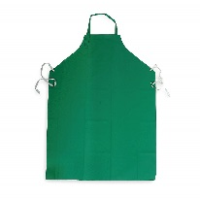  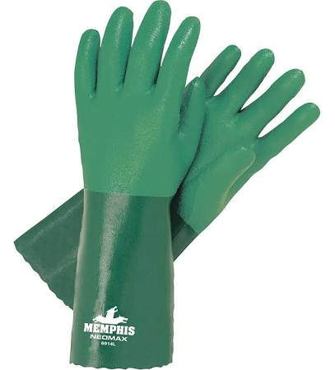  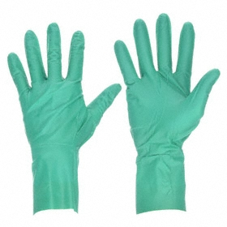  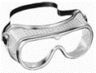
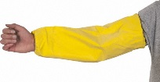
- Risk of splash/work with >100 ml add: face shield, impervious apron & sleeves
(or coverall), and gloves rated for nitric acid (e.g., 16–18 mil neoprene gloves).
- Wash hands at time of glove change.
Other | Emergencies | - See Emergency Response webpage or flip chart and/or lab specific chemical hygiene plan.  - For clean-up of small spills (<100 ml), neutralize with sodium carbonate from edge to center, then absorb with inert material.  - Do not use combustible materials such as saw dust to absorb nitric acid spills!
 | Waste | See lab-specific chemical hygiene plan, Lab Chemical Waste Management Practice, and Drain Disposal Practice. DO NOT MIX nitric acid waste with incompatible wastes (e.g., organics)!!!
 | Training | Sign signature page in lab-specific chemical hygiene plan to indicate review.
 | Questions | Contact OESO Lab Safety at 919-684-8822 or labsafety@dm.duke.edu

Lab-Specific Safety Information for
Nitric Acid
Supplements the Guidelines for Safe Use of Nitric Acid
Lab | PI Name | Click or tap here to enter PI Name
 | Location | Enter building(s) and room(s) where lab is located
Lab-Specific Hazard Controls | Purchase  Details | Maximum container size | Enter maximum container size purchased
 |  | Maximum  concentration | Enter maximum concentration purchased |  |  | Order 70% or lower when possible
 |  | Container type | Enter the container material | Purchase in PVC coated or HDPE “poly” bottle if possible
 |  | Specific product information | Enter supplier name/product number or purity/grade to purchase
 | Storage | Specific location | Enter rooms and areas designated for storage
 | Use Information | Designated work area  (specific room(s) and area(s)) | Enter rooms and areas designated for use
 |  | Maximum quantity | Enter maximum quantity to be used at a time
 |  | PPE Storage Location | Enter location where specific PPE is stored (e.g. neoprene gloves, sleeves, apron, etc.)
 |  | Location of supplies for  spill clean-up | Enter location of spill supplies (sodium carbonate and inert absorbent)
 | Waste Information | Details about waste (location, type of container) | Enter location of waste container, type of container used |  | DO NOT mix  with organic waste!
 | Details of Process | - Enter steps used in lab process(es) or experiment(s)

