Duke OESO Guidelines for Safe Use of
Toxic & Health Hazard Powders
(and suspensions/solutions)
Examples: acrylamide, boric acid, trypan blue, many hazardous drugs
Complete Lab-Specific Safety Information on pages 2- 4 for particularly hazardous powders.
Hazards | Potential Hazards | - Acutely toxic powders can cause systemic toxicity or death.  - Exposure to powders can also cause health hazards (such as cancer, reproductive effects, mutations, respiratory sensitization, and organ damage) and/or irritation of the eyes, skin, or respiratory system.  - Some powders may also have physical hazards (not covered by these guidelines).  - Powders (and suspensions/solutions) can form aerosols that may lead to exposure.  - See chemical Safety Data Sheet (SDS) for specific hazard information.
Hazard Controls | Selection & Purchase | - Purchase the smallest quantity practical.  - When possible, order the material
 |  | - In liquid form OR | - In pre-weighed amounts, in a sealed septum-top vial, so that diluent can be injected directly into the vial.
 | Storage & Transport | - Dry powders must be in sealed shatter-resistant containers during transportation. Use a secondary container if the container is not shatter resistant.  - Keep toxic powders away from any incompatible materials.
 | Engineering Controls | - Use a chemical fume hood with particularly hazardous and respiratory sensitizing substances if aerosols could be created, including for:  - Any work with open containers of dry powder, and  - Open or pressurized manipulations of suspensions or solutions.  - When there is no risk of exposure to hazardous vapors or gases, a biological safety cabinet (BSC) may be used instead. |  |  |  |  |  | 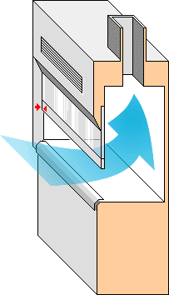
 | Work Practice Controls | - Designate a specific work area for toxic powders and label the area.  - Line work area with absorbent, leak-proof bench pads.  - If weighing dry powders, place balance in hood OR  - Tare (pre-weigh) an empty container with a lid.  - Go to hood, add powder to container, close lid.  - Go to balance to weigh.  - Return to hood to make solution or manipulate powder.  - Use an anti-static gun if powder sticks to sides of vial, etc.  - Decontaminate the work area:
 |  | - Wet-clean using a compatible solvent OR |  | - HEPA vacuum daily.
 | Personal Protective Equipment  (PPE) | - Minimum PPE: fastened lab coat, nitrile (or latex) gloves*, and safety glasses  - If “fatal in contact with skin”: 2 pairs nitrile gloves* |  |  | 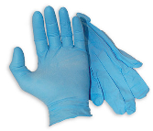  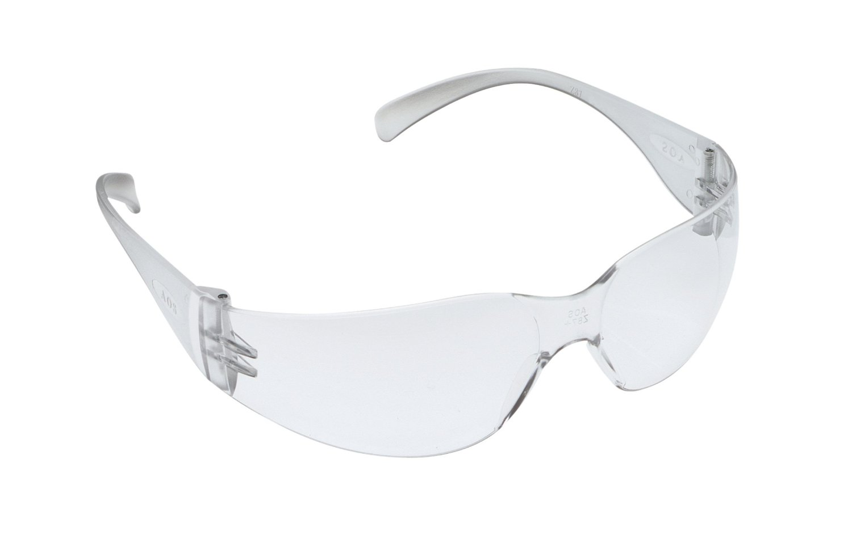  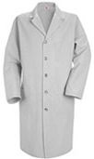
 |  | - Risk of splash/large amounts, add: Goggles & Tyvek sleeves  - Change gloves immediately if contaminated & every two hours.  - Wash hands at time of glove change. |  |  |  | 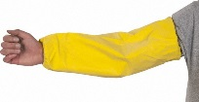  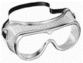
 |  | *Check the manufacturer’s glove guide for glove effectiveness with any solvents you are using.
Other | Emergencies | See Emergency Response webpage or flip chart and/or lab specific chemical hygiene plan.
 | Waste | See lab-specific chemical hygiene plan, Lab Chemical Waste Management Practice, and Drain Disposal Practice.
 | Training | Sign signature page in lab-specific chemical hygiene plan to indicate review.
 | Questions | Contact OESO Lab Safety at 919-684-8822 or labsafety@dm.duke.edu.

Lab-Specific Safety Information for
Toxic & Health Hazard Powders
Supplements the Guidelines for Safe Use of Toxic & Health Hazard Powders
for particularly hazardous (Action B) powders.
May also be used for hazardous (Action C) powders.
Lab | PI Name | Click or tap here to enter PI Name
 | Location | Enter building(s) and room(s) where lab is located
Notes for using this Guideline: ONLY for use with chemicals that meet ALL of the following criteria:
- Action B or C (NOT Action A) as determined by the GHS Lookup Tool or Action Matrix & SDS for your product
- Solid at room temperature
- ONLY have HEALTH hazards in any of these classifications: acutely toxic (inhalation, dermal, and/or oral), carcinogens, mutagens, reproductive hazards, respiratory/skin sensitizers, irritants, corrosive to skin/eyes, and/or specific target organ toxicity.
If the chemical is flammable, corrosive, and/or an oxidizer, check the relevant box(es) below and attach the appropriate guideline(s) to this completed toxic powders guideline.
If the chemical has other physical hazards (reacts violently with water, contact with acid forms toxic gas, etc.) in addition to the health hazards, you must use this OESO SOP template to create a separate lab-specific SOP.
For Action A (high risk) chemicals, use the OESO SOP template to create a lab-specific SOP – it must be approved by the PI and, in many cases, by OESO.
Lab-Specific Hazard Controls | Chemical Information | Chemical Name | Chemical 1  Enter Chemical Name | Chemical 2  Enter Chemical Name | Chemical 3  Enter Chemical Name
 |  | CAS Number | Enter CAS Number | Enter CAS Number | Enter CAS Number
 |  | GHS Hazard Classes and Categories  If the powder is corrosive or oxidizing, or dissolved in a flammable liquid, check the appropriate box(es) at right and refer to the relevant guideline(s) as well. | Enter All GHS Hazard Classes and their Category (e.g. Carcinogenicity, Category 1A)  ☐ Particularly Hazardous  ☐ Corrosive Guideline  ☐ Oxidizer Guideline  ☐ Flammable Guideline | Enter All GHS Hazard Classes and their Category (e.g. Carcinogenicity, Category 1A)  ☐ Particularly Hazardous  ☐ Corrosive Guideline  ☐ Oxidizer Guideline  ☐ Flammable Guideline | Enter All GHS Hazard Classes and their Category (e.g. Carcinogenicity, Category 1A)  ☐ Particularly Hazardous  ☐ Corrosive Guideline  ☐ Oxidizer Guideline  ☐ Flammable Guideline
 | Purchase  Details | Maximum container size | Enter maximum container size purchased | Enter maximum container size purchased | Enter maximum container size purchased
 |  | Container type | Enter the container material | Enter the container material | Enter the container material
 |  | Specific product information | Enter supplier name/product number or purity/grade to purchase | Enter supplier name/product number or purity/grade to purchase | Enter supplier name/product number or purity/grade to purchase
 | Storage | Specific location | Enter specific storage location | Enter specific storage location | Enter specific storage location
 |  | Special storage requirements | Enter any special storage requirements | Enter any special storage requirements | Enter any special storage requirements
 | Use Information | Designated work area (specific room(s) and area(s)) if particularly hazardous  LABEL WORK AREA | Enter rooms, fume hoods, BSCs, or other areas designated for use | Enter rooms, fume hoods, BSCs, or other areas designated for use | Enter rooms, fume hoods, BSCs, or other areas designated for use
 |  | Maximum quantity | Enter maximum quantity to be used at a time | Enter maximum quantity to be used at a time | Enter maximum quantity to be used at a time
 |  | Typical concentration used | Enter typical concentration used | Enter typical concentration used | Enter typical concentration used
 |  | Solvent to be used | If a solvent other than water is used, also state type of gloves to be used | If a solvent other than water is used, also state type of gloves to be used | If a solvent other than water is used, also state type of gloves to be used
 |  | Specific Glove Information | ☒ 1 pair of 4 mil Nitrile gloves  ☐ 2 pairs of 4 mil Nitrile gloves  ☐ Specify type(s) of gloves if not nitrile | ☒ 1 pair of 4 mil Nitrile gloves  ☐ 2 pairs of 4 mil Nitrile gloves  ☐ Specify type(s) of gloves if not nitrile | ☒ 1 pair of 4 mil Nitrile gloves  ☐ 2 pairs of 4 mil Nitrile gloves  ☐ Specify type(s) of gloves if not nitrile
 |  | Other Required PPE | ☒Standard Lab Coat  ☒ Safety Glasses  ☐ Chemical Splash Goggles  ☐ Other PPE Needed | ☒Standard Lab Coat  ☒ Safety Glasses  ☐ Chemical Splash Goggles  ☐ Other PPE Needed | ☒Standard Lab Coat  ☒ Safety Glasses  ☐ Chemical Splash Goggles  ☐ Other PPE Needed
 |  | PPE Storage Location | Specific PPE storage location | Specific PPE storage location | Specific PPE storage location
 |  | Work Area Decontamination  (must be completed for Particularly Hazardous chemicals) | Work area decontamination supply type and location. Include any special PPE needed. | Work area decontamination supply type and location. Include any special PPE needed. | Work area decontamination supply type and location. Include any special PPE needed.
 |  | Location & type of spill clean-up supplies | Spill supply type and location. | Spill supply type and location. | Spill supply type and location.
 | Waste Disposal | Chemical Waste Information | Enter location of waste container, type of container used. | Enter location of waste container, type of container used. | Enter location of waste container, type of container used.
 | Details of Process for Chemical 1 | - Click or tap here to enter details specific to your lab’s process with Chemical 1.
 | Details of Process for Chemical 2 | - Click or tap here to enter details specific to your lab’s process with Chemical 2.
 | Details of Process for Chemical 3 | - Click or tap here to enter details specific to your lab’s process with Chemical 3.

