Duke OESO Guidelines for Safe Use of
Aqua Regia
Concentrated Nitric Acid and Hydrochloric Acid
Complete Lab-Specific Safety Information on page 2
Hazards | Potential Hazards | - Aqua regia is a powerful oxidizer that releases toxic gases that are fatal by inhalation (e.g. nitrosyl chloride (category 1), nitrogen dioxide (category 2), and chlorine (category 2)).  - It can EXPLODE if stored in a closed container or if mixed with organics.  - Solutions are highly corrosive: Causes burns to eyes, skin, or mucous membranes.  - Relevant exposure limits: nitric acid – 2 ppm, hydrochloric acid – 2 ppm, nitrogen dioxide – 0.2 ppm ceiling, chlorine – 0.5 ppm.  - See Safety Data Sheets (SDSs) for specific hazard information.
Hazard Controls | Selection & Purchase | Aqua Regia has many potential physical and health hazards. A less hazardous solution/process should be used if possible.  - Buy specific absorbent pads or pillows compatible with nitric acid for absorbing small spills.
 | Storage & Transport | - Never store Aqua Regia for later use; only make enough for immediate use.  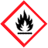  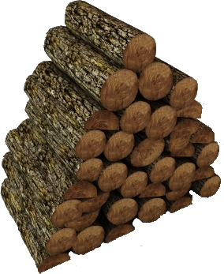  - Keep away from:  Organic  Material  - Organics  - Reducing agents  - Flammables  - Ensure primary and secondary containers are free from organic chemicals/solvents.
 | Engineering Controls | - Eyewash and safety shower required in immediate work area. | 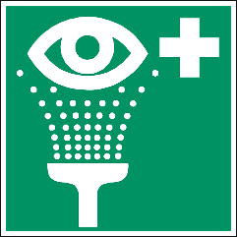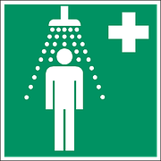 | - Work in a chemical fume hood that contains NO ORGANIC MATERIAL.  - Keep sash down while reactions are in progress. |  |  |  | 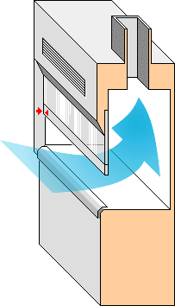
 | Work Practice Controls | - Work with the smallest amount possible inside a clean secondary container such as a glass tray or glass baking dish.  - Never add organics to Aqua Regia (due to explosion risk).  - NEVER CAP a container holding active Aqua Regia solution.  - Never remove Aqua Regia from the hood.  - Immediately after using Aqua Regia, follow instructions on page 2 for dilution and neutralization of unused solution.  - Wipe work area with soap and water when work is complete. |  |  |  |  | 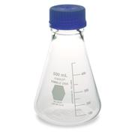  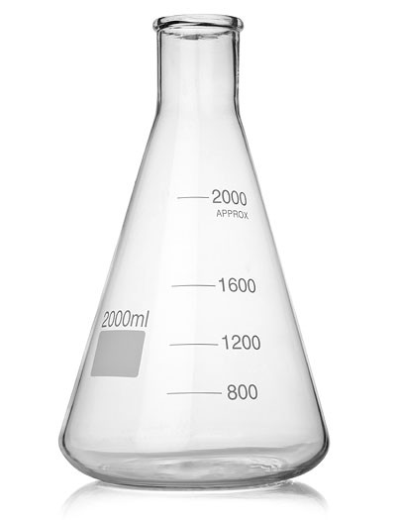
 | Personal Protective Equipment  (PPE) | - Minimum PPE: gloves resistant to nitric and hydrochloric acids (e.g. 18-mil neoprene or laminate), safety goggles, and buttoned lab coat. 5mil neoprene gloves can be used for 25ml or less.  - Change gloves immediately if contaminated; wash hands at time of glove change. |  |  |  | 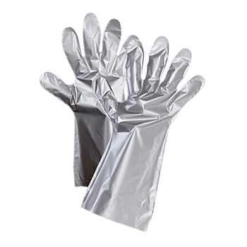  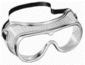
 |  | - Risk of splash or >100ml, add: face shield, impervious apron and sleeves (or coverall) |  |  | 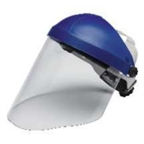  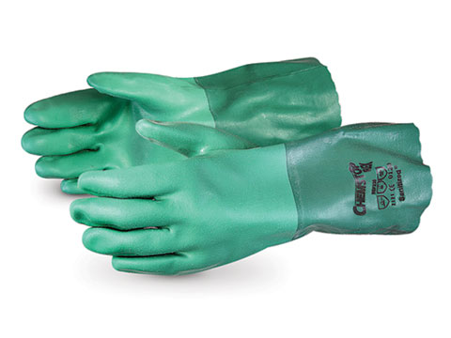
Other | Emergencies | See Emergency Response webpage or flip chart and/or lab specific chemical hygiene plan.
 | Small spills & Waste | Aqua regia waste MUST be neutralized by following the procedure on page 2 before disposal!  Disposal: After neutralized solution has cooled to room temperature, submit waste to OESO unless approved for drain disposal. (Approval for drain disposal will depend on what is dissolved in the Aqua Regia.) See also Drain Disposal Practice, lab-specific chemical hygiene plan and Lab Chemical Waste Management Practice. Steps for lab clean-up of small spills are shown on p.2.
 | Training | Sign lab-specific SOP to indicate review of this guideline and lab-specific procedures.
 | Questions | Contact OESO Lab Safety at 919-684-8822 or labsafety@dm.duke.edu.

Procedure for Neutralizing Aqua Regia (up to 250 ml*)
Neutralization | - Calculate volume of water needed: ~ 7.5x dilution (e.g., 750 ml water for 100 ml Aqua Regia)  - Calculate mass of magnesium hydroxide (Mg(OH)₂) needed: 0.533 g per ml of Aqua Regia  - Prepare bromothymol blue (BB) solution: add 0.8 g BB to 100 ml water and a small drop of NaOH  - Wear FULL PPE shown on previous page!  - Place a stir plate inside a secondary container (with NO organic chemical residue in it), preferably a large glass tray or glass baking dish  - Place a clean GLASS beaker on the stir plate. It must be big enough that it will never be more than 2/3 full (even after dilution is complete). (E.g., a beaker ≥1.4 L is needed to neutralize 100 ml Aqua Regia.)  - Add water as calculated in #1. Add stir bar and turn on stir plate.  - Add Mg(OH)₂ as calculated in #2 and a dash of the bromothymol blue solution.  - SLOWLY add Aqua Regia. Do not allow to overheat. If your solution turns yellow and there is still undissolved Mg(OH)₂, let solution stir longer. Test the pH and add more Mg(OH)₂ if necessary. (pH must be between 6 and 9 for waste pickup or drain disposal.)  - Allow solution to cool before moving, capping, or transferring to another container.  *If you need to neutralize more than 250 ml of Aqua Regia (which requires a beaker ≥ 3.4 L – likely a 4 L beaker), work in batches. If you have never neutralized Aqua Regia, neutralize no more than 50 ml the first time.

Procedure for Cleaning Small Spills (less than 50ml)
Small Spills | This procedure is only for clean-up of small spills (<50 ml) inside the chemical fume hood. If there is a spill larger than 50ml or that occurs outside the fume hood, the spill would be considered an emergency and should be referred to OESO by following instructions on the Emergency Response webpage or flip chart and/or lab specific chemical hygiene plan.  - Wear gloves and other PPE listed under the PPE section above. It’s important to have the correct gloves that are resistant to aqua regia.  - Slowly neutralize the spilled aqua regia with sodium bicarbonate. Sprinkle the sodium bicarbonate from edge to center. Be prepared for large amounts of bubbling and heat to be generated.  - After the bubbling stops, check the pH of the spill area with pH paper that has been wet with water. If the spill is still acidic, keep adding sodium bicarbonate until the solution is either neutral or slightly basic.  - Once the aqua regia has been neutralized and stops bubbling, sweep up the residue using acid resistant absorbent pads or a brush and dust pan and place the waste into an open container.  - Allow the waste container to sit overnight in the hood, then close waste container.  - Dispose of debris as neutralized aqua regia waste through OESO.  NOTE: Do not use organic or combustible materials such as saw dust or paper towels to absorb aqua regia spills! solution to cool before moving, capping, or transferring to another container.

Lab-Specific Safety Information for
Aqua Regia
Supplements the Guidelines for Safe Use of Aqua Regia
Lab | PI Name | Click or tap here to enter PI Name |  | PI Approval (signature):  Date: Click or tap to enter a date.
 | Location | Enter building(s) and room(s) where lab is located
Lab-Specific Hazard Controls | Purchase  Details | Maximum component container size | Enter maximum container size purchased for each acid
 |  | Maximum component concentration | Enter maximum concentration purchased for each acid |  | For nitric acid, order 70% or lower when possible
 |  | Component container type | Enter the container material for each acid
 |  | Specific product information | Enter supplier name/product number or purity/grade to purchase
 | Storage | Specific location of component acids | Enter location of component storage |  |  |  | Do NOT store prepared Aqua Regia!
 | Use Information | Designated work area  (specific room(s) and area(s)) | Enter rooms and areas designated for use
 |  | Reasons and Situations for use of Aqua Regia: | Enter the reasons and situations you would use Aqua Regia
 |  | Maximum quantity to be made at one time | Enter maximum quantity to be made at a time
 |  | Gloves  (Note other PPE requirements in Guidelines) | ☐ 18-mil neoprene  ☐ Laminate  ☐ Other Enter gloves to be used
 |  | Location of supplies for  neutralization and nitric acid safe spill clean-up  NO ORGANIC MATERIAL | Mg(OH)₂ Location: Enter location of Mg(OH)₂  Bromothymol Blue Location: Enter location of Bromothymol Blue  Neutralization Glassware Location: Enter location of glassware  Enter location of nitric acid safe neutralization and spill supplies
 | Waste Information | Details about waste (location, type of container) | ☐ Drain disposal allowed based on anticipated uses  (No hazardous or heavy metals!)  ☐ Waste disposed of through OESO  Enter location of waste container, type of container used
 | Details of Process | - Enter steps used in lab process(es) or experiment(s)

