Duke OESO Guidelines for Safe Use of
Formalin, Formaldehyde Solutions, and Paraformaldehyde
Complete Lab-Specific Safety Information on page 2.

Facts | - Formaldehyde (CAS 50-00-0) is H₂CO. This is the simplest aldehyde and is a gas at room temperature.  - Formalin is a saturated formaldehyde solution (usually 37%), so 10% formalin is roughly 3.74% formaldehyde.  - Some solutions have methanol added to stop polymerization; these solutions may be flammable or combustible.  - Paraformaldehyde; PFA (CAS 30525-89-4) is polymerized formaldehyde. PFA is used to make very pure formaldehyde solutions or can be heated to create pure formaldehyde gas.
Hazards | Potential Hazards - Formaldehyde | - Acutely toxic via ingestion, inhalation, and skin contact.  - Causes skin corrosion and serious eye damage.  - Skin sensitizer; may cause an allergic skin reaction. |  |  | - Suspected mutagen.  - Carcinogen.
Hazard Controls | Selection & Purchase | - Use a safer alternative when possible.  - Purchase the smallest containers at the lowest concentration practical.  - If storing a large amount (>2L), purchase spill kit with formaldehyde neutralizer or solidifier.
 | Storage & Transportation | 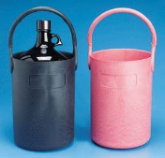  - Store with flammables in tightly-closed shatter-resistant containers.  - Store away from oxidizers, reducing agents, metals, and acids (not in cold room).  - Use secondary container for transport.
 | Engineering Controls | - Eyewash required in immediate work area.  - Eyewash-drench hose preferred.  - Safety shower may be required for large quantities. |  | - Work with concentrated solutions (>4%) and all solids only in a chemical fume hood.  - Dilute solutions (<4%) can be used on benchtop in small quantities if containers are opened only briefly. |  |  |  | 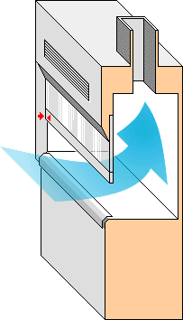
 | Work Practice Controls | - Labs handling >100 ml regularly on the benchtop must contact OESO Lab Safety for exposure assessment.  Formaldehyde Work Area: Danger! Toxic!  - Designate a work area for formaldehyde and label it. ↗  - Tare (pre-weigh) empty container with lid.  - Go to hood, add powder, close lid.  - Go to balance to weigh.  - Return to hood.  - Keep containers closed as much as possible.  - Line work area with absorbent, leak-proof bench pads.  - If weighing, place balance in hood OR use Tare Method →  - Decontaminate with soap and water solution.
 | Personal Protective Equipment | Minimum PPE:  - Nitrile (or latex) gloves (Change immediately if contaminated and every 2 hours. Wash hands at time of change.)  - Splash goggles  - Fully buttoned lab coat with sleeves extending to the wrists. |  |  |  | 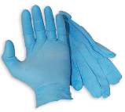  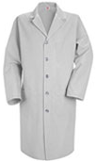  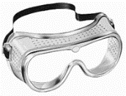
 |  | Risk of splash/large amounts: (in addition to the above, wear)  - Face shield.  - Tyvek sleeves and/or gown/apron. |  |  |  |  | 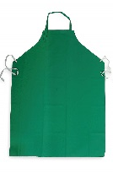
Other | Emergencies | See Emergency Response webpage or flip chart and/or lab specific chemical hygiene plan.  Contact OESO Spill team for spills outside fume hood if there is eye or respiratory irritation.
 | Waste | See lab-specific chemical hygiene plan. ≤10% formalin (≤3.75% formaldehyde) can be disposed down the drain. PFA & solutions must be collected as chemical waste.
 | Training | Sign signature page in Lab-Specific Chemical Hygiene Plan to indicate review and follow lab-specific instructions for “Online Training” below.
 | Questions | Contact OESO Lab Safety at 919-684-8822.

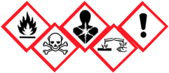
Lab-Specific Safety Information for
Formalin, Formaldehyde Solutions, and Paraformaldehyde
Supplements the Guidelines for Safe Use of Formalin, Formaldehyde solutions, and PFA
Lab | PI Name | Click or tap here to enter PI Name
 | Location | Enter building(s) and room(s) where lab is located
Lab-Specific Hazard Controls | Purchase  Details | Select Type of Product | 10% Formalin or  10% Neutral Buffered Formalin (NBF)  ☐ | 37% Formaldehyde solution  ☐ | Paraformaldehyde Solid and/or PFA solution  ☐
 |  | Maximum container size | Enter maximum container size purchased | Enter maximum container size purchased | Enter maximum container size purchased
 |  | Container type | Enter the container material | Enter the container material | Enter the container material
 |  | Specific product information | Enter supplier name/product number or purity/grade to purchase | Enter supplier name/product number or purity/grade to purchase | Enter supplier name/product number or purity/grade to purchase
 | Storage | Specific location  Not in cold room! | Enter specific storage location | Enter specific storage location | Enter specific storage location
 | Use Information | Designated work area | Enter rooms and areas designated for use | Enter rooms and areas designated for use | Enter rooms and areas designated for use
 |  | Max. quantity to use at a time | Enter maximum quantity | Enter maximum quantity | Enter maximum quantity
 |  | Max. conc. to use at a time | Enter maximum % if different than 10% | Enter maximum % if different than 37% | Enter maximum % if solution
 |  | Location and type of spill supplies | Spill supply type and location
 | Waste Disposal | Select Method of Disposal for Chemical Waste | ☐ Drain Disposal  ☐ Waste Collection:  Collection Location | ☐ Drain Disposal ONLY if final USE conc. is <3.8%  ☐ Waste Collection:  Collection Location | NO Drain Disposal  ☐ Waste Collection:  Collection Location
 | Online Training | Formaldehyde Exposure Awareness | ☒ Recommended by OESO for all users before starting work  ☐ Required by PI for all users before starting work  ☐ Required by OSHA for users in Clinical, Pathology, and Anatomy labs exposed to >0.1 ppm formaldehyde in air (see training for specific scenarios)
 |  | Formaldehyde Hazard Communication | ☐ Required by PI for all users before starting work  ☐ Required by OSHA for users in Clinical, Pathology, and Anatomy labs exposed to <0.1 ppm formaldehyde in air (see training for specific scenarios)
 | Details of Process | Click or tap here to enter details specific to your lab’s process with formalin, formaldehyde solutions, and/or paraformaldehyde.

