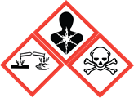
Duke OESO Guidelines for Safe Use of
Phenol (CAS 108-95-2)
Includes TRIzol and other mixtures containing phenol
Complete Lab-Specific Safety Information on page 3
Hazards | Potential Hazards | - Severe systemic toxicity can result from exposure via any route and can affect the nervous system, heart, blood vessels, liver, lung and/or kidneys, possibly leading to death.  - Phenol is very hazardous in case of skin contact – it is toxic and corrosive, causing painful burns and rapid absorption that may lead to systemic toxicity. Skin exposure results in pain, then numbness, blanching, severe burns, and eschar formation.  - May cause severe eye injury (including blindness) if it contacts the eyes.  - Serious effects from inhalation exposure are less likely if effective engineering controls and work practices are used. Special care is needed when heating phenol, or in case of a spill. If inhaled, phenol can cause upper respiratory irritation, lung damage, or systemic effects.  - Toxic by ingestion – see systemic toxicity note above.  - Exposure limits: OSHA Permissible Exposure Limit- 5 ppm as an 8-hr time-weighted average.  - When pure, phenol has a sweet, tar-like odor that is readily detected at low concentrations (0.05 ppm in air).  - Considered Particularly Hazardous (Action B in the GHS Lookup tool) due to need for specialized first aid and systemic toxicity from skin contact.  - For more information, see the SDS and the Lab Chemical Safety Summary for Phenol.  - NOTE: TRIzol reagent presents the additional hazard of releasing a toxic gas when in contact with acids or bleach, as well as the hazards from phenol.
Hazard Controls - 1 | Selection & Purchase | - Purchase in the smallest container practical for lab use, ideally pre-mixed with other reagents needed for your process.  - Purchase in a shatter-resistant container if available (such as PVC-coated glass).  - Purchase Phenol Exposure Kit (list on page 3) including polyethylene glycol 300 or 400.
 | Storage & Transport | - Transport phenol in secondary containment, preferably a clean polyethylene or other non-reactive acid/solvent bottle carrier.  - Keep container in cool, well-ventilated area (NOT a cold room).  - Keep container tightly closed when not in use.  - Store in secondary containment away from moisture, strong oxidizers, strong bases, sulfuric acid, nitric acid, water + heat, and chemically active metals, such as aluminum or magnesium powder, sodium, potassium, and lithium. May be corrosive to plastics or rubber.  - Store below eye level and avoid storing on the floor.  - Avoid ignition sources.
 | Engineering Controls | - An eyewash (preferably eyewash/drench hose combo unit) must be located in the immediate area. See also emergency shower and eyewash policy.  - For >50 ml of >25% phenol, a safety shower is also required.  - Work in a fume hood with open containers (>50 ml) or when heating.  - Small volumes (<50 ml) can be handled safely on the benchtop at or below room temperature, as long as skin and eye contact is avoided. | 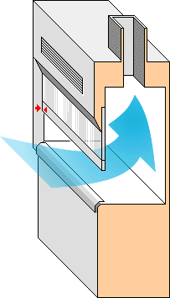  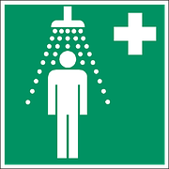  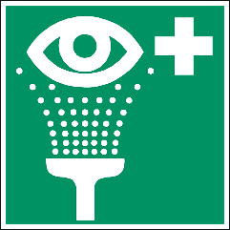
 | Work Practice Controls | - Designate an area for working with phenol, and label it as such.  - Post the Phenol Hazard Alert near the designated phenol work area.  - Keep Phenol Exposure Kit near the designated phenol work area.  - Use in the smallest quantities and lowest concentration practicable for the experiment being performed. Keep containers closed as much as possible.  - Avoid heating if possible, as this increases risk of inhalation exposure.  - After work with phenol is complete, wipe down work area with soap and water solution.

Hazard Controls - 2 | Personal Protective Equipment  (PPE) | 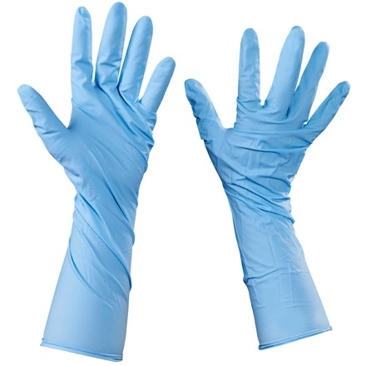  Be sure to check the glove guide for the specific glove you purchase if not listed here. Not all laminate gloves provide good protection for these chemicals.  x2  Required PPE:  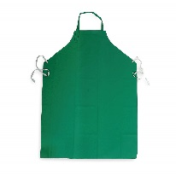  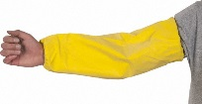  - Two pairs 4 mil or one pair 8 mil nitrile gloves with extended cuffs. (Phenol readily penetrates 4-mil nitrile gloves.)  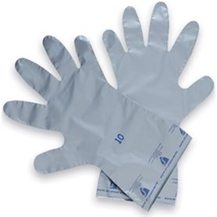  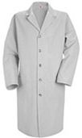  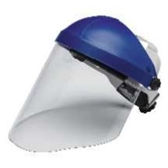  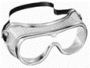  - Immediately change gloves that are splashed or contaminated!  - Splash goggles  - Fully buttoned lab coat  Silver Shield for spill clean up  - For splashes, wear face shield over goggles, chemical resistant sleeves, and impervious apron  If phenol and chloroform will be used together, please review the Chloroform Guideline and the Phenol-Chloroform note below. Special care needs to be taken due to phenol’s severe skin hazard and chloroform’s quick penetration of most gloves.  NOTE for employees with skin conditions that increase the permeability of the skin such as (but not limited to) psoriasis, atopic eczema, or ichthyosis: A greater level of PPE than indicated above should be used. For example, Viton®-butyl or Silver Shield® gloves for hands with a skin condition or an impervious apron for torso with a skin condition.
Other | Emergencies | - In case of skin exposure use Phenol Exposure Kit and First Aid Instructions below, then seek IMMEDIATE medical attention. (For medical advice about exposures, call the Exposure hotline at 919-684-8115.)  - See Emergency Response webpage or flip chart and/or lab-specific chemical hygiene plan.  - For clean-up of spills under 50 ml, use Silver Shield®, Viton® or Viton®-butyl, or other glove rated for slow breakthrough with phenol and other chemicals present. (Those listed also protect against chloroform.) Do not use double nitrile gloves for spills due to phenol’s very serious effects via skin. For larger spills, or if you don’t have adequate gloves, contact Duke Police at 919-684-2444 to activate Duke’s Chemical Spill Response Team.
 | Waste | Accumulate for chemical waste disposal through OESO. See also lab-specific chemical hygiene plan, Duke’s Chemical Waste Policy, and Lab Chemical Waste Management Practice (linked here)
 | Training | Sign signature page in lab-specific chemical hygiene plan to indicate review.
 | Questions | Contact OESO Lab Safety at 919-684-8822 or labsafety@dm.duke.edu.

Phenol - Chloroform Note
If phenol and chloroform will be used together, please note that chloroform penetrates nitrile gloves even more readily than phenol and can degrade the gloves, allowing phenol to contact the skin. Plan work to avoid glove contact, wear doubled 4-mil thick nitrile gloves (or a single pair of 8-mil thick nitrile gloves) with extended cuff, and change gloves immediately if there is a splash. If extensive work with phenol and chloroform is done in the lab, consider reusable Viton® or Viton®-butyl gloves, which provide good protection from both of these chemicals and can be used to clean up spills involving both.

Phenol Exposure Kit and First Aid Instructions
Phenol Exposure Kit – any lab using phenol should have these supplies on hand. We have split the list into minimum and recommended sections.
At minimum, keep on hand:
- 1 liter pharmaceutical (USP or NF) grade polyethylene glycol (PEG), 300 or 400 molecular mass (e.g., Kollisolv® PEG 400).
- Laminate film gloves (Silver Shield®) or reusable Viton® or Viton®-butyl gloves.
- 10 gauze pads or sponges at minimum (Sterile or non-sterile).
  - More gauze pads would be necessary if large amounts of phenol are used.
- Large poly bags for waste (e.g., 1 gallon Ziploc®).
- Copy of these guidelines and the Phenol Hazard Alert.
Other highly recommended items:
These should be included in the kit if more than 50 ml of phenol are used.
- At least 25 total gauze pads or sponges.
- Large cotton roll (e.g., VWR 470161-446) and/or wiping cloths (e.g., VWR 500030-610; -611).
- Large squeeze-bottle of liquid hand soap. (A squeeze bottle allows much faster application than a pump dispenser.)
- Tyvek® coveralls for use if clothing is contaminated and not able to be worn.
First Aid instructions for contaminated skin (see note about eye exposure below):
Decontamination must begin as soon as possible to minimize phenol absorption. While decontamination is ongoing, have a colleague call the Exposure Hotline at 919-684-8115 for advice on seeking medical attention based on the size & severity of the burn. If phenol is left on the skin, it will penetrate rapidly and lead to cell death and gangrene. Skin exposures affecting >60 in² (>380 cm²) could be fatal. Exposure to >100 cm² requires an Emergency Room visit. Phenol has local anesthetic properties and can cause extensive damage before pain is felt.
- Move away from the spill location if possible.
- Those providing first aid shall don protective gloves (laminate, Viton® or Viton®-butyl), safety goggles (or glasses if goggles are not available), and lab coat. Nitrile gloves may be worn over laminate to improve dexterity. Do not put gloves on contaminated hands! The injured person, if able, can assist.
- Remove contaminated clothing immediately, including any contaminated leather items.
- Ensure you have bags open and available to collect contaminated gloves, clothing, and gauze or cloths that have been used to clean the affected area.
- For small areas of skin, irrigate affected areas with PEG 300 or 400, or swab with gauze pads or cotton wiping cloths soaked in PEG immediately and repeatedly until the phenol smell is gone.
  - If PEG is not available or if you run out, use vegetable oil, isopropyl alcohol or soap and water.
  - If gauze or cotton wiping cloths are not available, irrigate area with PEG and use other absorbent material to gently wipe the affected area.
- For large skin exposures, flush with COPIOUS amounts of water (safety shower or drench hose), then wash affected area with soap and water, flushing continually, for at least 15 minutes. (Soap helps disperse and remove phenol.) Keep reapplying soap throughout the 15 minutes. If phenol smell remains, use PEG as directed in number 5 above.
- For splashes to the eyes, irrigate with COPIOUS amounts of water (eyewash or drench hose). Continue flushing for 15 minutes. Do not use lesser amounts of water, as this will only dilute the phenol and expand the area exposed instead of washing the phenol away.
- After removing phenol from skin or eyes, seek immediate medical attention.
- Double-bag any contaminated absorbent materials. Close & label bag; submit a chemical waste pickup request.
- Double-bag contaminated clothing and personal items. OESO highly recommends disposing of contaminated clothing along with the contaminated absorbent material to prevent later contamination at home.
- After the medical emergency is over, refill Phenol Exposure Kit to replenish any used items.
- Report the exposure using the Report of Work-Related Injury or Illness form on the HR website.

Lab-Specific Safety Information for
Phenol
Supplements the Guidelines for Safe Use of Phenol
Lab | PI Name | Click or tap here to enter PI Name
 | Location | Enter building(s) and room(s) where lab is located
Lab-Specific Hazard Controls | Purchase  Details | Maximum container size | Enter maximum container size purchased
 |  | Maximum  concentration | Enter maximum concentration purchased
 |  | Container type | Enter the container material | Purchase in PVC-coated bottle if possible
 |  | Specific product information | Enter supplier name/product number or purity/grade to purchase
 | Storage | Specific location | Enter rooms and areas designated for storage |  | Not a cold room!
 | Use Information | Designated work area  (specific room(s) and area(s)) | Enter rooms and areas designated for use
 |  | Maximum quantity | Enter maximum quantity to be used at a time
 |  | Other Chemicals Used with Phenol (e.g. Chloroform) | Enter other chemicals that may be used with phenol such as chloroform, isoamyl alcohol, etc.
 |  | PPE Storage Location | Enter location where specific PPE is stored (e.g. extended cuff gloves, 8 mil nitrile gloves, chemical resistant sleeves, or apron, etc.)
 | Emergency Information | Type and Location of Phenol Exposure Kit | Minimum to keep on hand  ☐ 1 liter USP or NF polyethylene glycol, 300 or 400 molecular mass (e.g., Kollisolv® PEG 400).  ☐ Laminate film gloves (Silver Shield®).  OR ☐ Viton® or Viton®-butyl gloves  ☐ 10 Gauze pads or sponges (minimum)  ☐ Large poly bags for waste (e.g., 1 gallon Ziploc®).  ☐ Copy of these Guidelines and the Phenol Hazard Alert  Highly Recommended  ☐ 25 Gauze pads or sponges (minimum)  ☐ Wiping cloths (e.g., VWR 500030-610; or -611) OR ☐ Large cotton roll (e.g., VWR 470161-446) (May be used instead of gauze pads)  ☐ Large squeeze-bottle of liquid hand soap  ☐ Tyvek® coveralls (for use if clothing is contaminated)  Location: Enter location where specific First Aid materials are stored.
 |  | Location of supplies for  spill clean-up | Gloves from the Phenol Exposure Kit can be used for clean up.  Enter location of spill supplies
 | Waste Information | Details about waste (location, type of container) | Enter location of waste container, type of container used
 | Details of Process | Enter steps used in lab process(es) or experiment(s)

