Hydrogen peroxide, 30%  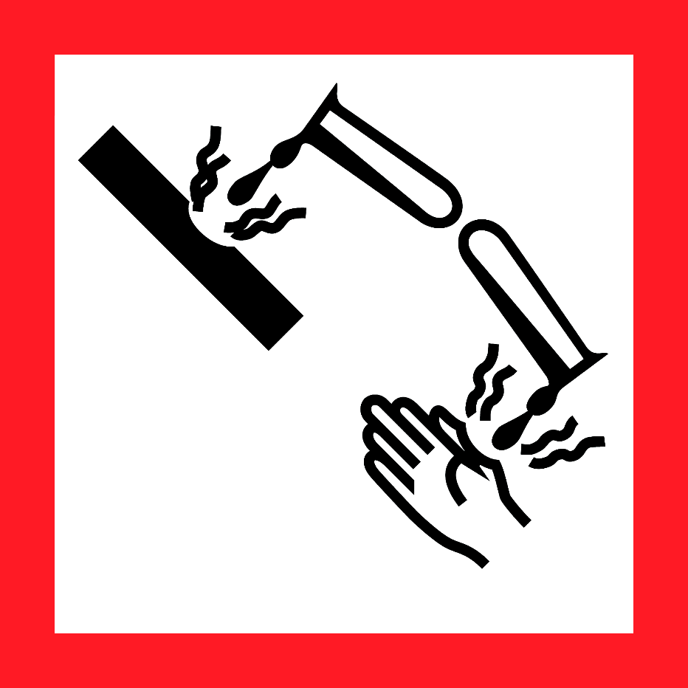  Danger  HAZARD STATEMENTS:  May cause fire or explosion; Strong oxidizer. Harmful if swallowed. Causes severe skin burns and eye damage. Causes serious eye damage. Harmful to aquatic life.  PRECAUTIONARY STATEMENTS:  Keep away from heat. Keep/store away from clothing/combustible materials. Take any precaution to avoid mixing with combustibles.  Wash skin thoroughly after handling. Do not eat, drink or some when using this product. Avoid release to the environment. Wear protective gloves/protective clothing/eye protection/ face protection.  Wear fire/flame resistant/retardant clothing. Store locked up. Dispose of contents/container to an approved waste disposal plant.  IF SWALLOWED: Call a POISON CENTER or doctor/physician if you feel unwell. Rinse mouth. Do NOT induce vomiting. IF ON SKIN: (or hair): Remove/Take off Immediately all contaminated clothing. Rinse skin with water/shower. IF INHALED: Remove victim to fresh air and Keep at rest in a position comfortable for breathing. Immediately call a POISON CENTER or doctor/physician. IF IN EYES: Rinse cautiously with water for several minutes. Remove contact lenses, if present and easy to do. Continue rinsing. Immediately call a POISON CENTER or doctor/physician. IF ON CLOTHING: Rinse immediately contaminated clothing and skin with plenty of water before removing clothes. In case of fire: Use dry sand, dry chemical, or alcohol-resistant foam for extinction. In case of major fire and large quantities: Evacuate area. Fight fire remotely due to the risk of explosion.  Supplier Identification & Emergency Phone#:  Sigma-Aldrich  3050 Spruce Street  SAINT LOUIS MO 63103  Emergency Phone # : (314) 776-6555  See the Safety Data Sheet for more information. |  | Hydrogen peroxide, 30%  Danger  HAZARD STATEMENTS:  May cause fire or explosion; Strong oxidizer. Harmful if swallowed. Causes severe skin burns and eye damage. Causes serious eye damage. Harmful to aquatic life.  PRECAUTIONARY STATEMENTS:  Keep away from heat. Keep/store away from clothing/combustible materials. Take any precaution to avoid mixing with combustibles.  Wash skin thoroughly after handling. Do not eat, drink or some when using this product. Avoid release to the environment. Wear protective gloves/protective clothing/eye protection/ face protection.  Wear fire/flame resistant/retardant clothing. Store locked up. Dispose of contents/container to an approved waste disposal plant.  IF SWALLOWED: Call a POISON CENTER or doctor/physician if you feel unwell. Rinse mouth. Do NOT induce vomiting. IF ON SKIN: (or hair): Remove/Take off Immediately all contaminated clothing. Rinse skin with water/shower. IF INHALED: Remove victim to fresh air and Keep at rest in a position comfortable for breathing. Immediately call a POISON CENTER or doctor/physician. IF IN EYES: Rinse cautiously with water for several minutes. Remove contact lenses, if present and easy to do. Continue rinsing. Immediately call a POISON CENTER or doctor/physician. IF ON CLOTHING: Rinse immediately contaminated clothing and skin with plenty of water before removing clothes. In case of fire: Use dry sand, dry chemical, or alcohol-resistant foam for extinction. In case of major fire and large quantities: Evacuate area. Fight fire remotely due to the risk of explosion.  Supplier Identification & Emergency Phone#:  Sigma-Aldrich  3050 Spruce Street  SAINT LOUIS MO 63103  Emergency Phone # : (314) 776-6555  See the Safety Data Sheet for more information.
Hydrogen peroxide, 30%  Danger  HAZARD STATEMENTS:  May cause fire or explosion; Strong oxidizer. Harmful if swallowed. Causes severe skin burns and eye damage. Causes serious eye damage. Harmful to aquatic life.  PRECAUTIONARY STATEMENTS:  Keep away from heat. Keep/store away from clothing/combustible materials. Take any precaution to avoid mixing with combustibles.  Wash skin thoroughly after handling. Do not eat, drink or some when using this product. Avoid release to the environment. Wear protective gloves/protective clothing/eye protection/ face protection.  Wear fire/flame resistant/retardant clothing. Store locked up. Dispose of contents/container to an approved waste disposal plant.  IF SWALLOWED: Call a POISON CENTER or doctor/physician if you feel unwell. Rinse mouth. Do NOT induce vomiting. IF ON SKIN: (or hair): Remove/Take off Immediately all contaminated clothing. Rinse skin with water/shower. IF INHALED: Remove victim to fresh air and Keep at rest in a position comfortable for breathing. Immediately call a POISON CENTER or doctor/physician. IF IN EYES: Rinse cautiously with water for several minutes. Remove contact lenses, if present and easy to do. Continue rinsing. Immediately call a POISON CENTER or doctor/physician. IF ON CLOTHING: Rinse immediately contaminated clothing and skin with plenty of water before removing clothes. In case of fire: Use dry sand, dry chemical, or alcohol-resistant foam for extinction. In case of major fire and large quantities: Evacuate area. Fight fire remotely due to the risk of explosion.  Supplier Identification & Emergency Phone#:  Sigma-Aldrich  3050 Spruce Street  SAINT LOUIS MO 63103  Emergency Phone # : (314) 776-6555  See the Safety Data Sheet for more information. |  | Hydrogen peroxide, 30%  Danger  HAZARD STATEMENTS:  May cause fire or explosion; Strong oxidizer. Harmful if swallowed. Causes severe skin burns and eye damage. Causes serious eye damage. Harmful to aquatic life.  PRECAUTIONARY STATEMENTS:  Keep away from heat. Keep/store away from clothing/combustible materials. Take any precaution to avoid mixing with combustibles.  Wash skin thoroughly after handling. Do not eat, drink or some when using this product. Avoid release to the environment. Wear protective gloves/protective clothing/eye protection/ face protection.  Wear fire/flame resistant/retardant clothing. Store locked up. Dispose of contents/container to an approved waste disposal plant.  IF SWALLOWED: Call a POISON CENTER or doctor/physician if you feel unwell. Rinse mouth. Do NOT induce vomiting. IF ON SKIN: (or hair): Remove/Take off Immediately all contaminated clothing. Rinse skin with water/shower. IF INHALED: Remove victim to fresh air and Keep at rest in a position comfortable for breathing. Immediately call a POISON CENTER or doctor/physician. IF IN EYES: Rinse cautiously with water for several minutes. Remove contact lenses, if present and easy to do. Continue rinsing. Immediately call a POISON CENTER or doctor/physician. IF ON CLOTHING: Rinse immediately contaminated clothing and skin with plenty of water before removing clothes. In case of fire: Use dry sand, dry chemical, or alcohol-resistant foam for extinction. In case of major fire and large quantities: Evacuate area. Fight fire remotely due to the risk of explosion.  Supplier Identification & Emergency Phone#:  Sigma-Aldrich  3050 Spruce Street  SAINT LOUIS MO 63103  Emergency Phone # : (314) 776-6555  See the Safety Data Sheet for more information.

