Methanol 99.8%  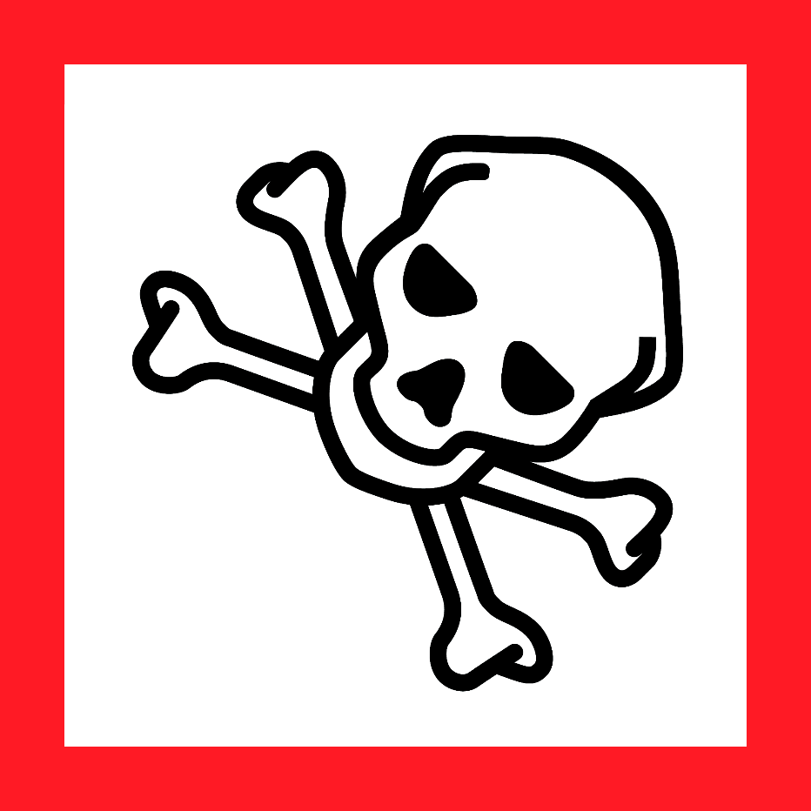  Danger  HAZARD STATEMENTS:  Highly flammable liquid and vapor.  Toxic if swallowed, in contact with skin or if inhaled.  Causes damage to organs.  PRECAUTIONARY STATEMENTS:  Keep away from heat/sparks/open flames/hot surfaces. No smoking. Keep container tightly closed. Ground/bond container and receiving equipment. Use explosion-proof electrical/ ventilating/ lighting/ equipment. Use only non-sparking tools. Take precautionary measures against static discharge. Do not breathe dust/ fume/ gas/ mist/ vapours/ spray. Wash skin thoroughly after handling. Do not eat, drink or smoke when using this product. Use only outdoors or in a well-ventilated area. Wear protective gloves/ eye protection/ face protection. Store in a well-ventilated place. Keep container tightly closed. Keep cool. Store locked up. Dispose of contents/ container to an approved waste disposal plant.  IF SWALLOWED: Immediately call a POISON CENTER or doctor/ physician. Rinse mouth.  IF ON SKIN (or hair): Remove/ Take off immediately all contaminated clothing. Rinse skin with water/ shower.  IF INHALED: Remove victim to fresh air and keep at rest in a position comfortable for breathing. Call a POISON CENTER or doctor/ physician.  IF exposed: Call a POISON CENTER or doctor/ physician.  In case of fire: Use dry sand, dry chemical or alcohol-resistant foam for extinction.  Supplier Identification & Emergency Phone#:  Sigma-Aldrich  3050 Spruce Street  SAINT LOUIS MO 63103  Emergency Phone # : (314) 776-6555  See the Safety Data Sheet for more information. |  | Methanol 99.8%  Danger  HAZARD STATEMENTS:  Highly flammable liquid and vapor.  Toxic if swallowed, in contact with skin or if inhaled.  Causes damage to organs.  PRECAUTIONARY STATEMENTS:  Keep away from heat/sparks/open flames/hot surfaces. No smoking. Keep container tightly closed. Ground/bond container and receiving equipment. Use explosion-proof electrical/ ventilating/ lighting/ equipment. Use only non-sparking tools. Take precautionary measures against static discharge. Do not breathe dust/ fume/ gas/ mist/ vapours/ spray. Wash skin thoroughly after handling. Do not eat, drink or smoke when using this product. Use only outdoors or in a well-ventilated area. Wear protective gloves/ eye protection/ face protection. Store in a well-ventilated place. Keep container tightly closed. Keep cool. Store locked up. Dispose of contents/ container to an approved waste disposal plant.  IF SWALLOWED: Immediately call a POISON CENTER or doctor/ physician. Rinse mouth.  IF ON SKIN (or hair): Remove/ Take off immediately all contaminated clothing. Rinse skin with water/ shower.  IF INHALED: Remove victim to fresh air and keep at rest in a position comfortable for breathing. Call a POISON CENTER or doctor/ physician.  IF exposed: Call a POISON CENTER or doctor/ physician.  In case of fire: Use dry sand, dry chemical or alcohol-resistant foam for extinction.  Supplier Identification & Emergency Phone#:  Sigma-Aldrich  3050 Spruce Street  SAINT LOUIS MO 63103  Emergency Phone # : (314) 776-6555  See the Safety Data Sheet for more information.
Methanol 99.8%  Danger  HAZARD STATEMENTS:  Highly flammable liquid and vapor.  Toxic if swallowed, in contact with skin or if inhaled.  Causes damage to organs.  PRECAUTIONARY STATEMENTS:  Keep away from heat/sparks/open flames/hot surfaces. No smoking. Keep container tightly closed. Ground/bond container and receiving equipment. Use explosion-proof electrical/ ventilating/ lighting/ equipment. Use only non-sparking tools. Take precautionary measures against static discharge. Do not breathe dust/ fume/ gas/ mist/ vapours/ spray. Wash skin thoroughly after handling. Do not eat, drink or smoke when using this product. Use only outdoors or in a well-ventilated area. Wear protective gloves/ eye protection/ face protection. Store in a well-ventilated place. Keep container tightly closed. Keep cool. Store locked up. Dispose of contents/ container to an approved waste disposal plant.  IF SWALLOWED: Immediately call a POISON CENTER or doctor/ physician. Rinse mouth.  IF ON SKIN (or hair): Remove/ Take off immediately all contaminated clothing. Rinse skin with water/ shower.  IF INHALED: Remove victim to fresh air and keep at rest in a position comfortable for breathing. Call a POISON CENTER or doctor/ physician.  IF exposed: Call a POISON CENTER or doctor/ physician.  In case of fire: Use dry sand, dry chemical or alcohol-resistant foam for extinction.  Supplier Identification & Emergency Phone#:  Sigma-Aldrich  3050 Spruce Street  SAINT LOUIS MO 63103  Emergency Phone # : (314) 776-6555  See the Safety Data Sheet for more information. |  | Methanol 99.8%  Danger  HAZARD STATEMENTS:  Highly flammable liquid and vapor.  Toxic if swallowed, in contact with skin or if inhaled.  Causes damage to organs.  PRECAUTIONARY STATEMENTS:  Keep away from heat/sparks/open flames/hot surfaces. No smoking. Keep container tightly closed. Ground/bond container and receiving equipment. Use explosion-proof electrical/ ventilating/ lighting/ equipment. Use only non-sparking tools. Take precautionary measures against static discharge. Do not breathe dust/ fume/ gas/ mist/ vapours/ spray. Wash skin thoroughly after handling. Do not eat, drink or smoke when using this product. Use only outdoors or in a well-ventilated area. Wear protective gloves/ eye protection/ face protection. Store in a well-ventilated place. Keep container tightly closed. Keep cool. Store locked up. Dispose of contents/ container to an approved waste disposal plant.  IF SWALLOWED: Immediately call a POISON CENTER or doctor/ physician. Rinse mouth.  IF ON SKIN (or hair): Remove/ Take off immediately all contaminated clothing. Rinse skin with water/ shower.  IF INHALED: Remove victim to fresh air and keep at rest in a position comfortable for breathing. Call a POISON CENTER or doctor/ physician.  IF exposed: Call a POISON CENTER or doctor/ physician.  In case of fire: Use dry sand, dry chemical or alcohol-resistant foam for extinction.  Supplier Identification & Emergency Phone#:  Sigma-Aldrich  3050 Spruce Street  SAINT LOUIS MO 63103  Emergency Phone # : (314) 776-6555  See the Safety Data Sheet for more information.

