Chemical Label Template
Instructions for adding Pictograms

- The label template is in a 3” X 5” format and can be changed to meet your needs.
- Use the information found on the chemical label from the supplier or from the SDS to fill out the label template.
- Copy the appropriate pictogram(s) from the table below and paste into the label template pictogram text box (only one can be copied and pasted at a time).
- Copy over or delete the text that is in the pictogram text box. Spaces can be added between pictograms.

Pictograms
Health Hazard | Flame | Exclamation | Gas Cylinder | Corrosion | Exploding Bomb | Flame over Circle | Environment | Skull and Crossbones
 |  |  |  | 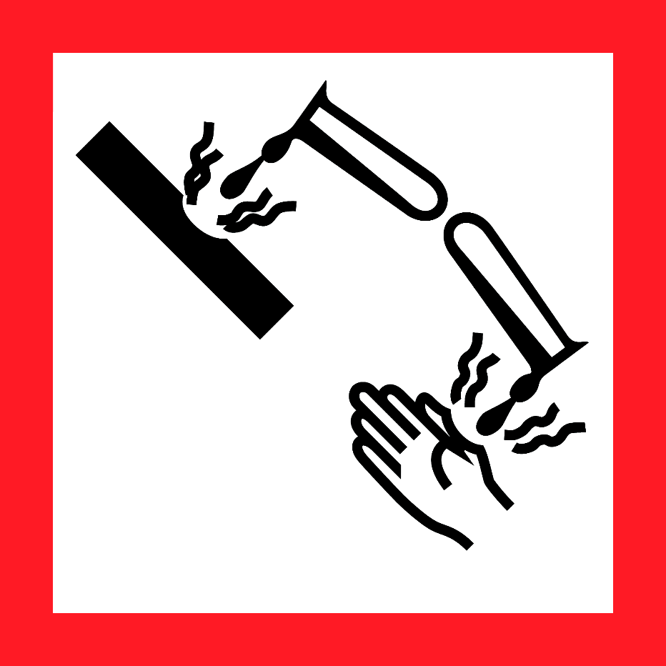 | 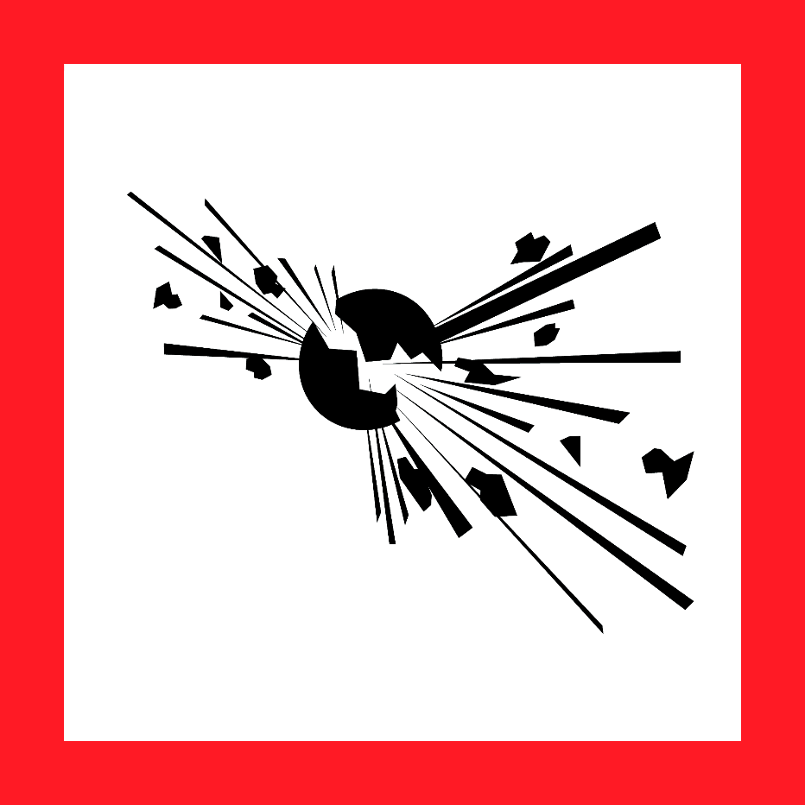 |  |  | 