Potassium Cyanide, ≥98%  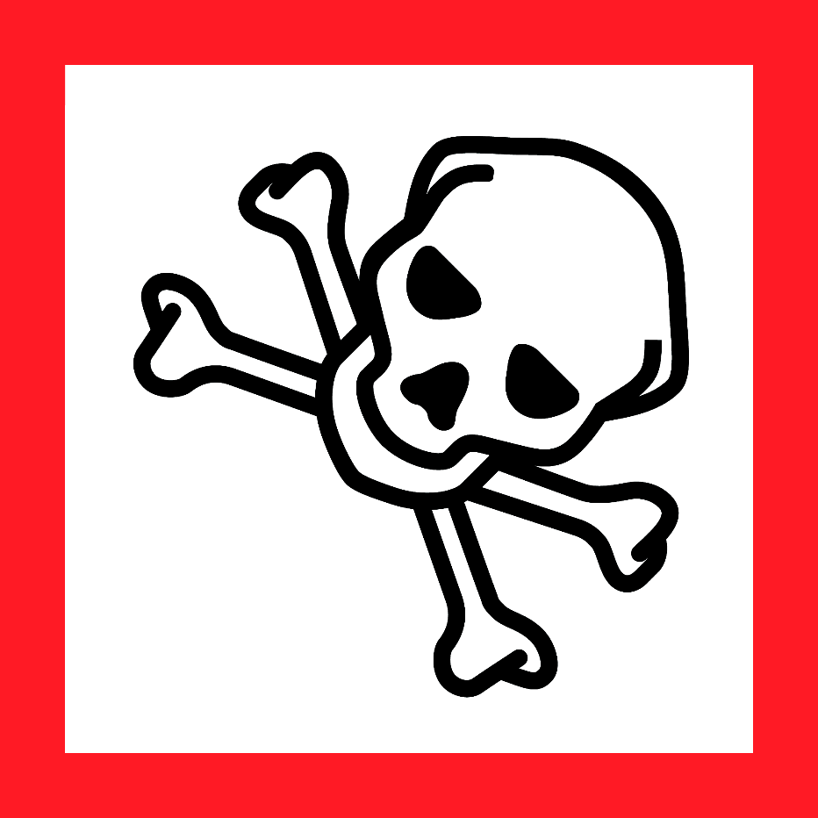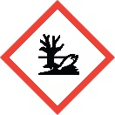  Danger  HAZARD STATEMENTS:  May be corrosive to metals. Fatal if swallowed, in contact with skin, or if inhaled. Causes damage to organs (heart, testes, brain) if swallowed. Causes damage to organs (thyroid) through prolonged or repeated exposure. Very toxic to aquatic life with long lasting effects.  PRECAUTIONARY STATEMENTS:  Keep only in original container. Do not breathe dust/ fume/ gas/ mist/ vapours/ spray. Do not get in eyes, on skin, or on clothing. Wash skin thoroughly after handling. Do not eat, drink or smoke when using this product. Use only outdoors or in a well-ventilated area. Avoid release to the environment. Wear protective gloves/ protective clothing. Wear respiratory protection. Remove/Take off immediately all contaminated clothing. Wash contaminated clothing before reuse. Absorb spillage to prevent material damage. Collect spillage. Store in a well-ventilated place. Keep container tightly closed. Store locked up. Store in corrosive resistant stainless steel container with a resistant inner liner. Dispose of contents/ container to an approved waste disposal plant.  IF SWALLOWED: Immediately call a POISON CENTER or doctor/physician. Rinse mouth. IF ON SKIN: Gently wash with plenty of soap and water. Immediately call a POISON CENTER or doctor/physician. IF INHALED: Remove victim to fresh air and keep at rest in a position comfortable for breathing. Immediately call a POISON CENTER or doctor/physician. IF exposed: Call a poison Center or doctor/physician.  Hazards not otherwise classified (HNOC) or not covered by GHS:  Contact with acids liberates very toxic gas.  Supplier Identification & Emergency Phone#:  Sigma-Aldrich  3050 Spruce Street  SAINT LOUIS MO 63103  Emergency Phone # : (314) 776-6555  See the Safety Data Sheet for more information. |  | Potassium Cyanide, ≥98%  Danger  HAZARD STATEMENTS:  May be corrosive to metals. Fatal if swallowed, in contact with skin, or if inhaled. Causes damage to organs (heart, testes, brain) if swallowed. Causes damage to organs (thyroid) through prolonged or repeated exposure. Very toxic to aquatic life with long lasting effects.  PRECAUTIONARY STATEMENTS:  Keep only in original container. Do not breathe dust/ fume/ gas/ mist/ vapours/ spray. Do not get in eyes, on skin, or on clothing. Wash skin thoroughly after handling. Do not eat, drink or smoke when using this product. Use only outdoors or in a well-ventilated area. Avoid release to the environment. Wear protective gloves/ protective clothing. Wear respiratory protection. Remove/Take off immediately all contaminated clothing. Wash contaminated clothing before reuse. Absorb spillage to prevent material damage. Collect spillage. Store in a well-ventilated place. Keep container tightly closed. Store locked up. Store in corrosive resistant stainless steel container with a resistant inner liner. Dispose of contents/ container to an approved waste disposal plant.  IF SWALLOWED: Immediately call a POISON CENTER or doctor/physician. Rinse mouth. IF ON SKIN: Gently wash with plenty of soap and water. Immediately call a POISON CENTER or doctor/physician. IF INHALED: Remove victim to fresh air and keep at rest in a position comfortable for breathing. Immediately call a POISON CENTER or doctor/physician. IF exposed: Call a poison Center or doctor/physician.  Hazards not otherwise classified (HNOC) or not covered by GHS:  Contact with acids liberates very toxic gas.  Supplier Identification & Emergency Phone#:  Sigma-Aldrich  3050 Spruce Street  SAINT LOUIS MO 63103  Emergency Phone # : (314) 776-6555  See the Safety Data Sheet for more information.
Potassium Cyanide, ≥98%  Danger  HAZARD STATEMENTS:  May be corrosive to metals. Fatal if swallowed, in contact with skin, or if inhaled. Causes damage to organs (heart, testes, brain) if swallowed. Causes damage to organs (thyroid) through prolonged or repeated exposure. Very toxic to aquatic life with long lasting effects.  PRECAUTIONARY STATEMENTS:  Keep only in original container. Do not breathe dust/ fume/ gas/ mist/ vapours/ spray. Do not get in eyes, on skin, or on clothing. Wash skin thoroughly after handling. Do not eat, drink or smoke when using this product. Use only outdoors or in a well-ventilated area. Avoid release to the environment. Wear protective gloves/ protective clothing. Wear respiratory protection. Remove/Take off immediately all contaminated clothing. Wash contaminated clothing before reuse. Absorb spillage to prevent material damage. Collect spillage. Store in a well-ventilated place. Keep container tightly closed. Store locked up. Store in corrosive resistant stainless steel container with a resistant inner liner. Dispose of contents/ container to an approved waste disposal plant.  IF SWALLOWED: Immediately call a POISON CENTER or doctor/physician. Rinse mouth. IF ON SKIN: Gently wash with plenty of soap and water. Immediately call a POISON CENTER or doctor/physician. IF INHALED: Remove victim to fresh air and keep at rest in a position comfortable for breathing. Immediately call a POISON CENTER or doctor/physician. IF exposed: Call a poison Center or doctor/physician.  Hazards not otherwise classified (HNOC) or not covered by GHS:  Contact with acids liberates very toxic gas.  Supplier Identification & Emergency Phone#:  Sigma-Aldrich  3050 Spruce Street  SAINT LOUIS MO 63103  Emergency Phone # : (314) 776-6555  See the Safety Data Sheet for more information. |  | Potassium Cyanide, ≥98%  Danger  HAZARD STATEMENTS:  May be corrosive to metals. Fatal if swallowed, in contact with skin, or if inhaled. Causes damage to organs (heart, testes, brain) if swallowed. Causes damage to organs (thyroid) through prolonged or repeated exposure. Very toxic to aquatic life with long lasting effects.  PRECAUTIONARY STATEMENTS:  Keep only in original container. Do not breathe dust/ fume/ gas/ mist/ vapours/ spray. Do not get in eyes, on skin, or on clothing. Wash skin thoroughly after handling. Do not eat, drink or smoke when using this product. Use only outdoors or in a well-ventilated area. Avoid release to the environment. Wear protective gloves/ protective clothing. Wear respiratory protection. Remove/Take off immediately all contaminated clothing. Wash contaminated clothing before reuse. Absorb spillage to prevent material damage. Collect spillage. Store in a well-ventilated place. Keep container tightly closed. Store locked up. Store in corrosive resistant stainless steel container with a resistant inner liner. Dispose of contents/ container to an approved waste disposal plant.  IF SWALLOWED: Immediately call a POISON CENTER or doctor/physician. Rinse mouth. IF ON SKIN: Gently wash with plenty of soap and water. Immediately call a POISON CENTER or doctor/physician. IF INHALED: Remove victim to fresh air and keep at rest in a position comfortable for breathing. Immediately call a POISON CENTER or doctor/physician. IF exposed: Call a poison Center or doctor/physician.  Hazards not otherwise classified (HNOC) or not covered by GHS:  Contact with acids liberates very toxic gas.  Supplier Identification & Emergency Phone#:  Sigma-Aldrich  3050 Spruce Street  SAINT LOUIS MO 63103  Emergency Phone # : (314) 776-6555  See the Safety Data Sheet for more information.

