Sodium Borohydride, ≥99%  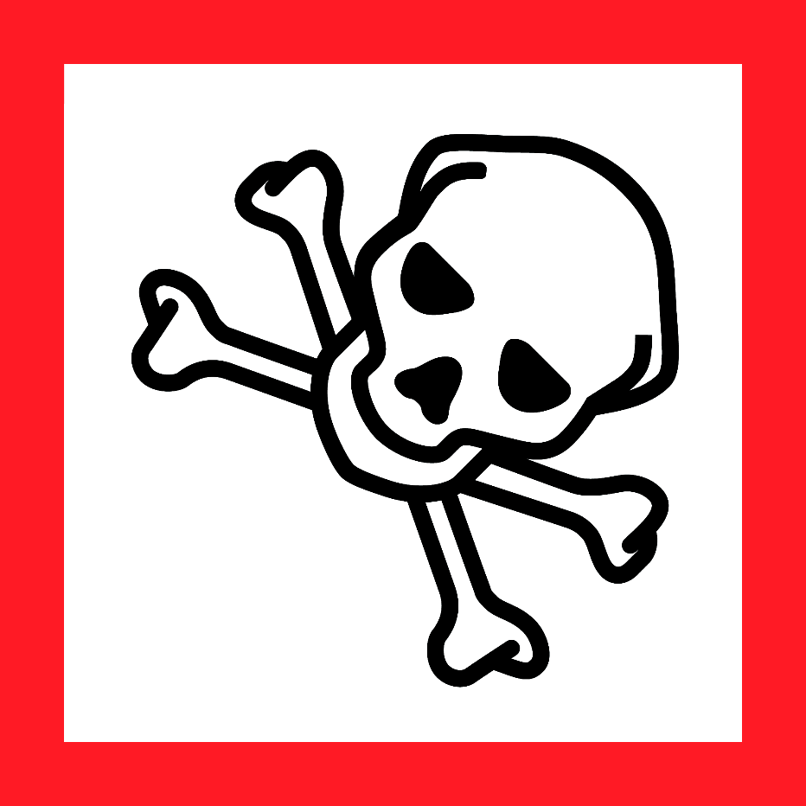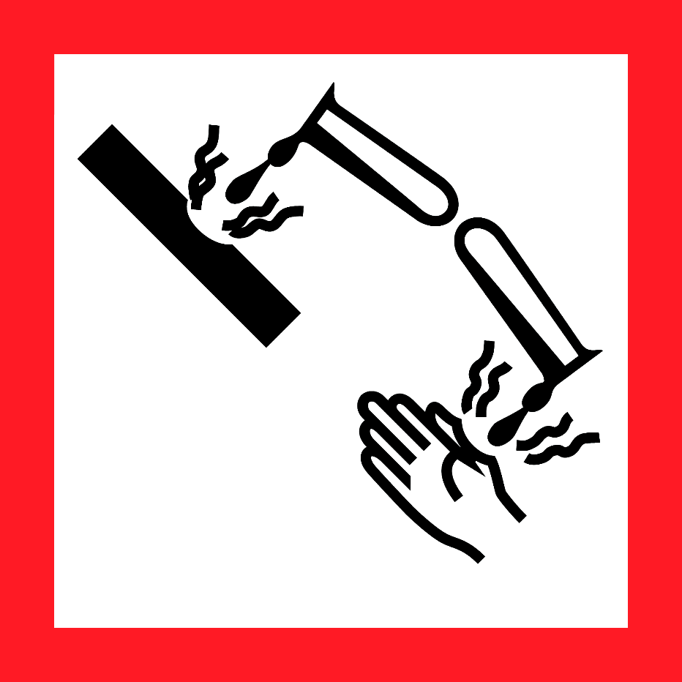  Danger  HAZARD STATEMENTS:  In contact with water releases flammable gases which may ignite spontaneously.  Toxic if swallowed or in contact with skin.  Causes severe skin burns and eye damage.  PRECAUTIONARY STATEMENTS:  Keep away from any possible contact with water, because of violent reaction and possible flash fire. Handle under inert gas. Protect from moisture. Do not breathe dust or mist. Wash skin thoroughly after handling. Do not eat, drink or smoke when using this product. Wear protective gloves/ protective clothing/ eye protection/face protection. Brush off loose particles from skin. Immerse in cool water/ wrap in wet bandages. Remove/Take off immediately all contaminated clothing. Wash contaminated clothing before reuse. Store in a dry place. Store in a closed container. Store locked up. Dispose of contents/ container to an approved waste disposal plant.  IF SWALLOWED: Call a POISON CENTER or doctor/physician. Rinse mouth. Do NOT induce vomiting. IF ON SKIN (or hair): Remove/ Take off immediately all contaminated clothing. Rinse with water/shower. IF INHALED: Remove victim to fresh air and Keep at rest in a position comfortable for breathing. IF IN EYES: Rinse cautiously with water for several minutes. Remove contact lenses, if present and easy to do. Continue rinsing. Immediately call a POISON CENTER or doctor/physician. Specific measures (see supplemental first aid instructions in SDS). In case of fire: Use dry sand, dry chemical, or alcohol-resistant foam for extinction.  Supplier Identification & Emergency Phone#:  Sigma-Aldrich; 3050 Spruce Street  SAINT LOUIS MO 63103  Emergency Phone # : (314) 776-6555  See the Safety Data Sheet for more information. |  | Sodium Borohydride, ≥99%  Danger  HAZARD STATEMENTS:  In contact with water releases flammable gases which may ignite spontaneously.  Toxic if swallowed or in contact with skin.  Causes severe skin burns and eye damage.  PRECAUTIONARY STATEMENTS:  Keep away from any possible contact with water, because of violent reaction and possible flash fire. Handle under inert gas. Protect from moisture. Do not breathe dust or mist. Wash skin thoroughly after handling. Do not eat, drink or smoke when using this product. Wear protective gloves/ protective clothing/ eye protection/face protection. Brush off loose particles from skin. Immerse in cool water/ wrap in wet bandages. Remove/Take off immediately all contaminated clothing. Wash contaminated clothing before reuse. Store in a dry place. Store in a closed container. Store locked up. Dispose of contents/ container to an approved waste disposal plant.  IF SWALLOWED: Call a POISON CENTER or doctor/physician. Rinse mouth. Do NOT induce vomiting. IF ON SKIN (or hair): Remove/ Take off immediately all contaminated clothing. Rinse with water/shower. IF INHALED: Remove victim to fresh air and Keep at rest in a position comfortable for breathing. IF IN EYES: Rinse cautiously with water for several minutes. Remove contact lenses, if present and easy to do. Continue rinsing. Immediately call a POISON CENTER or doctor/physician. Specific measures (see supplemental first aid instructions in SDS). In case of fire: Use dry sand, dry chemical, or alcohol-resistant foam for extinction.  Supplier Identification & Emergency Phone#:  Sigma-Aldrich; 3050 Spruce Street  SAINT LOUIS MO 63103  Emergency Phone # : (314) 776-6555  See the Safety Data Sheet for more information.
Sodium Borohydride, ≥99%  Danger  HAZARD STATEMENTS:  In contact with water releases flammable gases which may ignite spontaneously.  Toxic if swallowed or in contact with skin.  Causes severe skin burns and eye damage.  PRECAUTIONARY STATEMENTS:  Keep away from any possible contact with water, because of violent reaction and possible flash fire. Handle under inert gas. Protect from moisture. Do not breathe dust or mist. Wash skin thoroughly after handling. Do not eat, drink or smoke when using this product. Wear protective gloves/ protective clothing/ eye protection/face protection. Brush off loose particles from skin. Immerse in cool water/ wrap in wet bandages. Remove/Take off immediately all contaminated clothing. Wash contaminated clothing before reuse. Store in a dry place. Store in a closed container. Store locked up. Dispose of contents/ container to an approved waste disposal plant.  IF SWALLOWED: Call a POISON CENTER or doctor/physician. Rinse mouth. Do NOT induce vomiting. IF ON SKIN (or hair): Remove/ Take off immediately all contaminated clothing. Rinse with water/shower. IF INHALED: Remove victim to fresh air and Keep at rest in a position comfortable for breathing. IF IN EYES: Rinse cautiously with water for several minutes. Remove contact lenses, if present and easy to do. Continue rinsing. Immediately call a POISON CENTER or doctor/physician. Specific measures (see supplemental first aid instructions in SDS). In case of fire: Use dry sand, dry chemical, or alcohol-resistant foam for extinction.  Supplier Identification & Emergency Phone#:  Sigma-Aldrich; 3050 Spruce Street  SAINT LOUIS MO 63103  Emergency Phone # : (314) 776-6555  See the Safety Data Sheet for more information. |  | Sodium Borohydride, ≥99%  Danger  HAZARD STATEMENTS:  In contact with water releases flammable gases which may ignite spontaneously.  Toxic if swallowed or in contact with skin.  Causes severe skin burns and eye damage.  PRECAUTIONARY STATEMENTS:  Keep away from any possible contact with water, because of violent reaction and possible flash fire. Handle under inert gas. Protect from moisture. Do not breathe dust or mist. Wash skin thoroughly after handling. Do not eat, drink or smoke when using this product. Wear protective gloves/ protective clothing/ eye protection/face protection. Brush off loose particles from skin. Immerse in cool water/ wrap in wet bandages. Remove/Take off immediately all contaminated clothing. Wash contaminated clothing before reuse. Store in a dry place. Store in a closed container. Store locked up. Dispose of contents/ container to an approved waste disposal plant.  IF SWALLOWED: Call a POISON CENTER or doctor/physician. Rinse mouth. Do NOT induce vomiting. IF ON SKIN (or hair): Remove/ Take off immediately all contaminated clothing. Rinse with water/shower. IF INHALED: Remove victim to fresh air and Keep at rest in a position comfortable for breathing. IF IN EYES: Rinse cautiously with water for several minutes. Remove contact lenses, if present and easy to do. Continue rinsing. Immediately call a POISON CENTER or doctor/physician. Specific measures (see supplemental first aid instructions in SDS). In case of fire: Use dry sand, dry chemical, or alcohol-resistant foam for extinction.  Supplier Identification & Emergency Phone#:  Sigma-Aldrich; 3050 Spruce Street  SAINT LOUIS MO 63103  Emergency Phone # : (314) 776-6555  See the Safety Data Sheet for more information.

