Clean Ziploc Bags
No Other Plastics

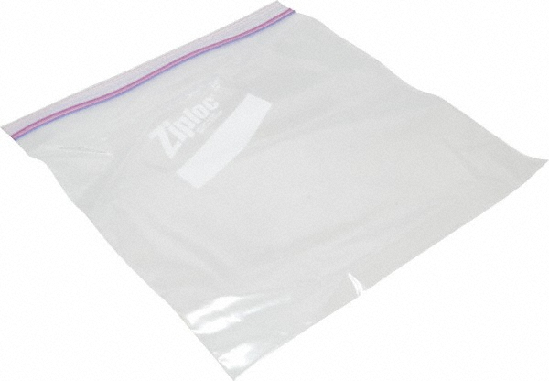

Reusable
Triple H₂O Rinsed Bottles
No Hazardous Chemical Bottles

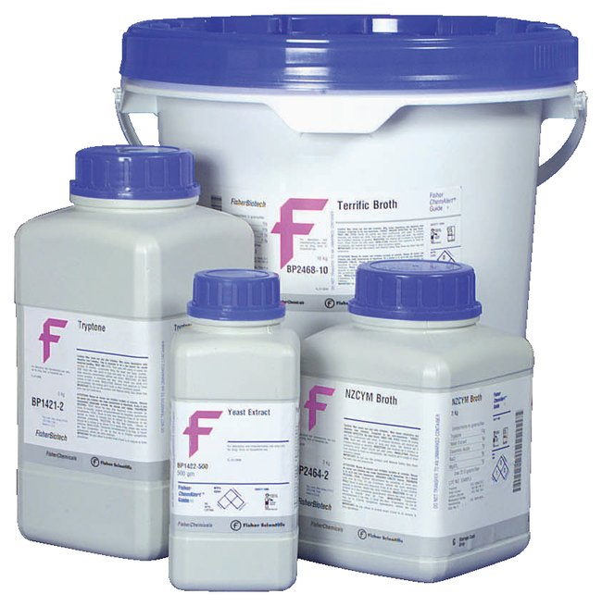

Reusable for chemical waste
Styrofoam Recycling Please Remove All Labels

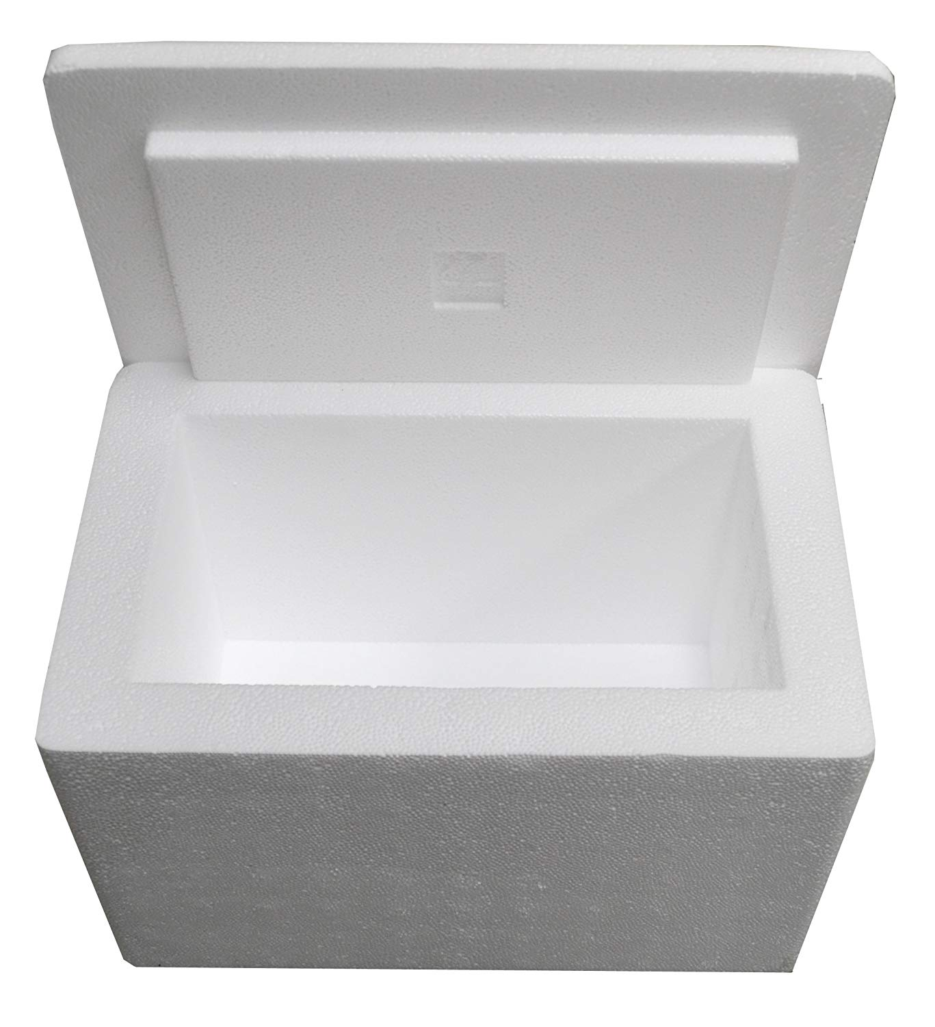

Reusable
Plastic/Glass Bottles and Aluminum Cans
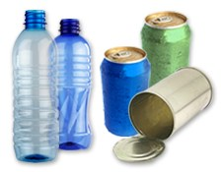

No regular trash: cups, plastic food containers, or plastic bags
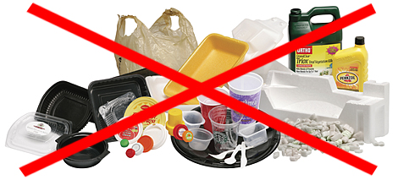

Clean Broken Glass
No Contaminated Glass

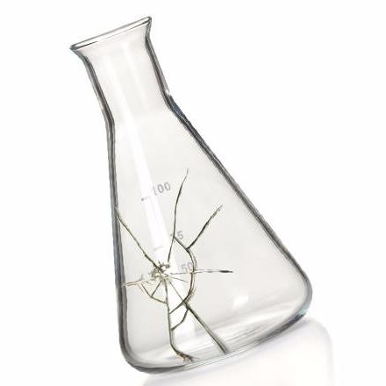

Cardboard Recycling
No Plastic/Paper

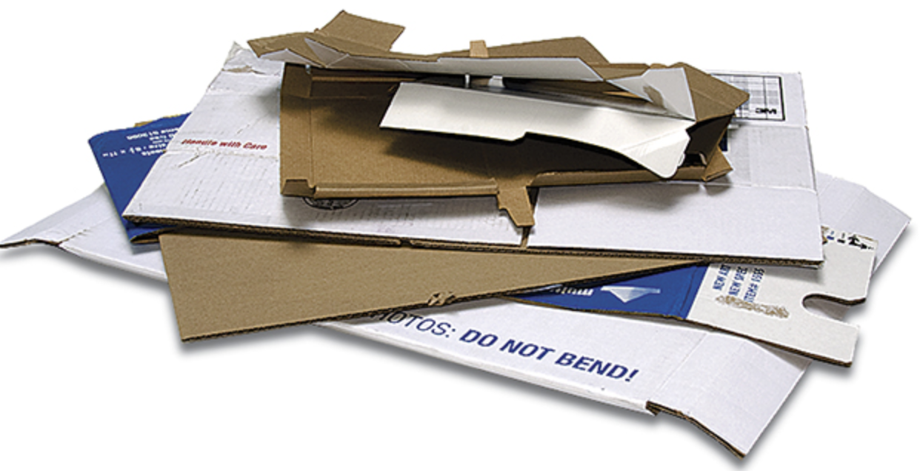

Cardboard Box Recycling

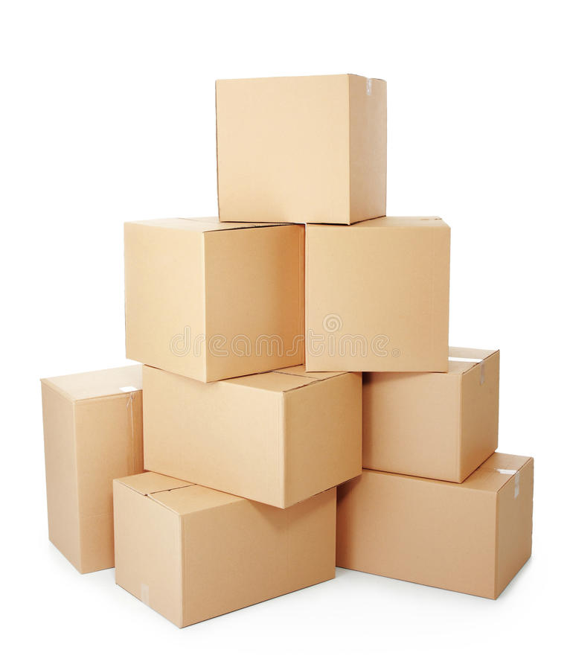

Reusable
Blend Paper Recycling
No Magazines

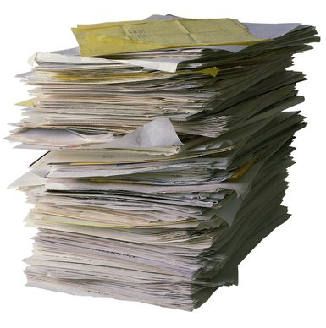

Reusable for notes
PACKAGES & DELIVERIES
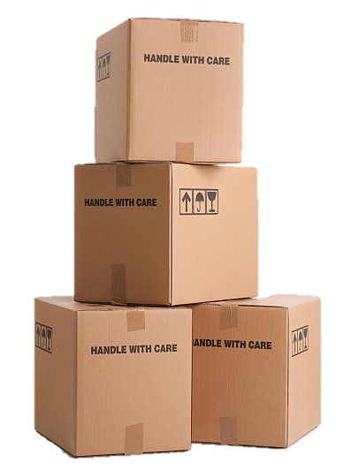

Thank you!
<Lab contact name> <phone #>
AUTOCLAVED BIOHAZARDOUS WASTE

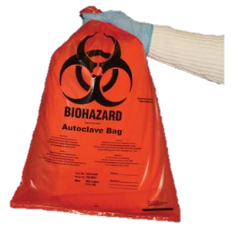

<Instructions on how to dispose of autoclaved biohazardous waste>
