1M Sodium Hydroxide  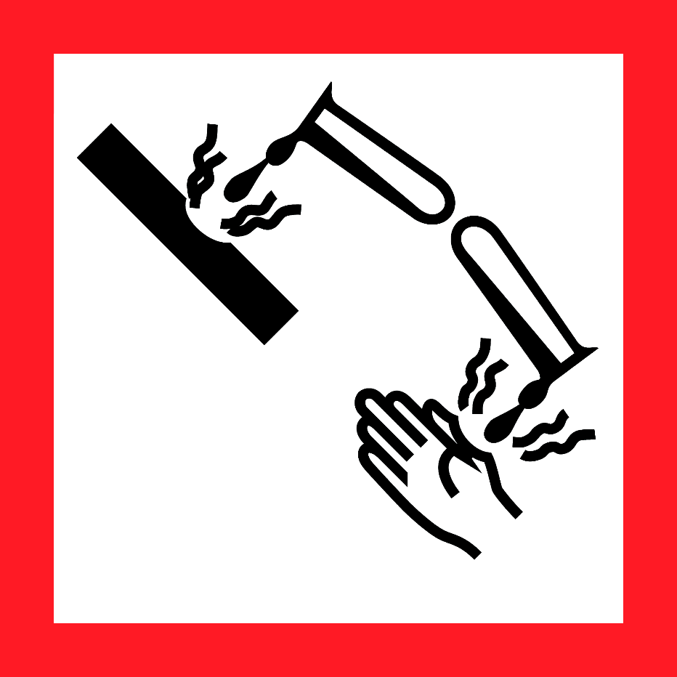  Danger  HAZARD STATEMENTS:  May be corrosive to metals.  Causes severe skin burns and eye damage.  Causes serious eye damage.  PRECAUTIONARY STATEMENTS:  Keep only in original container. Wash skin thoroughly after handling. Wear protective gloves/ protective clothing/ eye protection/ face protection. Wash contaminated clothing before reuse. Absorb spillage to prevent material damage. Store locked up. Store in corrosive resistant stainless steel container with a resistant inner liner. Dispose of contents/ container to an approved waste disposal plant.  IF SWALLOWED: Rinse mouth. Do NOT induce vomiting.  IF ON SKIN (or hair): Take off immediately all contaminated  clothing. Rinse skin with water/ shower.  IF INHALED: Remove person to fresh air and keep comfortable for breathing. Immediately call a POISON CENTER or doctor/ physician.  IF IN EYES: Rinse cautiously with water for several minutes. Remove contact lenses, if present and easy to do. Continue rinsing. Immediately call a POISON CENTER or doctor/ physician.  Supplier Identification & Emergency Phone#:  Sigma-Aldrich  3050 Spruce Street  SAINT LOUIS MO 63103  Emergency Phone # : (314) 776-6555  See the Safety Data Sheet for more information. |  | 1M Sodium Hydroxide  Danger  HAZARD STATEMENTS:  May be corrosive to metals.  Causes severe skin burns and eye damage.  Causes serious eye damage.  PRECAUTIONARY STATEMENTS:  Keep only in original container. Wash skin thoroughly after handling. Wear protective gloves/ protective clothing/ eye protection/ face protection. Wash contaminated clothing before reuse. Absorb spillage to prevent material damage. Store locked up. Store in corrosive resistant stainless steel container with a resistant inner liner. Dispose of contents/ container to an approved waste disposal plant.  IF SWALLOWED: Rinse mouth. Do NOT induce vomiting.  IF ON SKIN (or hair): Take off immediately all contaminated  clothing. Rinse skin with water/ shower.  IF INHALED: Remove person to fresh air and keep comfortable for breathing. Immediately call a POISON CENTER or doctor/ physician.  IF IN EYES: Rinse cautiously with water for several minutes. Remove contact lenses, if present and easy to do. Continue rinsing. Immediately call a POISON CENTER or doctor/ physician.  Supplier Identification & Emergency Phone#:  Sigma-Aldrich  3050 Spruce Street  SAINT LOUIS MO 63103  Emergency Phone # : (314) 776-6555  See the Safety Data Sheet for more information.
1M Sodium Hydroxide  Danger  HAZARD STATEMENTS:  May be corrosive to metals.  Causes severe skin burns and eye damage.  Causes serious eye damage.  PRECAUTIONARY STATEMENTS:  Keep only in original container. Wash skin thoroughly after handling. Wear protective gloves/ protective clothing/ eye protection/ face protection. Wash contaminated clothing before reuse. Absorb spillage to prevent material damage. Store locked up. Store in corrosive resistant stainless steel container with a resistant inner liner. Dispose of contents/ container to an approved waste disposal plant.  IF SWALLOWED: Rinse mouth. Do NOT induce vomiting.  IF ON SKIN (or hair): Take off immediately all contaminated  clothing. Rinse skin with water/ shower.  IF INHALED: Remove person to fresh air and keep comfortable for breathing. Immediately call a POISON CENTER or doctor/ physician.  IF IN EYES: Rinse cautiously with water for several minutes. Remove contact lenses, if present and easy to do. Continue rinsing. Immediately call a POISON CENTER or doctor/ physician.  Supplier Identification & Emergency Phone#:  Sigma-Aldrich  3050 Spruce Street  SAINT LOUIS MO 63103  Emergency Phone # : (314) 776-6555  See the Safety Data Sheet for more information. |  | 1M Sodium Hydroxide  Danger  HAZARD STATEMENTS:  May be corrosive to metals.  Causes severe skin burns and eye damage.  Causes serious eye damage.  PRECAUTIONARY STATEMENTS:  Keep only in original container. Wash skin thoroughly after handling. Wear protective gloves/ protective clothing/ eye protection/ face protection. Wash contaminated clothing before reuse. Absorb spillage to prevent material damage. Store locked up. Store in corrosive resistant stainless steel container with a resistant inner liner. Dispose of contents/ container to an approved waste disposal plant.  IF SWALLOWED: Rinse mouth. Do NOT induce vomiting.  IF ON SKIN (or hair): Take off immediately all contaminated  clothing. Rinse skin with water/ shower.  IF INHALED: Remove person to fresh air and keep comfortable for breathing. Immediately call a POISON CENTER or doctor/ physician.  IF IN EYES: Rinse cautiously with water for several minutes. Remove contact lenses, if present and easy to do. Continue rinsing. Immediately call a POISON CENTER or doctor/ physician.  Supplier Identification & Emergency Phone#:  Sigma-Aldrich  3050 Spruce Street  SAINT LOUIS MO 63103  Emergency Phone # : (314) 776-6555  See the Safety Data Sheet for more information.

