Standard Operating Procedure for Safe Handling of
SARS-CoV-2/COVID-19 specimens (including whole blood, serum, plasma, tissues, and mucosal samples) in BSL2 + enhanced*** containment

Title of Procedure: Safe Laboratory Work with SARS-CoV-2/COVID-19 specimens

Introduction and Purpose of Work: Coronaviruses are large, enveloped, positive strand RNA viruses. Coronaviruses cause disease in birds and many species of mammals, including humans. Zoonotic transmission can result in rapid spread and/or severe disease as observed during the Severe Acute Respiratory Syndrome coronavirus (SARS-CoV) epidemic in 2002-2003, the Middle East Respiratory Syndrome coronavirus (MERS-CoV) outbreak that began in 2012, and the global spread of SARS coronavirus 2 (SARS-CoV-2), the etiologic agent of the current COVID-19 pandemic.

The primary goal of SARS-CoV-2/COVID-19 specimens research performed in this laboratory is to ________________.

Research done in the ____________ laboratories located ________________ building to study _______________ will not involve work propagating live SARS-CoV-2. We will NOT incubate COVID-19 specimens for growth nor will we place samples in permissive cells for propagation as this may be deemed SARS-CoV-2 propagation, which is required to occur at BSL3 containment. In our work, our aims are ________________.

Although no assays will be performed with live or potentially infectious SARS-CoV-2, our research will involve the use of _________ samples. All work with SARS-CoV-2/COVID-19 specimens, will be conducted in enhanced BSL-2 laboratory space (BSL-2 with BSL-3 practices) within the _______ (building or lab). This laboratory is confined by a closable door and is NOT an open lab space. Access to the laboratory is controlled when work is being conducted.

This document describes standard operating procedures for safe handling of SARS-CoV-2 infected specimens.

PIs: | Lab Location:
Original Issue Date: | Revision Date (to be updated within 3 years):
Prepared by: | OESO (Biological Safety Office) Approval  Signature:

Applicable Regulatory Statutes / Guidelines:

- CDC/NIH’s Biosafety in the Microbiological and Biomedical Laboratories (BMBL) (https://www.cdc.gov/labs/BMBL.html) Biosafety Level 2 (BSL-2) is suitable for work involving agents that pose moderate hazards to personnel and the environment. Laboratory personnel have specific training in handling pathogenic agents and are supervised by scientists competent in handling infectious agents and associated procedures. Access to the laboratory is restricted when work is being conducted. All procedures in which infectious aerosols or splashes may be created are conducted in biological safety cabinets (BSCs) or other physical containment equipment.

- Select Agent Rules (http://www.cdc.gov/od/sap/): Currently, SARS-CoV-2 is not a select agent identified in the select agent regulations. Therefore, the possession, use and transfer of SARS-CoV-2 is not regulated by the Federal Select Agent Program (FSAP). As the Federal Select Agent Program gains more information about the SARS-CoV-2, we will work with OESO-Biological Safety Division to reassess the select agent status as needed. Any changes in the select agent status of SARS-CoV-2 will be published in the Federal Register.

- The Centers for Disease Control and Prevention (CDC) has issued interim laboratory biosafety guidelines for collecting and handling specimens potentially containing SARS-CoV-2 and laboratories working with SARS-CoV-2 (COVID-19) should adhere to this guidance.
CDC guidelines indicate that while virus isolation should only be conducted in a BSL-3 laboratory using BSL-3 work practices, routine diagnostic testing of specimens can be handled in a BSL-2 laboratory using Standard Precautions (https://www.cdc.gov/coronavirus/2019-nCoV/lab/lab-biosafety-guidelines.html).

- The Duke SARS-CoV-2 (COVID-19) Research Laboratory Biosafety Guidelines expands upon the CDC guidelines regarding required Enhancements to standard BSL2 when handling unfixed specimens:
https://www.safety.duke.edu/sites/default/files/SARS-CoV-2%20(COVID-19)%20Biosafety%20Guidelines.pdf

The following procedures require BSL2 with these enhanced practices:
- Processing, aliquoting or preparing specimens for research use and storage
- Preparation of chemical- or heat-fixed specimens for microscopic analysis
- Nucleic acid extraction of specimens for molecular analysis
- Preparation of inactivated specimens for other laboratory assessments
- Performing diagnostic tests (e.g. serology) that do not involve activities with the potential to propagate virus.
- Inoculating bacterial or mycological culture media

Specimens are defined as, but not limited to, blood, serum, plasma, tissues, feces, urine, sputum, mucosal swabs or washes/secretions collected from any species.

IATA/DOT Shipping Regulations: Anyone packaging or preparing shipping papers must be trained to ship unfixed specimens shipped under UN 3373, Biological Substance, Category B. https://www.safety.duke.edu/biological-safety/shipment-biological-materials.
https://www.iata.org/contentassets/5b7bfb49568442049a384623cefb3cea/covid-19-guidance.pdf.

RISK ASSESSMENT:

Hazard Identification: SARS-CoV-2 is a coronavirus that can cause COVID-19, which can include symptoms of headache, fever, difficulty breathing and life-threatening complications. Immune compromised individuals are at higher risk for severe disease. These specimens from contain SARS-CoV-2 virus, especially during severe disease. Universal/standard precautions plus enhancements will be followed as if exposures in the lab could lead to possible infection.

Routes of Transmission: Natural modes of transmission of coronavirus are incompletely defined, but likely includes exposure to inhalation of infectious aerosols, droplets, or exposure via splash or transfer if infectious material on fomites (surfaces) to mucosal membranes such the eyes, nose, and/or mouth. It is unclear if parenteral inoculation such as accidental needlesticks can lead to transmission of these viruses.

Routes of Exposure: The most likely route of laboratory exposure to coronaviruses is from exposure of mucosal membranes to droplets, or aerosols, via inhalation or ingestion, or via direct contact (splashes, hand-to-face contact). Additional exposure risks may include contamination of non-intact skin from accidental injury with contaminated sharps (needles, pipette tips, etc.). Coronaviruses may survive outside hosts for several days and therefore the risk of exposure also extends to contact with laboratory objects or equipment if these inanimate objects have been contaminated with coronavirus.

Mitigation of Risk: Exposure and infection risks will be minimized through use of appropriate enhanced BSL2 + enhanced safety precautions as described below.

MEDICAL CONSIDERATIONS:

Medical Screening and Surveillance:

All personnel that actively handle virus, human cell cultures, or human specimens in the lab must complete the following through Employee Occupational Health and Wellness (EOHW) (919-684-3136), Duke Clinic in the sub-basement of the Orange Zone (Room 0320):

- EOHW health screening for laboratory worker upon hire.
- Must be offered the hepatitis B vaccination

EOHW also offers reproductive health review for lab workers who are considering pregnancy and may have concerns for working with coronaviruses. Vaccination is required for Duke staff.

Accidental exposures, such as splash to the face or a sharps injury shall be reported immediately to EOHW by dialing 919-684-8115. The operator will connect you with an EOHW representative that will help categorize the risk of developing occupationally-acquired infection and provide advice on an appropriate post-exposure treatment.

PRECAUTIONS:

The CDC and Duke Guidelines require use of BSL-2 with enhancements for working with SARS-CoV-/COVID-19 specimens. All laboratory work shall fully comply with biosafety level 2 (BSL2) containment described in the current edition of the guidelines: CDC/NIH’s Biosafety in the Microbiological and Biomedical Laboratories: https://www.cdc.gov/labs/BMBL.html plus the added enhancements below. See door sign for entry requirements.

***This Standard Operating Procedure describes safe handling of SARS-CoV-2/COVID-19 specimens in the enhanced BSL2 laboratory space requires compliance with the following enhancements to standard BSL2 practices:
- Any procedure with the potential to generate aerosols or droplets (e.g. vortexing, cell sorting, ELISA plate washing) will be performed in a certified Class II Biological Safety Cabinet (BSC). BSC must be decontaminated with an EPA approved disinfectant for coronavirus
- Personnel will wear a closed front gown, face shield and double pair of gloves. All PPE is kept inside the laboratory where it is used.
- Centrifugation of specimens must be performed using sealed centrifuge rotors or sample cups. These will be opened ONLY in the BSC.
- The use of sharps will be eliminated wherever possible. Processing of blood/serum/plasma/body fluids can be done in absence of any sharps. Tissue processing may require the use of surgical scissors.
- All waste (including disposable PPE) from sample processing is kept inside the laboratory until it is packaged and ready for removal for treatment (onsite autoclaving or completely sealed in Stericycle-provided transport packaging). See transport, shipping, or waste.

Procedural Methods and Materials:

Door Signage & Equipment Labeling: Warning signage is posted at the laboratory entrance by the investigative staff anytime agent is present. Biohazard signage will indicate the specific materials present, special instructions, and emergency contact information. Biohazard Signage will also be posted on freezers or other equipment where coronaviruses are stored.

- Posting of signs is research staff’s responsibility
- Signs will be posted to equipment and at room entry at all times when hazardous material is present.
- Signs will be removed by research staff when hazardous material is no longer present.

Access to laboratory and equipment: Access to laboratories and equipment within the lab are restricted to personnel who have been trained and access approved by the Principal Investigator (PI) or designee. The laboratory personnel must enforce the institutional policies that control access to the laboratory, i.e. no unauthorized personnel unless they are accompanied by an approved person or given permission to enter the room by the PI or designee, or an approved person listed on this SOP.

Personal Protective Equipment (PPE):

The following PPE are required prior to lab work: closed front, wrap-around gown, face shield and double pair of gloves.

Methods to minimize personal exposure:
The following standard and special practices, safety equipment, and facility requirements apply to the BSL-2 containment practices.

1. Hand hygiene has been cited frequently as the single most important practice to reduce the transmission of infectious agents in laboratory settings. Hands must be washed as soon as possible when they come in contact with potentially infectious materials. A vigorous handwashing with a mild soap for 20 seconds is appropriate. Hands must also be washed after gloves are removed, and before exiting the laboratory.

2. Policies for the safe handling of sharps, such as needles, scalpels, pipettes, and broken glassware are:
- Minimize use of sharps through use of plasticware or other safer alternatives whenever possible.
- Used or broken sharps must be carefully placed in conveniently located puncture- resistant containers used for sharps disposal.
- Broken glassware must not be handled directly. Instead, it must be removed using a brush and dustpan, tongs, or forceps and must be placed in a puncture resistant container for decontamination by autoclaving.

Methods to prevent the release of infectious agents/protect workers from aerosols, splashes, splatters:
Perform all procedures to minimize the creation of splashes and/or aerosols. All open container work will be confined to a BSC. Sealed centrifuge aerosol-tight caps, cups and/or rotors will be opened only in a BSC.

Specimen transport and removal from the laboratory:
Materials hand-carried to another lab or building:
At a minimum, materials are double-packaged prior to transport. At least one layer of packaging must be leak-proof if the material is a liquid.
- For packages containing liquids, absorbent material must be included in sufficient quantity to absorb the entire contents of the primary containers should a spill occur.
- The outer sides of the carrier must be sprayed with a bleach solution (1:10) and wiped. Rinse with water, if necessary. Hard plastic exteriors are best for cleanability. Once this step is complete, the outer surfaces of the carrier are considered safe for handling with bare hands. Gloves should not be worn to transport carriers outside the laboratory.
- A biohazard warning label shall be applied to the carrier to communicate the potential hazard of its contents.
Shipping:
Infectious material transferred to other institutions must be shipped by personnel specifically trained to ship infectious materials according to local, State, Federal, and International regulations. Personnel preparing packages and documents for shipping must complete the Duke online training module “Shipping Biological Materials”.

Cleaning & Disinfection:
Work surfaces will be disinfected at the end of each work period using an appropriate disinfectant as described below. Surfaces are sprayed with disinfectant and then wiped. Liquids potentially contaminated with these microbes will be treated with bleach (1:10 final concentration) for at least 10 minutes before disposal.

Acceptable Disinfectants:

A freshly-prepared 0.5% sodium hypochlorite (1:10 bleach) solution is also an appropriate disinfectant. Dilutions of bleach will be dated and discarded at least every 7 days. Do not mix with Vesphene.

A freshly-prepared 1:128 dilution of Vesphene IIse is an appropriate disinfectant. Dilutions of Vesphene will be dated and discarded at least every 14 days. Do not mix with bleach.

A 70% ethanol solution is an appropriate disinfectant for decontaminating surfaces in the absence of a spill.

Waste Treatment and Disposal Procedure:

Waste bins will not be stored in common use areas, but will be kept in the lab until contained, packaged, and ready for disposal.
Liquid specimen waste (that does not contain a chemical that will react with household bleach) is treated with 1:10 household bleach for 30 minutes before being carefully poured down the drain (while wearing full face protection), followed by a copious amount of water to prevent corrosion.
Solid waste materials (including used PPE) are packaged in leak-resistant biohazardous waste bags/containers which are color-coded red or orange for off-site treatment (incineration) and disposal service through Stericycle according to Duke Regulated Waste Management Policies (https://www.safety.duke.edu/biological-safety/regulated-waste).
a. Biohazardous waste bags, absorbent material, boxes, and labels are provided by Stericycle.
b. Bags and containers will be closed and sealed by lab staff (Stericycle pickup liaisons will not handle unsealed bags or boxes) following completion of work.
c. Closed/sealed solid waste boxes are picked up by Stericycle from designated holding area.

Spill and Accident Response Procedure:
- Alert people in the immediate area that a spill has occurred.
- As you are leaving, post a sign on the door: DO NOT ENTER. SPILL CLEANUP IN PROGRESS.
- Do not enter for 30 minutes.
- After 30 minutes, put on face shield, closed front gown, and double gloves.
- Cover the spill with paper towels or other absorbent material.
- Apply disinfectant to absorbent material, working in a circular motion from the edges of the spill area and proceed inward toward the center.
- Allow disinfectant to remain on spilled material for at least 10 minutes.
- Discard contaminated absorbent material into biohazard waste bag.
- Apply a secondary application of disinfectant to the spill area and wipe area with absorbent towels.
- Discard contaminated absorbent material into biohazard waste bag.
- Mop the floor of the lab with an appropriate disinfectant. You may follow this step by mopping with water. (Note: liquid waste generated while mopping the floors is decontaminated using chlorine bleach. A sufficient volume of undiluted bleach (at least 5.25% sodium hypochlorite) is added to the liquid waste to ensure no less than a 1:10 dilution of the undiluted bleach, and a contact time of at least 10 minutes is observed before the liquid is poured into the sink.)
- All absorbent towels, gloves and disposables that come into contact with the biohazardous material must be placed in the Biohazard trash. Bleach is not autoclaved.

Personnel Exposure to Biohazards
- Wash the affected area with soap and water. For exposures to mucous membranes, rinse with water only using the emergency eyewash station in the lab.
- Report exposure by calling the 24 hour Employee Health Exposure Hotline (115 from a campus phone/919-684-8115 from a non-campus phone).
- Complete the Report of Occupational Injury or Illness form found at https://hr.duke.edu/wellness/workers-compensation.
- Notify your supervisor.

Training
Training Requirements: Workers conducting research under this procedure must comply with the following training requirements:
  - Complete General Lab Safety Training provided by Duke’s Occupational and Environmental Safety Office (www.safety.duke.edu). This training is required annually and is documented by OESO.
  - Complete the BSL2 and Bloodborne Pathogens Training provided at the same website.
  - All personnel shall read and fully adhere to this SOP.
  - P.I. will keep documentation of personnel reading and understanding this lab-specific SOP using a signature page (attached).

AUTHORIZED PERSONNEL ONLY!

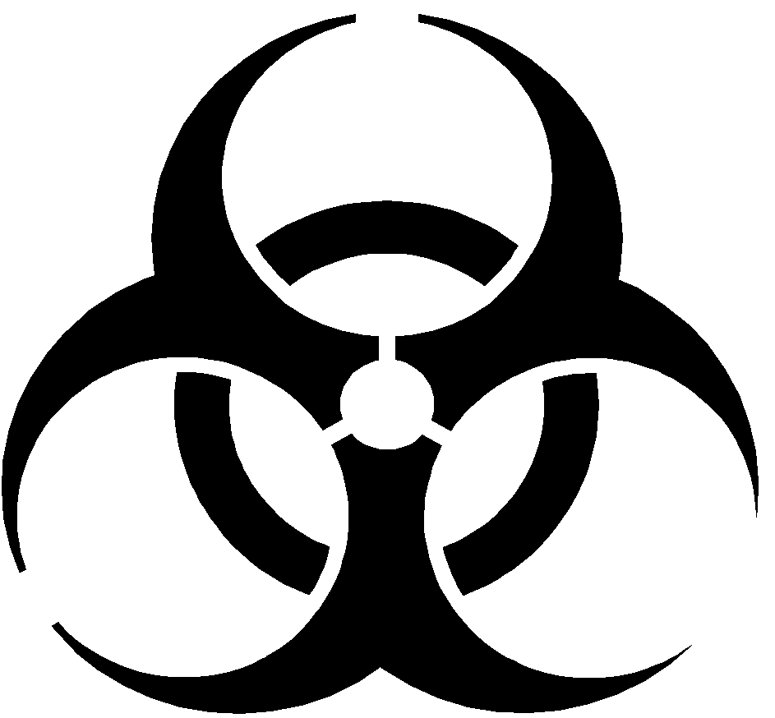

BIOHAZARD

BIOSAFETY LEVEL
2

Principal Investigator(s):
Agent (s):

Bldg: Room:

Special Instructions/ Requirements Prior to Entry or Exit:

Personnel will wear a closed front gown, face shield, and double pair of gloves for active work areas (areas not designated as clean by signage).
Access to active work areas limited to authorized users only.

REMOVE PPE AND WASH HANDS BEFORE LEAVING THE WORK AREA.
EMERGENCY CONTACT | CONTACT | WORK PHONE | ALTERNATIVE PHONE
PRIMARY
SECONDAY

Signature Page:

Standard Operating Procedure for Safe Handling of
SARS-CoV-2/COVID-19 specimens at BSL2 + enhanced containment

“I have read and understand this SOP. I agree to fully adhere to its requirements.”

