Danger! Releases HF! |  |  | Duke OESO Guidelines for Safe Use of  PMSF and other HF releasers  Covers: phenylmethylsulfonyl fluoride & other compounds listed below  Complete Lab-Specific Safety Information on page 2 |  | Danger! Releases HF!
Hazards | Potential Hazards | - Phenylmethanesulfonyl fluoride (PMSF), p-toluenesulfonyl fluoride, Sodium Fluoride (NaF), Potassium Fluoride (KF), and other fluoride compounds can release hydrogen fluoride (HF) in contact with acids and sometimes water (PMSF).  - HF is fatal in contact with skin, or if inhaled or swallowed. Causes severe skin and eye burns.  - PMSF hydrolyzes upon exposure to water liberating a toxic, acidic gas which, in contact with metal surfaces, can generate flammable and/or explosive hydrogen gas.  - HF Exposure limits: ACGIH TLV – 2 ppm ceiling, 0.5 ppm average over 8 hrs. OSHA PEL: 3 ppm.  - For more information, see the SDS, the PubChem Information for PMSF (or applicable compounds) and the Duke Guideline for Safe Use of Hydrofluoric Acid.
Hazard Controls | Selection & Purchase | - Purchase the smallest, shatter-resistant containers at the lowest concentration practical.  - Buy calcium gluconate gel for first aid for HF burns, and check expiration date regularly.  - Consider alternate methods such as Pefabloc SC, Halt cocktail, or other protease inhibitor instead of PMSF, or less hazardous compounds in lieu of other HF releasers.
 | Storage & Transport | - Store in compatible (e.g., polyethylene) primary and secondary containers.  - If making aqueous or acidic solutions DO NOT use glass containers – HF acid etches glass.  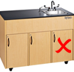  - Keep the primary container tightly closed.  - Store in a dry area away from acids.  - Store in secondary containment in a well-ventilated area.  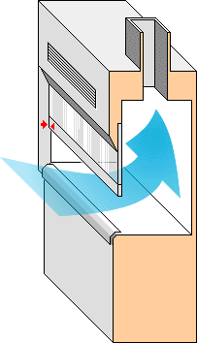  - Store below eye level but not on the floor.
 | Engineering Controls | - Eyewash is required in immediate work area. Safety shower required for work with > 200ml stock solution.  - Handle powders and concentrated solutions in a clean chemical fume hood. |  | 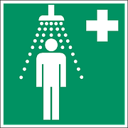
 | Work Practice Controls | - Use page 2 to create a lab-specific SOP. For PMSF get PI approval.  - Have an area in the laboratory that is designated and marked for HF releaser use.  - Keep PMSF and HF releasers away from acids and water/moisture. Use with DMSO is highly discouraged.  - DO NOT use glass, ceramic, or other incompatible containers if HF may be released.  - Once work is complete, decontaminate the area by wiping with a 10% sodium carbonate (Na₂CO₃, also known as soda ash) solution.
 | Personal Protective Equipment  (PPE) | 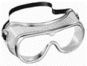  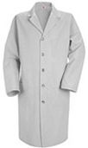  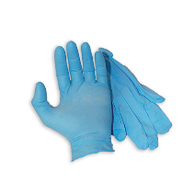  - Wear closed-toed shoes and clothing covering the legs.  x2  - Minimum PPE (See Duke HF acid guideline for spill PPE):  - Buttoned lab coat  - Safety goggles  - Double nitrile gloves (Change immediately if splashed) - Check compatibility with solvents  - Wash hands at time of glove change.
Other | Emergencies | - Use the Duke Guideline for Safe Use of Hydrofluoric Acid emergencies section if there is a medical emergency or spill. A Hydrofluoric Acid First Aid Guide is also available.  - DO NOT USE WATER to clean up spills! Use 10% sodium carbonate solution.  - See Emergency Response webpage or flip chart and/or lab specific chemical hygiene plan.
 | Waste | See lab-specific chemical hygiene plan, Lab Chemical Waste Management Practice, and Drain Disposal Practice. Do not combine with waste that contains incompatible chemicals such as water, oxidizing agents, strong bases, acids, and aqueous solutions.
 | Training | Sign signature page in lab-specific chemical hygiene plan to indicate review.
 | Questions | Contact OESO Lab Safety at 919-684-8822 or labsafety@dm.duke.edu.

Lab-Specific Safety Information for
PMSF and HF releasers
Supplements the Guidelines for Safe Use
Danger! Releases HF!
Danger! Releases HF!
of PMSF and HF releasers
PI signature is required for PMSF. OESO approval is not needed if using this Guideline.
Lab Info | PI Name | Click or tap here to enter PI Name |  | PI Signature:  Date: Click or tap to enter a date.
 | Location | Enter building(s) and room(s) where lab is located
Lab-Specific Hazard Controls  Lab-Specific Hazard Controls, continued | Purchase  Details | Specific HF releaser present | Enter HF releaser name | Enter HF releaser name | Enter HF releaser name
 |  | Maximum container size | Enter maximum container size purchased | Enter maximum container size purchased | Enter maximum container size purchased
 |  | Maximum concentration | Enter maximum concentration purchased | Enter maximum concentration purchased | Enter maximum concentration purchased
 |  | Container type | Enter the container material | Enter the container material | Enter the container material
 |  | Specific product info. | Enter supplier name/product number, purity/grade, liquid vs. powder. | Enter supplier name/product number, purity/grade, liquid vs. powder. | Enter supplier name/product number, purity/grade, liquid vs. powder.
 | Storage | Specific location | Enter specific storage location | Enter specific storage location | Enter specific storage location
 | Use Information | Designated work area (specific room(s) and area(s)) | Enter rooms and areas designated for use |  |  | Label work area!
 |  | Container type to use | Type of container in which HF releasers are used or stored in the lab |  |  | No Glass  For Aqueous Solutions!
 |  | Maximum quantity | Enter maximum quantity to be used at a time | Enter maximum quantity to be used at a time | Enter maximum quantity to be used at a time
 |  | Typical concentration used | Enter typical concentration used | Enter typical concentration used | Enter typical concentration used
 |  | Solvent (and gloves) to be used.  DMSO is highly discouraged | List solvent and provide type of gloves to be used | List solvent and provide type of gloves to be used | List solvent and provide type of gloves to be used
 |  | PPE Storage Location | Location of PPE supplies.
 |  | Location of supplies  for decontamination and spill clean-up | Location of 10% sodium carbonate solution and other spill supplies..
 | Exposure Response | Calcium Gluconate Location | Location of calcium gluconate gel for first aid use.
 | Waste Information | Details about waste (location, type of containers) | Enter waste collection details – location, type of container |  |  | Don’t mix with Aqueous Solutions!
 | Details of Process | - Enter steps used in lab process(es) or experiment(s)

