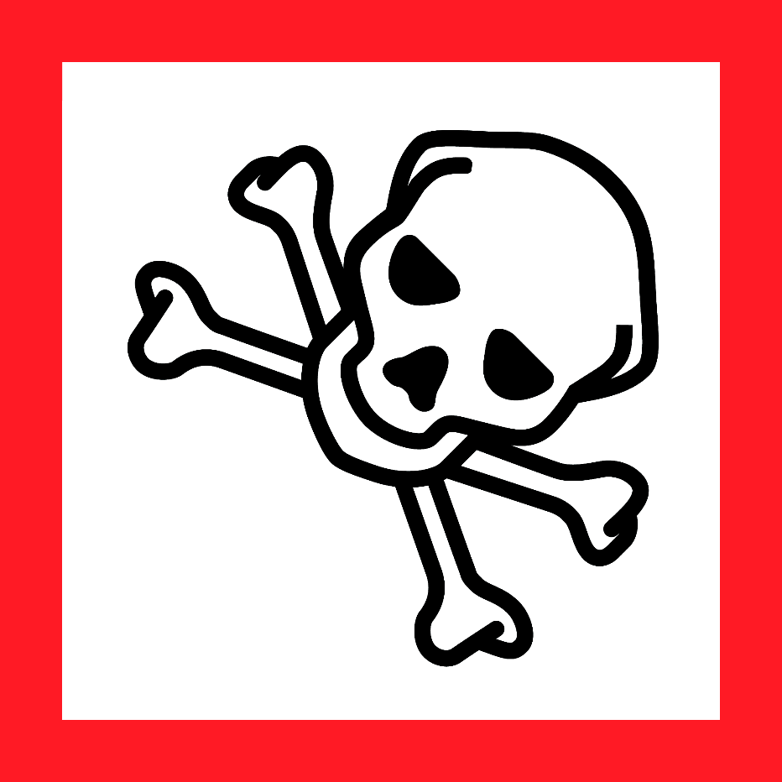
Duke OESO Guidelines for Safe Use of
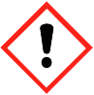
Toxic & Health Hazard Liquids
Examples: carbon tetrachloride, glutaraldehyde solution (complete p.2 for ≥10%);
also flammable: methanol, carbon disulfide, n-hexane, xylene
Hazards |  | Potential Hazards |  | - Exposure to toxic & health hazard liquids can occur through the skin (possibly after penetrating gloves), inhalation of vapors or aerosols, or by accidental ingestion or injection.  - Acutely toxic liquids can cause death or systemic toxicity.  - Exposure can also cause health hazards (such as cancer, reproductive effects, mutations, respiratory or skin sensitization, and organ damage) and/or irritation of the eyes, skin, or respiratory system.  - Some liquids may also have physical hazards (not covered by these guidelines).  - See Safety Data Sheet (SDS) for specific hazard information.  - Create a lab SOP with specific decontamination methods for particularly hazardous liquids.
Hazard Controls |  | Selection & Purchase |  | - Purchase the smallest containers at the lowest concentration practical.  - Purchase in shatter-resistant containers if available (such as plastic or PVC-coated glass).  - Purchase gloves not quickly penetrated by the liquid for cleaning up small spills.
 |  | Storage & Transport |  | 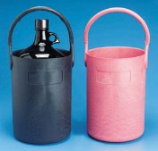  - Store below eye level but not on the floor, in a cabinet or on a shelf in a well-ventilated room. Do not store in cold rooms.  - Keep toxic liquids away from incompatible materials (see SDS for specifics).  - Organic materials away from oxidizers.  - See other guidelines for storage of flammbles, oxidizers, or corrosives.  - Transport toxic and health hazard liquids in a bottle carrier.
 |  | Engineering Controls |  | - Use a chemical fume hood with particularly hazardous and other odorous or volatile hazardous liquids when: |  |  |  |  |  | 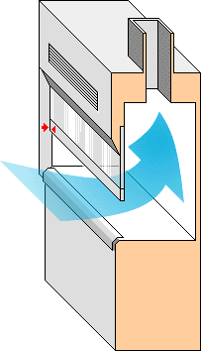
 |  |  |  | - Heating the liquid AND/OR |  |  | - Working with open containers
 |  |  |  | - Check with OESO to determine if small quantities or dilute solutions of toxic or health hazard liquids can be handled safely on the benchtop.
 |  | Work Practice Controls |  | - Designate a specific work area for particularly hazardous liquids and label it.  - Line work area with absorbent, leak-proof bench pads.  - Use in the smallest practical quantities for work being done.  - Plan work to avoid contact with gloves*. Change gloves immediately if contaminated.  - Change gloves* at least every 2 hours and wash hands at time of glove change.  - Decontaminate work area with an appropriate solvent or a solution of detergent and water.
 |  | Personal Protective Equipment  (PPE) |  | Minimum PPE:  - Nitrile gloves*  - Safety glasses  - Fastened lab coat |  | 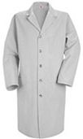  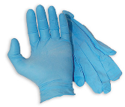  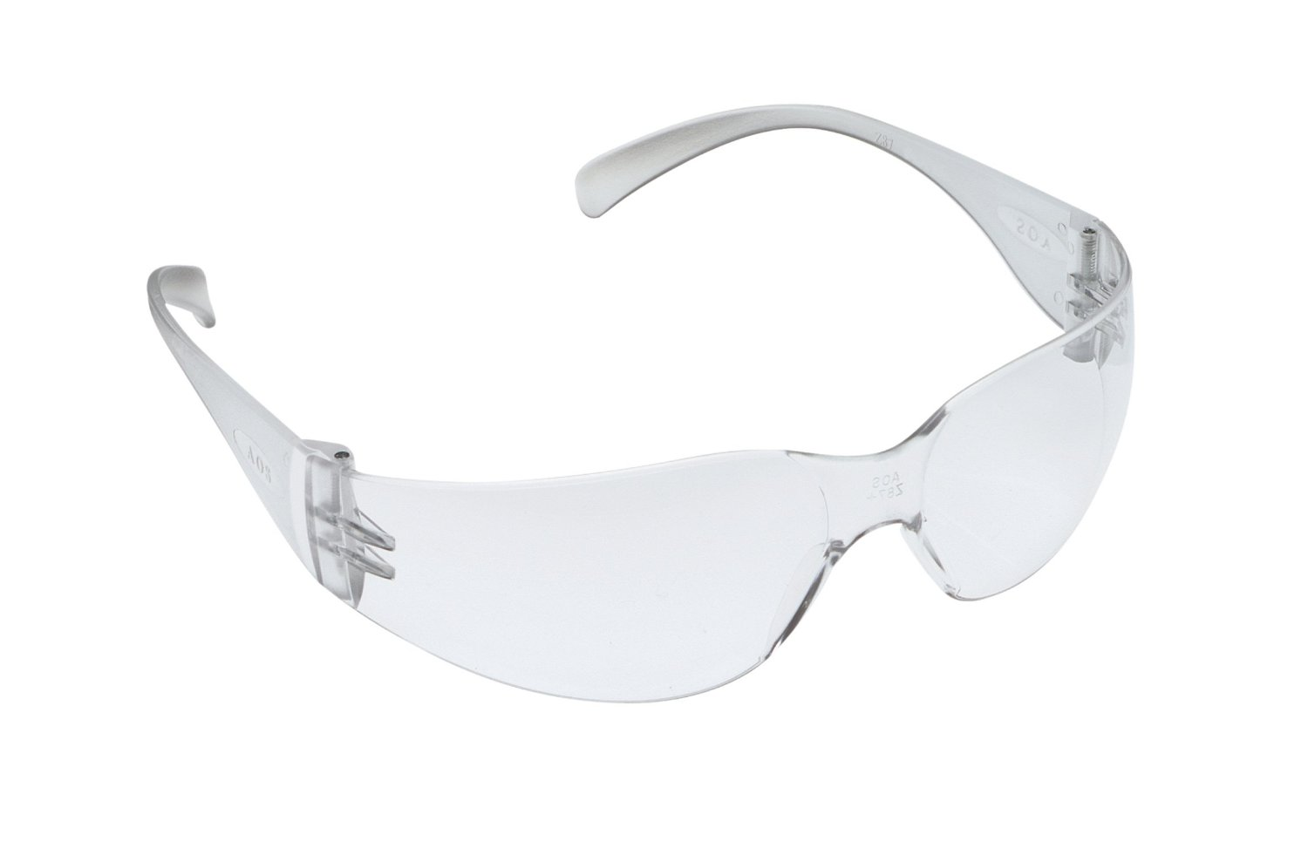 |  |  | If “fatal in contact with skin”: 2 pairs nitrile gloves or better*
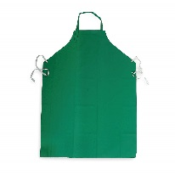
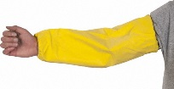
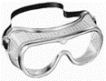
Risk of splash/large amounts, ADD:
- Goggles (and consider a face shield)
- Impervious sleeves and apron (or coverall)
 |  |  |  | *Check the manufacturer’s glove guide or SDS for glove breakthrough time.
Other  03-8-2023. Online with links at https://www.safety.duke.edu/chemical-hygiene/chemical-sops. |  | Emergencies |  | See Emergency Response webpage, Flip Chart, and/or lab specific chemical hygiene plan.
 |  | Waste |  | See lab-specific chemical hygiene plan, Lab Chemical Waste Management Practice, and Drain Disposal Practice.
 |  | Training |  | Sign signature page in lab-specific chemical hygiene plan to indicate review.
 |  | Questions |  | Contact OESO Laboratory Safety at 919-684-8822 or labsafety@duke.edu.
Lab-Specific Safety Information for
Toxic & Health Hazard LIQUIDS
Supplements the Guidelines for Safe Use of Toxic & Health Hazard Liquids
Lab | PI Name |  | Click or tap here to enter PI Name
 | Location |  | Enter building(s) and room(s) where lab is located
Notes for using this Guideline: ONLY for use with chemicals that meet ALL of the following criteria:
- Action B or C (NOT Action A) as determined by the GHS Lookup Tool or Action Matrix & SDS for your product.
- ONLY have HEALTH hazards in any of these classifications: acutely toxic (inhalation, dermal, and/or oral), carcinogens, mutagens, reproductive hazards, respiratory/skin sensitizers, irritants, corrosive to skin/eyes, and/or specific target organ toxicity.
If the chemical is flammable, corrosive, and/or an oxidizer, attach the appropriate guideline(s) to this completed toxic liquids guideline.
If the chemical has other physical hazards (reacts violently with water, contact with acid forms toxic gas, etc.) in addition to the health hazards, you must use this OESO SOP template to create a separate lab-specific SOP.
For Action A chemicals, use this OESO SOP template to create a lab-specific SOP – it must be approved by the PI and, in many cases, by OESO.
Lab-Specific Hazard Controls | Chemical Information |  | Chemical Name |  | Chemical 1  Enter Chemical Name |  |  | Chemical 2  Enter Chemical Name | Chemical 3  Enter Chemical Name
 |  |  | CAS Number |  | Enter CAS Number |  |  | Enter CAS Number | Enter CAS Number
 |  |  | GHS Hazard Classes and Categories  (If flammable, corrosive, or an oxidizer, check the appropriate box(es) at right and refer to the relevant guideline(s) as well.) |  | Enter All GHS Hazard Classes and their Category (e.g. Carcinogenicity, Category 1A)  ☐ Particularly Hazardous  ☐ Flammable Guideline  ☐ Corrosive Guideline ☐ Oxidizer Guideline |  |  | Enter All GHS Hazard Classes and their Category (e.g. Carcinogenicity, Category 1A)  ☐ Particularly Hazardous  ☐ Flammable Guideline  ☐ Corrosive Guideline ☐ Oxidizer Guideline | Enter All GHS Hazard Classes and their Category (e.g. Carcinogenicity, Category 1A)  ☐ Particularly Hazardous  ☐ Flammable Guideline  ☐ Corrosive Guideline ☐ Oxidizer Guideline
 | Purchase  Details |  | Maximum container size |  | Enter maximum container size purchased |  |  | Enter maximum container size purchased | Enter maximum container size purchased
 |  |  | Container type |  | Enter the container material |  |  | Enter the container material | Enter the container material
 |  |  | Specific product information |  | Enter supplier name/product number or purity/grade to purchase |  |  | Enter supplier name/product number or purity/grade to purchase | Enter supplier name/product number or purity/grade to purchase
 | Storage |  | Specific location |  | Enter specific storage location |  |  | Enter specific storage location | Enter specific storage location
 |  |  | Special storage requirements |  | Enter any special storage requirements |  |  | Enter any special storage requirements | Enter any special storage requirements
 | Use Information |  | Designated work area (specific room(s) and area(s)) if particularly hazardous  LABEL WORK AREA |  | Enter rooms, fume hoods, BSCs, or other areas designated for use |  |  | Enter rooms, fume hoods, BSCs, or other areas designated for use | Enter rooms, fume hoods, BSCs, or other areas designated for use
 |  |  | Maximum quantity |  | Enter maximum quantity to be used at a time |  |  | Enter maximum quantity to be used at a time | Enter maximum quantity to be used at a time
 |  |  | Typical concentration used |  | Enter typical concentration used |  |  | Enter typical concentration used | Enter typical concentration used
 |  |  | Specific Glove Information  USE APPROPRIATE GLOVES  *check SDS or glove guide |  | ☒ 1 pair of 4 mil Nitrile gloves  ☐ 2 pairs of 4 mil Nitrile gloves  ☐ 1 pair of Neoprene gloves  ☐ Specify type(s) of gloves if not nitrile or neoprene |  |  | ☒ 1 pair of 4 mil Nitrile gloves  ☐ 2 pairs of 4 mil Nitrile gloves  ☐ 1 pair of Neoprene gloves  ☐ Specify type(s) of gloves if not nitrile or neoprene | ☒ 1 pair of 4 mil Nitrile gloves  ☐ 2 pairs of 4 mil Nitrile gloves  ☐ 1 pair of Neoprene gloves  ☐ Specify type(s) of gloves if not nitrile or neoprene
 |  |  | Other Required PPE |  | ☒ Standard Lab Coat  ☒ Chemical Splash Goggles  ☐ Other PPE Needed |  |  | ☒ Standard Lab Coat  ☒ Chemical Splash Goggles  ☐ Other PPE Needed | ☒ Standard Lab Coat  ☒ Chemical Splash Goggles  ☐ Other PPE Needed
 |  |  | PPE Storage Location |  | Specific PPE storage location |  |  | Specific PPE storage location | Specific PPE storage location
 |  |  | Work Area Decontamination  (must be completed for Particularly Hazardous chemicals) |  | Work area decontamination supply type and location. Include any special PPE needed. |  |  | Work area decontamination supply type and location. Include any special PPE needed. | Work area decontamination supply type and location. Include any special PPE needed.
 |  |  | Location & type of spill clean-up supplies  (including glove type needed for spills) |  | Spill supply type and location. |  |  | Spill supply type and location. | Spill supply type and location.
 | Waste Disposal |  | Chemical Waste Information |  | Enter location of waste container, type of container used. |  |  | Enter location of waste container, type of container used. | Enter location of waste container, type of container used.
 | Details of Process for Chemical 1 |  | - Click or tap here to enter details specific to your lab’s process with Chemical 1.
 | Details of Process for Chemical 2 |  | - Click or tap here to enter details specific to your lab’s process with Chemical 2.
 | Details of Process for Chemical 3 |  | - Click or tap here to enter details specific to your lab’s process with Chemical 3.

