Duke OESO Guidelines for Safe Use of
STENCH!
STENCH!
β-mercaptoethanol (2-ME)
Complete Lab-Specific Safety Information on page 2.
Hazards | Potential Hazards | - Fatal in contact with skin, category 2 and therefore Particularly Hazardous. Rapidly absorbed through skin. Toxic if inhaled or ingested.  - Low odor threshold (0.12-0.64 ppm). Very unpleasant stench similar to odorant in natural gas. Misuse or spill may cause suspicion of natural gas leak.  - May cause allergic skin reaction. Causes eye damage and skin irritation.  - May cause liver or heart damage with repeated oral exposure.
Hazard Controls | Selection & Purchase | - Purchase the smallest, shatter resistant containers, at the lowest concentration feasible.  - Consider alternate methods and use a less hazardous substance if possible.  - Purchase butyl or laminate gloves for clean-up of small spills.
 | Storage & Transport | - Store away from metals, oxidizers, and any other incompatibles.  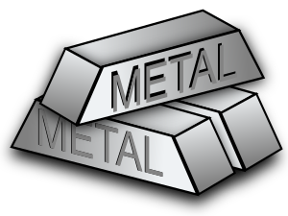  - Storage container must be tightly closed, resealed and stored upright.  - Store in sealed secondary container in a well ventilated area (not in a cold room). Do not store on the floor.
 | Engineering Controls | 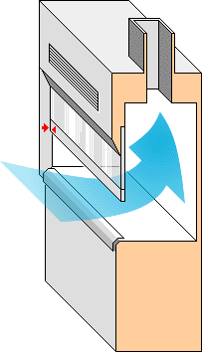  - Always work with 2-ME in a chemical fume hood or 100% exhausted biological safety cabinet (Class II, Type B2). |  | 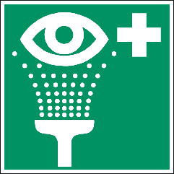  - Eyewash required in immediate work area. Eyewash-drench hose preferred.
 | Work Practice Controls | - Work with the smallest practicable amount for the experiment being performed.  - Designate a specific work area for 2-ME (within a hood or exhausted BSC) and label it.  - Keep containers closed as much as possible when not in use.  - Plan work to avoid glove contact.  - Clean work area & reusable equipment with soap, water and paper towels; dispose of paper towels as chemical waste. If stench remains, neutralize with an aqueous solution of sodium hypochlorite (bleach).
 | Personal Protective Equipment  (PPE) | 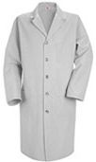  - Wear closed-toed shoes and clothing covering the legs.  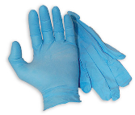  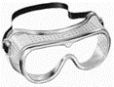  - Minimum PPE:  x2  - Buttoned lab coat  - Safety goggles  - TWO pairs nitrile gloves.  - Change gloves immediately if splashed. |  |  | 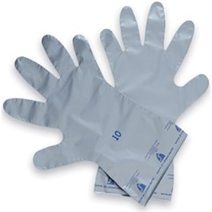  If glove contact is expected  or
 |  | - Risk of splash: ADD: chemical resistant sleeves & apron, face shield, and laminate or butyl gloves. | 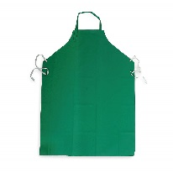  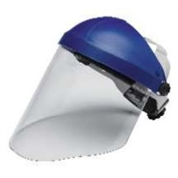  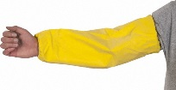  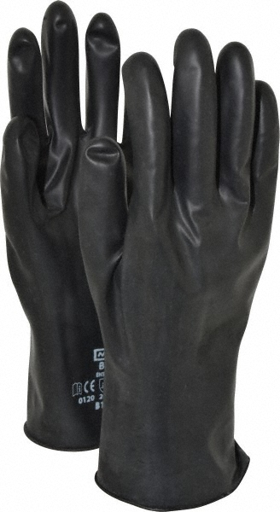
Other | Emergencies | - See Emergency Response webpage or flip chart and/or lab specific chemical hygiene plan.  - For clean-up of small (<10 ml) spills confined to the chemical fume hood, wear butyl or laminate gloves & other PPE noted above. Clean up with inert absorbent materials (i.e., vermiculite, dry sand). Clean spill area as indicated in Work Practice Controls section. Contaminated PPE and clean-up materials must be double-bagged and tightly sealed. Dispose as chemical waste.  - Other spills: Contact OESO Spill Response Team via Duke Police.
 | Waste | Store accumulating waste in hood until picked up by OESO. See also lab-specific chemical hygiene plan, Lab Chemical Waste Management Practice, and Drain Disposal Practice.
 | Training | Sign signature page in lab-specific chemical hygiene plan to indicate review.
 | Questions | Contact OESO Lab Safety at 919-684-8822 or labsafety@dm.duke.edu.

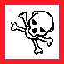  STENCH! |  | Lab-Specific Safety Information for  β-mercaptoethanol (2-ME)  Supplements the Guidelines for Safe Use of 2-ME |  |  | STENCH!
Lab | PI Name | Click or tap here to enter PI Name
 | Location | Enter building(s) and room(s) where lab is located
Lab-Specific Hazard Controls | Purchase  Details | Maximum container size | Enter maximum container sized purchased
 |  | Maximum concentration | Enter maximum concentration purchased
 |  | Container type | Enter the container material
 |  | Specific product information | Enter supplier name/product number or purity/grade to purchase
 | Storage | Specific location | Enter specific storage location | Not in a cold room!
 | Use Information | Designated work area  (specific room(s) and area(s)) | Enter rooms and areas designated for use
 |  | Maximum quantity | Enter maximum quantity to be used at a time
 |  | Location of supplies for decontamination | Bleach: Enter location of bleach  Paper Towels: Enter location of paper towels
 |  | Location of supplies for small spill clean-up  (Use decon supplies if needed) | ☐Laminate gloves: Location of Laminate Gloves (i.e. SilverShield)  ☐Butyl gloves: Location of butyl gloves  Location & Type of inert absorbent: Location of vermiculite or dry sand
 | Details of Process | - Enter steps used in lab process(es) or experiment(s)

