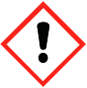
Duke OESO Guidelines for Safe Use of
Acrylamide
Complete Lab-Specific Safety Information on page 3
Hazards | Potential Hazards | - Acrylamide is used for polyacrylamide gel electrophoresis and to aid in DNA precipitation.  - Acrylamide is a Particularly Hazardous Substance because it is a probable human carcinogen.  - The OSHA Permissible Exposure Limit (PEL) for acrylamide is 0.3 mg/m³ for an 8-hr workday.  - ACGIH has a Threshold Limit Value (TLV) of 0.03 mg/m³ (0.01 ppm).  - Possible routes of exposure include inhalation, skin contact, eye contact, and ingestion.  - Acrylamide is highly toxic by inhalation and skin contact. It can easily penetrate intact skin.  - Acrylamide is known to affect the nervous system, with early signs of exposure including numbness, tingling, and tenderness to touch. Symptoms can be delayed several days to weeks, and if exposure continues (even in small quantities), other symptoms may arise including excessive sweating, blue-reddish skin, peeling of skin, and weakness in limbs.  - Acrylamide may cause sensitization by contact with skin.  - Animal studies have shown maternal and paternal reproductive health effects from exposure to acrylamide.  - Acrylamide may polymerize explosively if heated over 183°F (84°C) or when exposed to UV.  - Consult the Laboratory Chemical Safety Summary for acrylamide for additional hazard info.
Hazard Controls | Selection & Purchase | - Use a safer alternative when possible (pre-cast polyacrylamide gels or pre-made solution).  - Purchase the smallest containers at the lowest concentration needed for work.
 | Storage & Transport | 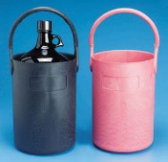  - Acrylamide must be in sealed, shatter-resistant containers during transportation.  If the container is not shatter-resistant, use a secondary container,  preferably a polyethylene or other non-reactive bottle carrier.  - Store in secondary containment in a well-ventilated area, away from heat and flame.  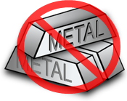  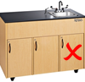  - Store away from incompatibles such as metals, oxidizing agents,  reducing agents, acids, bases, and peroxides.  - Store away from metals and do not store under the sink.  - Store below eye level but not on the floor.
 | Engineering Controls | 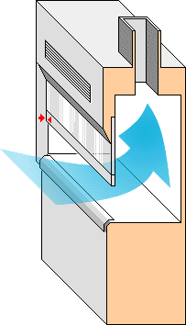  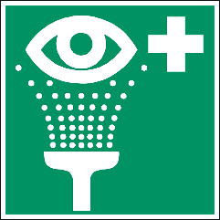  - Acrylamide (and suspensions/solutions) must be handled  in a chemical fume hood, exhausted biological safety cabinet  with negative pressure ductwork, or other exhausted enclosure.  - Work in a clean hood that is free of incompatibles (listed above).  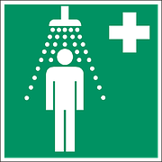  - Aerosols may be produced during any open handling of dry powder,  and during open or pressurized manipulations of suspensions.  It is recommended that labs post this information sheet on  Working Safely with Toxic Powders.  - Eyewashes and safety showers are required in immediate work areas.
 | Work Practice Controls | - When possible, order pre-cast polyacrylamide gels to avoid work with acrylamide powder. Acrylamide can also be ordered already in solution. Avoiding acrylamide powder significantly reduces risks.  - Use bench pads to cover areas that may become contaminated with acrylamide powder or suspensions for easy clean-up.  - Avoid contact with incompatible materials including metals, oxidizing agents, reducing agents, acids, bases, and peroxides.  - Change gloves regularly (at least every 2 hours) and wash hands at the time of glove change.  - Keep containers closed when not actively dispensing acrylamide.  - Keep away from heat and flame.  - If weighing dry acrylamide powder, place balance in chemical fume hood OR  - Tare (pre-weigh) an empty container with a lid.  - Go to chemical fume hood, add powder to the empty container, and close the lid.  - Go to the balance to weigh the container.  - Return to chemical fume hood to make solution or manipulate powder.  - Wipe down surfaces where acrylamide is used with a detergent and water solution. To fully decontaminate surfaces, use a 1.6% potassium persulfate solution followed by 1.6% sodium metabisulfite. Let it stand for 30 minutes, then wipe down with plenty of water.
 | Personal Protective Equipment  (PPE) | - Wear closed-toed shoes and clothing covering the legs.  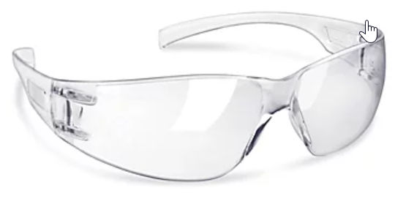  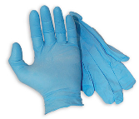  - Minimum PPE:  - Extended cuff nitrile gloves  - Lab coat  - Chemical safety glasses  Ensure there is no exposed skin between labcoat cuffs and gloves!  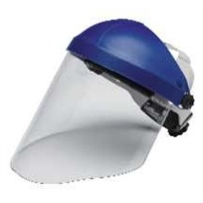  - If gloves are splashed or come in contact with acrylamide,  change gloves as soon as possible.  - Change gloves regularly (at least every 2 hours) and  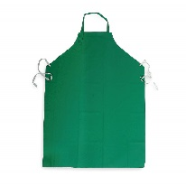  wash hands at the time of glove change.  - When handling suspensions/solutions, choose a glove  that is protective against the solvent.  - Risk of splash / large amounts (in addition to the above, wear):  - Butyl gloves (such as these from Uline), or double nitrile  - Chemical splash goggles and face shield  - Tyvek sleeves and/or a chemically resistant gown | 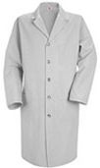  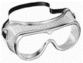  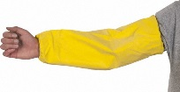  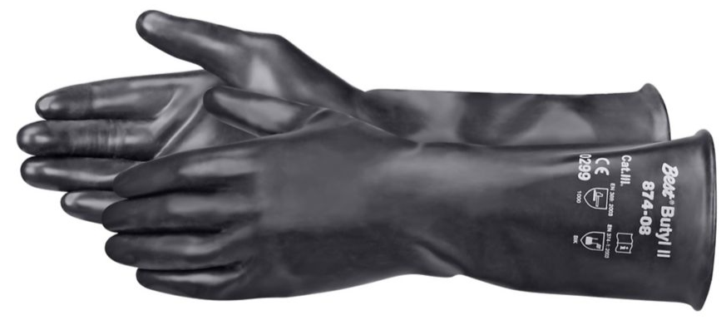
Other | Medical Emergencies | - See Emergency Response Guide and/or lab-specific chemical hygiene plan.  - For eye/skin exposure, flush with water for at least 15 min, then seek medical attention.  - If there is respiratory irritation with exposure, remove all persons from contaminated area and contact the OESO spill team by calling 911 from a campus phone or Duke Police at  919-684-2444 from any phone to request assistance.  - Contact Employee Occupational Health and Wellness (EOHW) at 919-684-8115 to report an exposure and obtain medical advice.  - For medical advice without exposure, call 919-684-3136.
 | Spills | - Spills of dry acrylamide powder outside of a chemical fume hood should be referred to the OESO spill response team (call 911 from a campus phone, or 919-684-2444 from any phone).  - Spills of dry acrylamide powder inside of a chemical fume hood should be wiped up using a cloth dampened with water, or wet the powder with water and then wipe with a dry cloth. Minimize the fume hood or enclosure opening during this process. Decontaminate the area with the solutions mentioned in the Work Practice Controls section. Place any clean-up materials into a bag and seal, then submit as hazardous chemical waste (see waste section below) through OESO Environmental Programs (call 919-684-2794 with questions).  - Spills of liquid forms of acrylamide should be absorbed with spill pads or other  non-combustible absorbent material and placed in containers for disposal.  - Once spill is cleaned, decontaminate the area as instructed above in Work Practice Controls.
 | Waste | - Unwanted acrylamide (and suspensions) must be disposed of following your laboratory-specific chemical hygiene plan, Duke University’s Chemical Waste Policy and the Laboratory Chemical Waste Management Practices.
 | Training | - Sign the signature page in the lab-specific chemical hygiene plan to indicate review.  - All personnel should also read and fully adhere to the lab-specific SOP for Toxic Powders.
 | Questions | - Contact OESO Lab Safety at 919-684-8822 or labsafety@duke.edu

Lab-Specific Safety Information for
ACRYLAMIDE
Supplements the Guidelines for Safe Use of Acrylamide
Lab | PI Name | Click or tap here to enter PI Name
 | Location | Enter building(s) and room(s) where lab is located
Lab-Specific Hazard Controls | Purchase  Details | When possible, order pre-cast polyacrylamide gels (or acrylamide solution) to avoid working with acrylamide powder. Avoiding work with acrylamide powder significantly reduces risks.
 |  | Maximum container size | Enter maximum container size purchased | Maximum container size
 |  | Maximum  concentration | Enter maximum concentration purchased | Order pre-cast polyacrylamide gels or acrylamide solution to avoid working with powder when possible.
 |  | Container type | Enter the container material
 |  | Specific product information | Enter supplier name/product number or purity/grade to purchase
 | Storage | Specific location | Enter rooms and areas designated for storage
 | Use Information | Designated work area  (specific room(s) and area(s)) | Enter rooms and areas designated for use | Handle powders and solutions in a chemical fume hood!
 |  | Maximum quantity | Enter maximum quantity to be used at a time
 |  | PPE Storage Location | Enter location where specific PPE is stored (e.g. extended cuff nitrile gloves, labcoat, chemical safety glasses and/or goggles, chemically resistant sleeves or apron, butyl gloves, etc.)
 |  | Decontamination method | Specify decontamination method:  ☐ Wipe down surfaces with a detergent and water solution.  ☐ Wipe down surfaces with 1.6% potassium persulfate solution, followed by 1.6% sodium metabisulfite solution. Let stand for 30 minutes, then wipe down with plenty of water.
 |  | Location of supplies for decontamination  (or spill clean-up) | Enter location of decontamination materials mentioned above, as well as any necessary spill supplies (e.g., cloth or paper towels, spill pads or absorbent material, etc.)  Dispose of used decon and/or clean-up materials as chemical waste.
 | Waste Information | Details about waste (location, type of container) | Enter location of waste container, type of container used
 | Details of Process | Enter steps used in lab process(es) or experiment(s)

