Duke OESO Guidelines for Safe Use of
Ethidium Bromide
AKA EtBr: Commonly used as a fluorescent marker in electrophoresis
Complete Lab-Specific Safety Information on page 2.
Hazards | Potential Hazards | - Ethidium Bromide, an odorless solid, is fatal if inhaled. It is therefore Particularly Hazardous.  - Ethidium bromide is a mutagen and is harmful if swallowed.  - Consult the Safety Data Sheet (SDS) and Laboratory Chemical Safety Summary.
Hazard Controls | Selection & Purchase | - Use a safer alternative when possible.  - Purchase the smallest containers at the lowest concentration practical.
 | Storage & Transportation | 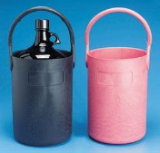  - Store/transport powder and solutions in sealed shatter-resistant containers.  - Secondary containment is advised for transport.  - Store away from strong oxidizing agents in a cool, dry place.
 | Engineering Controls | - Work in a chemical fume hood (or other exhausted enclosure) if aerosols could be created, including for:  - Open containers of dry powder  - Open or pressurized manipulations of suspensions/solutions. |  | 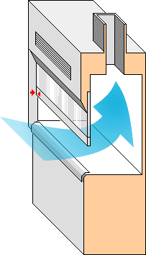 | - An eyewash or eyewash/drench hose is strongly recommended in the immediate work area. |  |  | 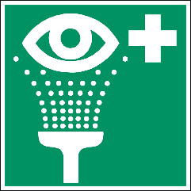
 | Work Practice Controls | - Label designated work area “Ethidium Bromide in use. Mutagen and toxic.” Post this Guideline nearby.  - Line the work area with a disposable plastic-backed absorbent pad.  - Keep containers closed as much as possible.  Ethidium Bromide Work Area  Danger!  Toxic! Mutagen!  - If weighing dry powders, place balance in hood OR  - Tare (pre-weigh) an empty container with a lid.  - Go to hood, add powder to container, close lid.  - Go to balance to weigh.  - Return to hood to make solution or manipulate powder.  - Check the work area for contamination using a UV light. If decontamination is needed, wipe up any excess liquid with paper towels then use either of the methods below.
 |  | - Wipe surface six times with wet paper towels.  OR | - Wet surface with ethanol. Sprinkle activated charcoal on top. Wipe up paste with paper towel.
 |  | - All decontamination materials must be disposed of as hazardous waste.
 | Personal Protective Equipment | 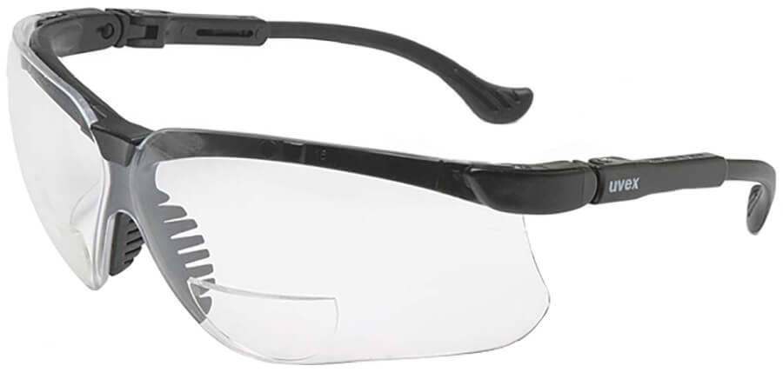  Minimum PPE:  - Safety glasses  - Nitrile gloves (Change Immediately if contaminated & every 2 hours. Wash hands at time of change)  - Fully buttoned lab coat with sleeves extending to the wrists. |  |  |  | 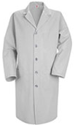  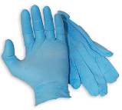
 |  | 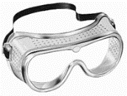  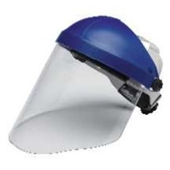  Risk of splash/large amounts: (in addition to the above, wear)  - Goggles and a face shield.  - A 2nd pair of nitrile gloves  - Sleeves or gown impermeable to powders |  |  |  | 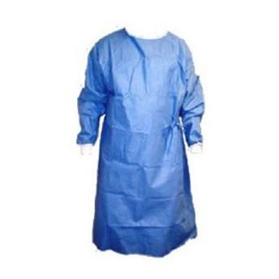  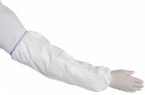
 |  | Check the manufacturer’s glove guide for glove effectiveness if using a solvent other than water.
Other | Emergencies | See Emergency Response Flip Chart and/or lab specific chemical hygiene plan.
 | Waste | See the Information Sheet on Disposal of Ethidium Bromide Waste.
 | Training | Sign signature page in lab-specific plan to indicate review.
 | Questions | Contact OESO Lab Safety at 919-684-8822.

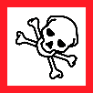 |  | Lab-Specific Safety Information for  Ethidium Bromide  Supplements the Guidelines for Safe Use of Ethidium Bromide
Lab | PI Name | Click or tap here to enter PI Name
 | Location | Enter building(s) and room(s) where lab is located
Lab-Specific Hazard Controls | Purchase  Details | Maximum container size | Enter maximum container sized purchased
 |  | Maximum concentration | Enter maximum concentration purchased
 |  | Container type | Enter the container material
 |  | Specific product information | Enter supplier name/product number or purity/grade to purchase
 | Storage | Specific location | Enter rooms and areas designated for use
 | Use Information | Designated work area  (specific room(s) and area(s)) | Enter rooms and areas designated for use
 |  | Maximum quantity | Enter maximum quantity to be used at a time
 |  | Decontamination method | ☐Wipe surface six times with wet paper towels  OR  ☐(Remove hot surfaces & sources of sparks/flame.) Wet surface with ethanol. Sprinkle activated charcoal on top. Wipe up paste with paper towel.  Dispose of used decontamination materials as chemical waste.
 |  | Location of supplies for decontamination  (or spill clean-up) | Enter location of decontamination supplies
 | Details of Process | - Enter steps used in lab process(es) or experiment(s)

