
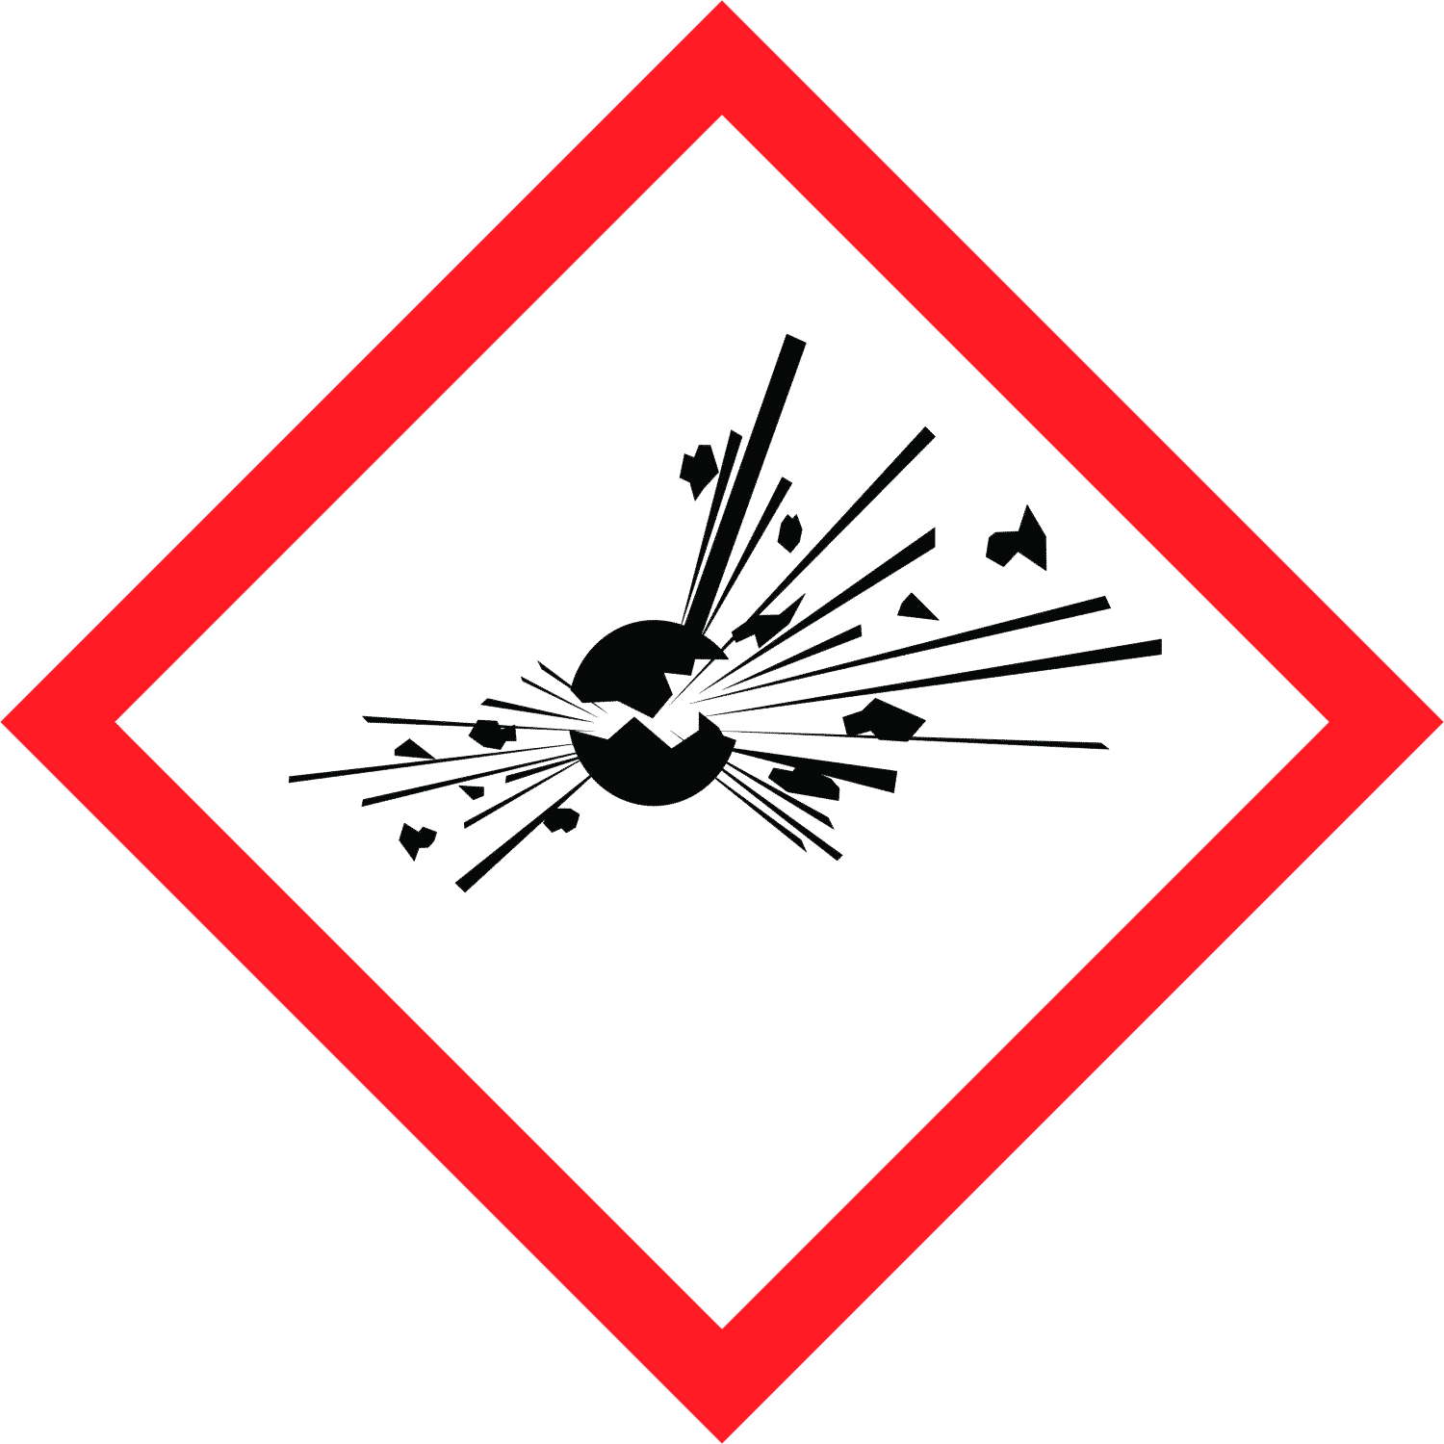

Duke OESO Guidelines for Safe Use of
Picric Acid
and Picric acid containing solutions
Complete Lab-Specific Safety Information on page 3
Common picric acid containing solutions: Bouin's solution, Zamboni fixative, Hollande fixative, Van Gieson stain
Picric Acid Guideline COMING SOON

A laboratory-specific Picric Acid Guideline is currently under development. Until the guideline is published, continue to follow the Chemical Hygiene Plan, and use the SDS and the blank SOP template to create a lab-specific SOP for your picric acid or picric acid-containing solution.
Note that picric acid is explosive when dry! Some picric acid solutions also contain formaldehyde!

