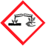  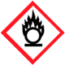  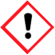 |  | Duke OESO Guidelines for Safe Use of  PIRANHA  Sulfuric acid (usually 98%) and hydrogen peroxide (usually 30%)  AKA: Acidic Piranha, Piranha Etch  Complete Lab-Specific Safety Information on page 3
Hazards | Potential Hazards |  | - Piranha is highly energetic and has many potential hazards. A less hazardous solution/process should be used if possible. Consider NanoStrip as an alternative.  - Piranha is a powerful oxidizer that can cause organic materials to spontaneously ignite.  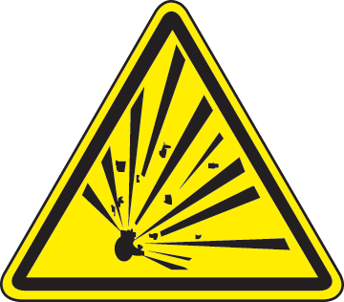  - It can react with metals to release flammable hydrogen gas and enough heat to ignite.  - It is highly corrosive: could cause burns of eyes, skin, or mucous membranes.  - Explosions can be caused by pressure buildup in a closed container.  - Explosions may occur if the hydrogen peroxide concentration is >50%.  - When solution is made (or contacts organics), reaction is exothermic (can reach >100˚C).
Hazard Controls | Storage & Transport |  | - Never store Piranha. Only make enough for immediate use.  - Never cap Piranha unless it has cooled overnight (in fume hood) and no more bubbles form if container is moved. After cooling, use of a vented cap is recommended.
 | Engineering Controls |  | - Eyewash and safety shower required in the immediate work area. | 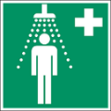 | - Work in a fume hood with the sash between you and the solution to help prevent inhalation hazards and protect from explosion. |  |  | 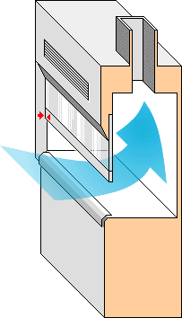
 | Work Practice Controls |  | - Use glass or Pyrex (Piranha is incompatible with plastic).  - Always ADD hydrogen peroxide TO sulfuric acid very slowly. Mix with extreme caution.
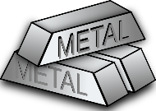
- Keep away from incompatible materials:
  - Organic materials (including solvents like acetone)
  - Acids and bases
  - Most metals
- Container may be hot from the exothermic reaction.
- Substrates must be rinsed and dried before using Piranha.
- Keep acid neutralization materials nearby (sodium bicarbonate).
- Never work alone – others in area must be familiar with Piranha.
 |  |  | - Once work with Piranha is complete, spray the area with a sodium bicarbonate solution, then wipe down the area with soap and water.
 | Personal Protective Equipment |  | 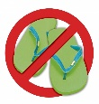  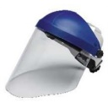  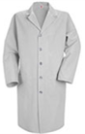  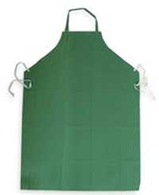  Minimize exposed skin.  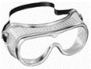  - Closed-toed shoes  - Safety goggles & face shield  - Lab coat & acid apron  - No exposed jewelry: necklaces, rings,  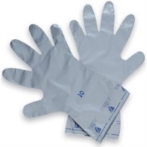  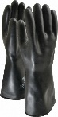  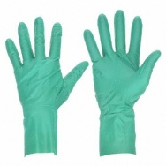  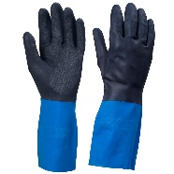  metallic bracelets, etc.  Gloves:*  - For less than 25ml of Piranha:  - Neoprene (5mil) OR gloves listed below.  - For more than 25ml:  - Neoprene over latex (ex. Showa Chem Master) OR Butyl OR Viton OR Laminate (SilverShield)  *Sulfuric acid penetrates standard nitrile laboratory gloves in <5 min; 30% hydrogen peroxide penetrates some standard nitrile gloves in < 10 min.

Other | Emergencies | See Emergency Response webpage or flip chart and/or lab specific chemical hygiene plan.  Spills: 919-684-2444 (911 from a campus land-line phone). Exposures: 919-684-8115.  - For clean-up of small spills (<25 ml) inside the chemical fume hood, see instructions below.
 | Waste | - Label container “For Piranha Solution Disposal ONLY- Do not add other types of chemicals”.  - Allow solution to cool and reaction to finish overnight within open container inside a fume hood.  - Move container slightly. If no bubbles form, cap container and submit to OESO for disposal.  - OESO will not accept containers that bubble when moved (i.e. if the reaction is not complete).  - Small amounts (25ml or less) of Piranha can be neutralized using the procedure on page 3.
 | Training | Sign signature page in lab-specific chemical hygiene plan to indicate review.
 | Questions | Contact OESO Lab Safety at 919-684-8822 or labsafety@dm.duke.edu.

Procedure for Cleaning Small Spills (less than 25ml)
Small Spills | This procedure is only for clean-up of small spills (<25 ml) inside the chemical fume hood. If there is a spill larger than 25ml or that occurs outside the fume hood, the spill would be considered an emergency and should be referred to OESO following instruction on the Emergency Response webpage or flip chart and/or lab specific chemical hygiene plan.  - Wear gloves and other PPE listed under the PPE section above. It’s important to have the correct gloves that are resistant to piranha.  - Slowly neutralize the spilled piranha with sodium bicarbonate. Sprinkle the sodium bicarbonate from edge to center. Be prepared for large amounts of bubbling and heat to be generated.  - After the bubbling stops, check the pH of the spill area with pH paper that has been wet with water. If the spill is still acidic, keep adding sodium bicarbonate until the solution is either neutral or slightly basic.  - Once the piranha has been neutralized and stops bubbling, sweep up the residue using acid resistant absorbent pads or a brush and dust pan and place the waste into an open container.  - Allow the waste container to sit overnight in the hood, then close the waste container  - Dispose of debris as neutralized piranha waste through OESO.  Do not use organic or combustible materials such as saw dust or paper towels to absorb piranha spills! Al solution to cool before moving, capping, or transferring to another container.

Procedure for Neutralizing Piranha Solution (25ml or less)
Neutralization | NOTE: The Piranha solution must have been left to cool and should no longer be bubbling before neutralizing (Both procedures adapted from Division of Research Safety at University of Illinois)  - Calculate volume of ice needed: ~ 5x dilution (e.g., 125g ice for 25 ml Piranha solution).  - Calculate the amount of KOH or NaOH needed for a 1M solution to neutralize the amount of Piranha solution with a small excess (2-3%).  - Make 1M KOH or NaOH solution and put aside.  - Wear FULL PPE shown on previous page!  - Place a stir plate inside a secondary container (with NO organic chemical residue in it).  - Place a clean GLASS beaker (not a flask or other container with a narrow neck) on the stir plate. It must be big enough that it will never be more than 2/3 full (even after dilution is complete).  - Add ice as calculated in #1.  - SLOWLY add Piranha solution to the ice. Add a stir bar.  - SLOWLY add 1M sodium or potassium hydroxide solution while stirring until a neutral pH is reached  - Temperature control is extremely important during this step. Temperature should be closely monitored and not allowed to go above 50C.  - When nearing the end of the neutralization, pH testing with phenolphthalein can be done. Do not add the phenolphthalein at the beginning as it will quickly be destroyed and will not give you the desired pH determination.  - Allow solution to cool overnight while stirring before moving, capping, or transferring to another container.  - See the Lab Chemical Waste Management Practice and Drain Disposal Practice, or contact OESO Environmental Programs (919-684-2794) to determine how to handle the neutralized waste.  Alternate Procedure if ice is not available:  - Calculate a ~10x dilution of water (e.g. 250ml water for 25ml Piranha).  - Fill a GLASS beaker 1 inch high with dry sodium bicarbonate and cover with the water from #1.  - Be sure to pick a beaker that will be large enough as carbon dioxide will form and bubble during the neutralization.  - Place the beaker inside a larger secondary container to ensure any splatters or spills can be contained  - VERY SLOWLY pour the Piranha solution into the beaker, stirring with a glass rod or stir bar and stir plate to mix the solution.  - The solution can easily foam over if too much is added too quickly or without adequate stirring  - Make sure there is solid sodium bicarbonate left in the beaker. Slowly add more if it is all consumed.  - Allow to cool overnight before moving, capping, or transferring to another container.  - See above to determine how to handle the neutralized waste.

Lab-Specific Safety Information for
Piranha Solution
Supplements the Guidelines for Safe Use of Piranha Solution
Lab | PI Name | Click or tap here to enter PI Name |  | PI Approval (signature):  Date: Click or tap to enter a date.
 | Location | Enter building(s) and room(s) where lab is located
Lab-Specific Hazard Controls | Purchase  Details | Maximum component container size | Enter maximum container size purchased for each component
 |  | Maximum component concentration | Enter maximum concentration purchased for each component
 |  | Component container type | Enter the container material for each component |  | Buy in PVC coated or HDPE(“poly”) bottles if possible
 |  | Specific product information | Enter supplier name/product number or purity/grade to purchase |  |  |  |  | H₂O₂ ≤ 30% is advised
 | Storage | Specific location(s) of component acid and hydrogen peroxide | Enter location of component storage |  |  |  | Do NOT store prepared Piranha!
 | Use Information | Designated work area  (specific room(s) and area(s)) | Enter rooms and areas designated for use
 |  | Reasons and Situations for use of Piranha: | Enter the reasons and situations you would use Piranha
 |  | Maximum quantity to be made at one time | Enter maximum quantity to be made at a time
 |  | Gloves  (Note other PPE requirements in Guidelines) | Less than 25ml: ☐ Neoprene 5mil ☐ Glove type is shown below  More than 25ml: ☐ Neoprene over latex (26 mil) ☐ Butyl  ☐ Viton ☐ Laminate (i.e., Silver Shield)
 |  | PPE Storage Location | Enter location where specific PPE is stored (e.g. specialized gloves, sleeves, apron, etc.)
 |  | Location of supplies for  spill clean-up | Enter location of spill clean-up supplies (sodium bicarbonate and acid resistant pads)
 | Waste Information | Details about waste (location, type of container) | ☐ Waste to be neutralized and drain disposed based on anticipated use (less than 25ml ONLY)  ☐ Drain disposal allowed based on anticipated uses  ☐ Waste to be disposed of through OESO  ☐ Neutralize prior to submitting pickup request (<25 ml only)  Enter location of waste container, type of container used |  |  |  |  |  | No Plastic!
 | Details of Process | - Enter steps used in lab process(es) or experiment(s)

