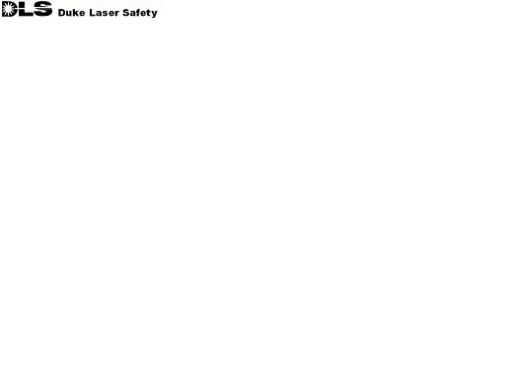 | LASER REGISTRATION FORM
Instructions: All Class 3b and 4 lasers are required to be registered with the DU/DUMC Laser Safety Officer. Complete applicable sections of this form for each laser to be registered and forward to:

Laser Safety Officer, Radiation Safety Office, BOX 3155 FAX: 668-2783

Principal Investigator: |  | Phone:

Laser Manufacturer:

Model Number:

Serial Number:

Clinical Engineering Number (Medical use only) ________________________________

Laser Location:
 | Building | Department | Room Number

Laser Type (Nd:YAG, etc):

Classification (3b or 4):

Wavelength (nm):

Beam Diameter (mm):

Beam Divergence (mrad):

Continuous Wave: Average power (Watts): _________
or
Pulsed: Energy per pulse (Joules): __________

Pulse repetition frequency (Hz): __________

Pulse width (s): __________

Fiber coupled: Numerical aperture _________

Purpose or Use:

Comments:

Principal Investigator’s Signature |  | Date
(no signature needed for electronic format)

