Rapicide PA, Part A  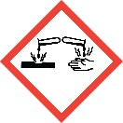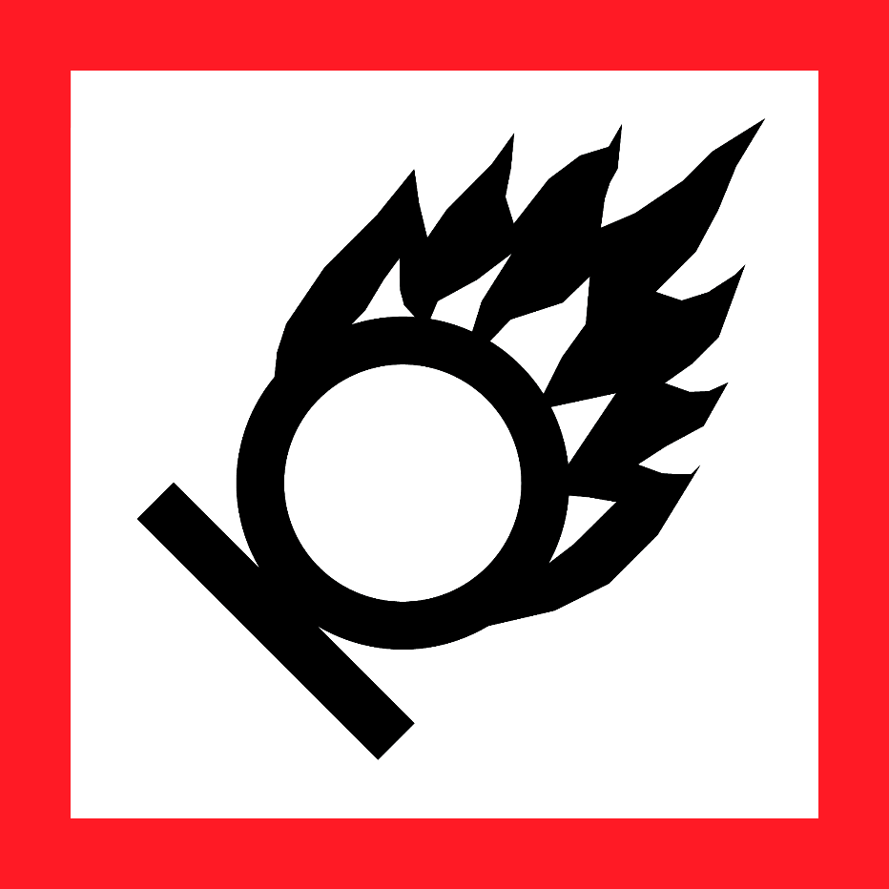  Danger  HAZARD STATEMENTS:  Harmful if swallowed. Causes skin irritation. Causes severe skin burns and eye damage. Causes serious eye damage. May cause fire. May cause respiratory irritation.  PRECAUTIONARY STATEMENTS:  Keep away from heat. Keep/store away from clothing/combustible materials. Take any precaution to avoid mixing with combustibles.  Wash skin thoroughly after handling. Do not eat, drink or some when using this product. Wear protective gloves/protective clothing/eye protection/ face protection. Store in a cool dry area. Keep container closed, but vented when not in use. Avoid release to the environment.  IF SWALLOWED: Drink large amounts of water. Call a POISON CENTER or doctor/physician if you feel unwell. Rinse mouth. Do NOT induce vomiting. IF ON SKIN: (or hair): Remove/Take off Immediately all contaminated clothing. Rinse skin with water. IF INHALED: Remove victim to fresh air. IF IN EYES: Rinse cautiously with water for at least 15-20 minutes. Remove contact lenses, if present, after the first 5 minutes and continue rinsing. If burn or irritation has occurred, seek medical attention. IF ON CLOTHING: Rinse immediately contaminated clothing and skin with plenty of water before removing clothes. In case of fire: Use water, foam CO₂, or dry chemicals for extinction.  Supplier Identification & Emergency Phone#:  Medivators  14605 28th Avenue North  Minneapolis, MN 55447  Emergency Phone # : CHEMTREC 1-800-424-9300  See the Safety Data Sheet for more information. |  | Rapicide PA, Part A  Danger  HAZARD STATEMENTS:  Harmful if swallowed. Causes skin irritation. Causes severe skin burns and eye damage. Causes serious eye damage. May cause fire. May cause respiratory irritation.  PRECAUTIONARY STATEMENTS:  Keep away from heat. Keep/store away from clothing/combustible materials. Take any precaution to avoid mixing with combustibles.  Wash skin thoroughly after handling. Do not eat, drink or some when using this product. Wear protective gloves/protective clothing/eye protection/ face protection. Store in a cool dry area. Keep container closed, but vented when not in use. Avoid release to the environment.  IF SWALLOWED: Drink large amounts of water. Call a POISON CENTER or doctor/physician if you feel unwell. Rinse mouth. Do NOT induce vomiting. IF ON SKIN: (or hair): Remove/Take off Immediately all contaminated clothing. Rinse skin with water. IF INHALED: Remove victim to fresh air. IF IN EYES: Rinse cautiously with water for at least 15-20 minutes. Remove contact lenses, if present, after the first 5 minutes and continue rinsing. If burn or irritation has occurred, seek medical attention. IF ON CLOTHING: Rinse immediately contaminated clothing and skin with plenty of water before removing clothes. In case of fire: Use water, foam CO₂, or dry chemicals for extinction.  Supplier Identification & Emergency Phone#:  Medivators  14605 28th Avenue North  Minneapolis, MN 55447  Emergency Phone # : CHEMTREC 1-800-424-9300  See the Safety Data Sheet for more information.
Rapicide PA, Part A  Danger  HAZARD STATEMENTS:  Harmful if swallowed. Causes skin irritation. Causes severe skin burns and eye damage. Causes serious eye damage. May cause fire. May cause respiratory irritation.  PRECAUTIONARY STATEMENTS:  Keep away from heat. Keep/store away from clothing/combustible materials. Take any precaution to avoid mixing with combustibles.  Wash skin thoroughly after handling. Do not eat, drink or some when using this product. Wear protective gloves/protective clothing/eye protection/ face protection. Store in a cool dry area. Keep container closed, but vented when not in use. Avoid release to the environment.  IF SWALLOWED: Drink large amounts of water. Call a POISON CENTER or doctor/physician if you feel unwell. Rinse mouth. Do NOT induce vomiting. IF ON SKIN: (or hair): Remove/Take off Immediately all contaminated clothing. Rinse skin with water. IF INHALED: Remove victim to fresh air. IF IN EYES: Rinse cautiously with water for at least 15-20 minutes. Remove contact lenses, if present, after the first 5 minutes and continue rinsing. If burn or irritation has occurred, seek medical attention. IF ON CLOTHING: Rinse immediately contaminated clothing and skin with plenty of water before removing clothes. In case of fire: Use water, foam CO₂, or dry chemicals for extinction.  Supplier Identification & Emergency Phone#:  Medivators  14605 28th Avenue North  Minneapolis, MN 55447  Emergency Phone # : CHEMTREC 1-800-424-9300  See the Safety Data Sheet for more information. |  | Rapicide PA, Part A  Danger  HAZARD STATEMENTS:  Harmful if swallowed. Causes skin irritation. Causes severe skin burns and eye damage. Causes serious eye damage. May cause fire. May cause respiratory irritation.  PRECAUTIONARY STATEMENTS:  Keep away from heat. Keep/store away from clothing/combustible materials. Take any precaution to avoid mixing with combustibles.  Wash skin thoroughly after handling. Do not eat, drink or some when using this product. Wear protective gloves/protective clothing/eye protection/ face protection. Store in a cool dry area. Keep container closed, but vented when not in use. Avoid release to the environment.  IF SWALLOWED: Drink large amounts of water. Call a POISON CENTER or doctor/physician if you feel unwell. Rinse mouth. Do NOT induce vomiting. IF ON SKIN: (or hair): Remove/Take off Immediately all contaminated clothing. Rinse skin with water. IF INHALED: Remove victim to fresh air. IF IN EYES: Rinse cautiously with water for at least 15-20 minutes. Remove contact lenses, if present, after the first 5 minutes and continue rinsing. If burn or irritation has occurred, seek medical attention. IF ON CLOTHING: Rinse immediately contaminated clothing and skin with plenty of water before removing clothes. In case of fire: Use water, foam CO₂, or dry chemicals for extinction.  Supplier Identification & Emergency Phone#:  Medivators  14605 28th Avenue North  Minneapolis, MN 55447  Emergency Phone # : CHEMTREC 1-800-424-9300  See the Safety Data Sheet for more information.

