Sodium Hydroxide pellets, ≥98%  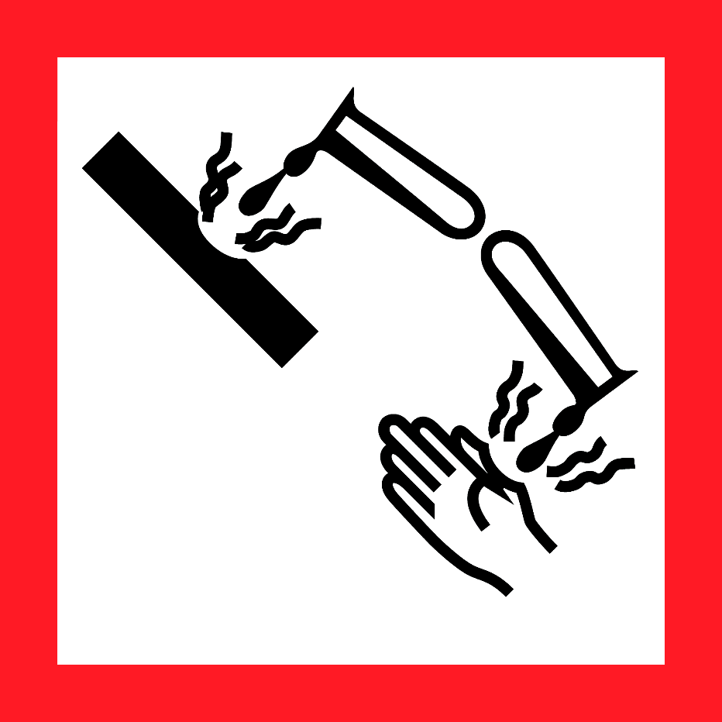  Danger  HAZARD STATEMENTS:  May be corrosive to metals.  Causes severe skin burns and eye damage.  Causes serious eye damage.  Harmful to aquatic life.  PRECAUTIONARY STATEMENTS:  Keep only in original container. Do not breathe dust or mist. Wash skin thoroughly after handling. Avoid release to the environment.  Wear protective gloves /protective clothing/ eye protection/face protection.  Wash contaminated clothing before reuse.  Absorb spillage to prevent material damage. Store locked up.  Store in corrosive resistant stainless steel container with a resistant inner liner. Dispose of contents/container to an approved waste disposal plant.  IF SWALLOWED: Rinse mouth. Do NOT induce vomiting.  IF ON SKIN (or hair): Remove/Take off Immediately all contaminated clothing. Rinse skin with water/shower.  IF INHALED: Remove victim to fresh air and Keep at rest in a position comfortable for breathing.  IF IN EYES: Rinse cautiously with water for several minutes. Remove contact lenses, if present and easy to do. Continue rinsing. Immediately call a POISON CENTER or doctor/physician.  Supplier Identification & Emergency Phone#:  Sigma-Aldrich  3050 Spruce Street  SAINT LOUIS MO 63103  Emergency Phone # : (314) 776-6555  See the Safety Data Sheet for more information. |  | Sodium Hydroxide pellets, ≥98%  Danger  HAZARD STATEMENTS:  May be corrosive to metals.  Causes severe skin burns and eye damage.  Causes serious eye damage.  Harmful to aquatic life.  PRECAUTIONARY STATEMENTS:  Keep only in original container. Do not breathe dust or mist. Wash skin thoroughly after handling. Avoid release to the environment.  Wear protective gloves /protective clothing/ eye protection/face protection.  Wash contaminated clothing before reuse.  Absorb spillage to prevent material damage. Store locked up.  Store in corrosive resistant stainless steel container with a resistant inner liner. Dispose of contents/container to an approved waste disposal plant.  IF SWALLOWED: Rinse mouth. Do NOT induce vomiting.  IF ON SKIN (or hair): Remove/Take off Immediately all contaminated clothing. Rinse skin with water/shower.  IF INHALED: Remove victim to fresh air and Keep at rest in a position comfortable for breathing.  IF IN EYES: Rinse cautiously with water for several minutes. Remove contact lenses, if present and easy to do. Continue rinsing. Immediately call a POISON CENTER or doctor/physician.  Supplier Identification & Emergency Phone#:  Sigma-Aldrich  3050 Spruce Street  SAINT LOUIS MO 63103  Emergency Phone # : (314) 776-6555  See the Safety Data Sheet for more information.
Sodium Hydroxide pellets, ≥98%  Danger  HAZARD STATEMENTS:  May be corrosive to metals.  Causes severe skin burns and eye damage.  Causes serious eye damage.  Harmful to aquatic life.  PRECAUTIONARY STATEMENTS:  Keep only in original container. Do not breathe dust or mist. Wash skin thoroughly after handling. Avoid release to the environment.  Wear protective gloves /protective clothing/ eye protection/face protection.  Wash contaminated clothing before reuse.  Absorb spillage to prevent material damage. Store locked up.  Store in corrosive resistant stainless steel container with a resistant inner liner. Dispose of contents/container to an approved waste disposal plant.  IF SWALLOWED: Rinse mouth. Do NOT induce vomiting.  IF ON SKIN (or hair): Remove/Take off Immediately all contaminated clothing. Rinse skin with water/shower.  IF INHALED: Remove victim to fresh air and Keep at rest in a position comfortable for breathing.  IF IN EYES: Rinse cautiously with water for several minutes. Remove contact lenses, if present and easy to do. Continue rinsing. Immediately call a POISON CENTER or doctor/physician.  Supplier Identification & Emergency Phone#:  Sigma-Aldrich  3050 Spruce Street  SAINT LOUIS MO 63103  Emergency Phone # : (314) 776-6555  See the Safety Data Sheet for more information. |  | Sodium Hydroxide pellets, ≥98%  Danger  HAZARD STATEMENTS:  May be corrosive to metals.  Causes severe skin burns and eye damage.  Causes serious eye damage.  Harmful to aquatic life.  PRECAUTIONARY STATEMENTS:  Keep only in original container. Do not breathe dust or mist. Wash skin thoroughly after handling. Avoid release to the environment.  Wear protective gloves /protective clothing/ eye protection/face protection.  Wash contaminated clothing before reuse.  Absorb spillage to prevent material damage. Store locked up.  Store in corrosive resistant stainless steel container with a resistant inner liner. Dispose of contents/container to an approved waste disposal plant.  IF SWALLOWED: Rinse mouth. Do NOT induce vomiting.  IF ON SKIN (or hair): Remove/Take off Immediately all contaminated clothing. Rinse skin with water/shower.  IF INHALED: Remove victim to fresh air and Keep at rest in a position comfortable for breathing.  IF IN EYES: Rinse cautiously with water for several minutes. Remove contact lenses, if present and easy to do. Continue rinsing. Immediately call a POISON CENTER or doctor/physician.  Supplier Identification & Emergency Phone#:  Sigma-Aldrich  3050 Spruce Street  SAINT LOUIS MO 63103  Emergency Phone # : (314) 776-6555  See the Safety Data Sheet for more information.

