Trophon® Sonex-HL®  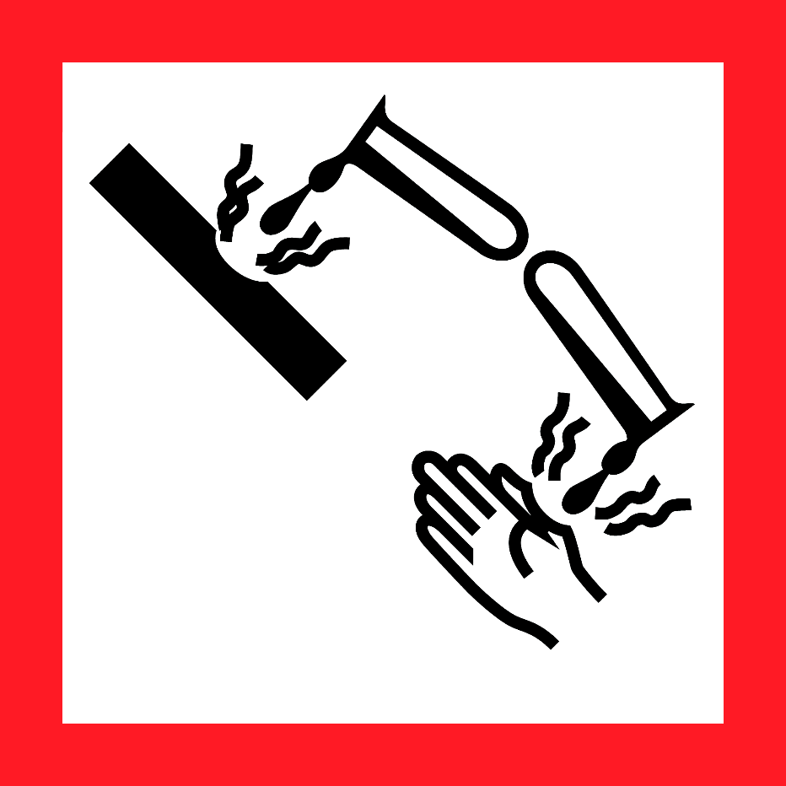  Danger  HAZARD STATEMENTS:  Oxidizer. Contact with other material may cause fire. Causes skin burns. Causes eye burns. May cause respiratory tract irritation. May be harmful if absorbed through skin. May be harmful if swallowed.  PRECAUTIONARY STATEMENTS:  Keep away from heat. Keep/store away from clothing/combustible materials. Take any precaution to avoid mixing with combustibles.  Wash skin thoroughly after handling. Do not eat, drink or some when using this product. Avoid release to the environment. Wear protective gloves/protective clothing/eye protection/ face protection.  Wear fire/flame resistant/retardant clothing. Store locked up. Dispose of contents/container to an approved waste disposal plant.  IF SWALLOWED: Call a POISON CENTER or doctor/physician immediately. Rinse mouth thoroughly with water. Do NOT induce vomiting. IF ON SKIN: (or hair): Remove/Take off Immediately all contaminated clothing. Rinse skin with water/shower. IF INHALED: Remove victim to fresh air. Consult a physician if irritation occurs and persists. IF IN EYES: Rinse immediately with plenty of water, also under the eyelids, for at least 15 minutes. Immediately call a POISON CENTER or doctor/physician. IF ON CLOTHING: Rinse immediately contaminated clothing and skin with plenty of water before removing clothes. In case of fire: Flood with water.  Supplier Identification & Emergency Phone#:  GE Healthcare  3000 North Grandview  Waukesha, WI 53188  Emergency Phone # : 1-877-715-9305  See the Safety Data Sheet for more information. |  | Trophon® Sonex-HL®  Danger  HAZARD STATEMENTS:  Oxidizer. Contact with other material may cause fire. Causes skin burns. Causes eye burns. May cause respiratory tract irritation. May be harmful if absorbed through skin. May be harmful if swallowed.  PRECAUTIONARY STATEMENTS:  Keep away from heat. Keep/store away from clothing/combustible materials. Take any precaution to avoid mixing with combustibles.  Wash skin thoroughly after handling. Do not eat, drink or some when using this product. Avoid release to the environment. Wear protective gloves/protective clothing/eye protection/ face protection.  Wear fire/flame resistant/retardant clothing. Store locked up. Dispose of contents/container to an approved waste disposal plant.  IF SWALLOWED: Call a POISON CENTER or doctor/physician immediately. Rinse mouth thoroughly with water. Do NOT induce vomiting. IF ON SKIN: (or hair): Remove/Take off Immediately all contaminated clothing. Rinse skin with water/shower. IF INHALED: Remove victim to fresh air. Consult a physician if irritation occurs and persists. IF IN EYES: Rinse immediately with plenty of water, also under the eyelids, for at least 15 minutes. Immediately call a POISON CENTER or doctor/physician. IF ON CLOTHING: Rinse immediately contaminated clothing and skin with plenty of water before removing clothes. In case of fire: Flood with water.  Supplier Identification & Emergency Phone#:  GE Healthcare  3000 North Grandview  Waukesha, WI 53188  Emergency Phone # : 1-877-715-9305  See the Safety Data Sheet for more information.
Trophon® Sonex-HL®  Danger  HAZARD STATEMENTS:  Oxidizer. Contact with other material may cause fire. Causes skin burns. Causes eye burns. May cause respiratory tract irritation. May be harmful if absorbed through skin. May be harmful if swallowed.  PRECAUTIONARY STATEMENTS:  Keep away from heat. Keep/store away from clothing/combustible materials. Take any precaution to avoid mixing with combustibles.  Wash skin thoroughly after handling. Do not eat, drink or some when using this product. Avoid release to the environment. Wear protective gloves/protective clothing/eye protection/ face protection.  Wear fire/flame resistant/retardant clothing. Store locked up. Dispose of contents/container to an approved waste disposal plant.  IF SWALLOWED: Call a POISON CENTER or doctor/physician immediately. Rinse mouth thoroughly with water. Do NOT induce vomiting. IF ON SKIN: (or hair): Remove/Take off Immediately all contaminated clothing. Rinse skin with water/shower. IF INHALED: Remove victim to fresh air. Consult a physician if irritation occurs and persists. IF IN EYES: Rinse immediately with plenty of water, also under the eyelids, for at least 15 minutes. Immediately call a POISON CENTER or doctor/physician. IF ON CLOTHING: Rinse immediately contaminated clothing and skin with plenty of water before removing clothes. In case of fire: Flood with water.  Supplier Identification & Emergency Phone#:  GE Healthcare  3000 North Grandview  Waukesha, WI 53188  Emergency Phone # : 1-877-715-9305  See the Safety Data Sheet for more information. |  | Trophon® Sonex-HL®  Danger  HAZARD STATEMENTS:  Oxidizer. Contact with other material may cause fire. Causes skin burns. Causes eye burns. May cause respiratory tract irritation. May be harmful if absorbed through skin. May be harmful if swallowed.  PRECAUTIONARY STATEMENTS:  Keep away from heat. Keep/store away from clothing/combustible materials. Take any precaution to avoid mixing with combustibles.  Wash skin thoroughly after handling. Do not eat, drink or some when using this product. Avoid release to the environment. Wear protective gloves/protective clothing/eye protection/ face protection.  Wear fire/flame resistant/retardant clothing. Store locked up. Dispose of contents/container to an approved waste disposal plant.  IF SWALLOWED: Call a POISON CENTER or doctor/physician immediately. Rinse mouth thoroughly with water. Do NOT induce vomiting. IF ON SKIN: (or hair): Remove/Take off Immediately all contaminated clothing. Rinse skin with water/shower. IF INHALED: Remove victim to fresh air. Consult a physician if irritation occurs and persists. IF IN EYES: Rinse immediately with plenty of water, also under the eyelids, for at least 15 minutes. Immediately call a POISON CENTER or doctor/physician. IF ON CLOTHING: Rinse immediately contaminated clothing and skin with plenty of water before removing clothes. In case of fire: Flood with water.  Supplier Identification & Emergency Phone#:  GE Healthcare  3000 North Grandview  Waukesha, WI 53188  Emergency Phone # : 1-877-715-9305  See the Safety Data Sheet for more information.

